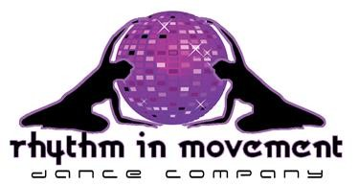

Event attending………………….……..................................................………………………….….
Full name…………………………………………………..……. Date of Birth ………...…...………. Address…………………………………………………………………………………………………………
…….………………………………………………………………………Postcode ……..….………..……. Telephone ……………………….……………..…..Mobile ......…………………………………………… Email ………………………………………………………………………….………………………………..
Are there any medical conditions, illnesses or allergies that we need to be aware of? e.g. physical/sensory disability, asthma, heart problems, joint problems, allergies, learning difficulties? Please also state medication taking if necessary
.............................................................................................................................................................
.............................................................................................................................................................
Emergency Contact Information

Full Name …………………………………………………………………………………………. Relationship to Student …………………..............................................................................
Telephone ……………………………….…..… Mobile …….…………………………………

Alex may take photographs and footage whilst participating for publicity purposes which may include social media and printed publications. We require your permission to use images and footage of you or your child. These images will be used appropriately and responsibly by Rhythm in Movement and stored as confidential information.

Please underline the appropriate and sign:

I give /do not give permission to Rhythm in Movement to use images or footage of my child which I understand may be used for publicity or for advertising purposes as explained above.

I have sent payment of £20 (Half term)/ £75 (Week intensive workshops)/£70 (if paid before the 1st July) for the Lincoln workshop/s to:

As with any physical activity, you should be confident on your ability to take part without detriment to your health. Participants taking part in any classes or events run by Rhythm in Movement Dance Company do so at their own risk, we will not accept responsibility for any accidental injury.

Signed …………………………………………………… Date …………………………………

www.rhythminmovement.co.uk alexlaw@rhythminmovement.co.uk 07540445002

