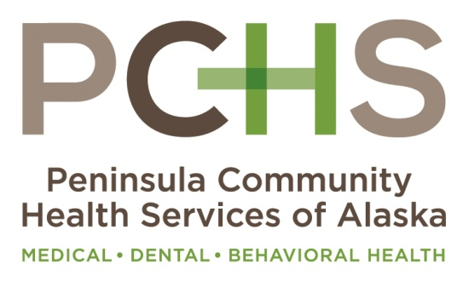
9/3/2015
Monica Adams
907-260-7300
madams@pchsak.org
FOR IMMEDIATE RELEASE

PCHS AWARDED FUNDING FOR NEW HEALTH CENTER IN KENAI
Peninsula Community Health Services of Alaska (PCHS) was awarded a “New Access Point” grant in the amount of $858,333 to open a new health center in Kenai. The award was one of 6 announced in August to Alaska health care agencies to expand access to care. The other awardees were the Aleutian Pribilof Islands Association, Dena’ Nena’ Henash, Girdwood Health Clinic, Kodiak Area Native Association, and Southcentral Foundation. PCHS is a private, community led, independent nonprofit health center based out of Soldotna serving 7,500 people annually with medical, dental, psychiatry, and behavioral health services. The new location will be in Kenai at what was the Benco Building at 805 Frontage Road on the first floor. PCHS purchased the building in 2012 with the intention of developing a center for Kenai, and had been seeking such a funding opportunity since 2010. The new center will provide full service family practice care with a special focus on the health care needs of women and children. Behavioral health services will also be offered there as well. Funding will be used to support the addition of a new physician, medical assistants, and support staff as well as equipment and supplies. This award was the second round of funding for 2015 provided by the Department of Health and Human Services to expand access for the delivery of comprehensive primary health care. This new center will be PCHS’s third location. “Because we offer significant discounts on our services to individuals and families based on their income level we could not operate without federal grants and support such as this. Many people think we are associated with the hospital, but we are not and must rely on grants like this in order to provide care to those who need it most. In 2014, 30% of our revenue, or $3.8 Million was spent on discounts, charity care, and fee adjustments, and without federal and state support we would not be able to do what we do for our community or for those most in need. This is a great opportunity for us to expand affordable, high quality services into Kenai. We already have an excellent dental center in Kenai now and now our patients who live in the Kenai area will have affordable and accessible care close to home. We care for all people regardless of age, income, insurance status, race or ethnicity, and accept new Medicaid, Medicare, private insurance and those without insurance.” stated Monica Adams, PCHS’s CEO. For more information about accessing health care services or about this new center please contact PCHS at www.pchsak.org or call 907-262-3119.

