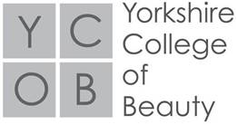

Level 4 Application form

Name: DOB:

Address: Contact number:

NI Number: Email Address:

Nationality: Male/Female (please circle)

Please state the name of the establishment where you attained your;

Level 2 Beauty Therapy: Awarding Body (e.g City & Guilds):

Level 3 Beauty Therapy: Awarding body (e.g City & Guilds):

State Level 3 route completed;

-General Beauty Therapy to include electrotherapy, electrolysis and massage

-Massage route to include; massage, Indian Head and Hot Stone

-Spa Therapy

GCSE/A Level or any other qualifications achieved (please also indicate grade/level achieved in Maths and English.)

Please indicate any additional Beauty Therapy courses completed:

Please state your employment history below.

What are your career aspirations on completion of this course?

Why do you feel that you should be offered a place on this course? (50 words)

What areas of the course interest you the most and why?

Signed…………………………

Date……………………………