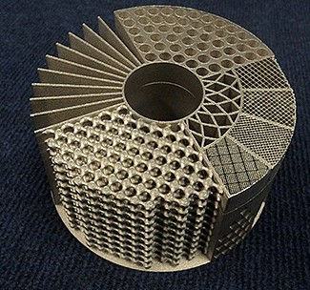
ADDITIVE MANUFACTURING
Not Just New Technology – A NEW Revolution
White Paper

The next industrial revolution has already begun. The capabilities of Additive Manufacturing (AD) also known as 3D printing is rapidly lowering the barriers to entry for manufacturing, product design and disruption to supply chain management. The same way the internet enabled on-line retailers who previously could not compete due to minimal footprint, small to medium OEM’s can strategically incorporate additive manufacturing to develop competitive advantage. The following information should broaden your perspective and generate the recognition for strategic thinking at the highest corporate level.
AN INDUSTRY ON THE RISE
Global 3D printing market forecast to be worth $3.32 billion by 2014
Visiongain – Report/1262 May 2014
Additive manufacturing is transforming the way manufacturing is done throughout the world. Unlike traditional manufacturing methods that mill or cut away from a slab of metal to produce a part, additive manufacturing (also referred to as 3D printing) "grows" parts directly from a CAD file using layers of fine metal powder and an electron beam or laser. The result is complex, fully dense parts without the waste, manufactured in a fraction of the time it would take using other methods. Due to its innovative and disruptive nature, additive manufacturing is being called The Next Industrial Revolution. – GE Aviation website
3D Printing
Starting the Next Industrial Revolution
June 2013- MSN News
PRODUCT DESIGN
EARLY ADOPTERS –
MIT Technology Review
Martin LaMonica on April 23, 2013

General Electric is making a radical departure from the way it has traditionally manufactured things. Its aviation division, the world’s largest supplier of jet engines, is preparing to produce a fuel nozzle for a new aircraft engine by printing the part with lasers rather than casting and welding the metal. The technique, known as additive manufacturing (because it builds an object by adding ultrathin layers of material one by one), could transform how GE designs and makes many of the complex parts that go into everything from gas turbines to ultrasound machines.

The rest of GE—together with its competitors—is watching closely. GE Power & Water, which makes large gas and wind turbines, has already identified parts it can make with the additive process, and GE Healthcare has developed a method to print transducers, the expensive ceramic probes used in ultrasound machines. “It’s really fundamentally changing the way we think about the company,” says Mark Little, GE’s chief technology officer.
Breaking with traditional manufacturing techniques, such as casting and machining material, gives GE product designers far greater flexibility. Additive manufacturing machines work directly from a computer model, so people can devise completely new shapes without regard for existing manufacturing limitations. “We can make configurations that we just couldn’t before,” Little says, GE’s chief technology officer. .
GE engineers are starting to explore how to use additive manufacturing with a wider range of metal alloys, including some materials specifically designed for 3-D printing. GE Aviation, for one, is looking to use titanium, aluminum, and nickel-chromium alloys. A single part could be made of multiple alloys, letting designers tailor its material characteristics in a way that’s not possible with casting. A blade for an engine or turbine, for example, could be made with different materials so that one end is optimized for strength and the other for heat resistance.
LEADING FORECASTS
McKinsey & Company, a global management consulting firm predicts that 3D printing will bring about a new paradigm in product development cycles. While 3D printers have been used for prototyping for years (Chart 1), the declining price of systems is allowing more businesses to adopt the technology. With the ability to model and print an object in a matter of hours, greater emphasis on client feedback and customer centered design are also reshaping product design cycles.
Chart 1 - Prototyping
Company | Product Type | Percent
Bose | Audio Equipment | 95 %
HP | Inkjet Printers | >95 %
MASCO | Varied | 80 %
SC Johnson | Consumer Products | 100 %
HP | Laser Printer | >90 %
Allen Bradley | Electronic Controls | > 90%
Chrysler | Automotive | 85 %
Approximate | Average | 90.7 %
What percentage of your company’s new designs of parts that will be injection molded is prototyped using an additive process? Charts courtesy of Tom Mueller.

While still maturing, McKinsey also sees that 3D printing is rapidly growing to meet the needs for short-run, high quality end-use parts. “As of 2011, only about 25 percent of the additive-manufacturing market involved the direct manufacture of end products,” read the report. “With a 60 percent annual growth rate, however, that is the industry’s fastest-growing segment.

As costs continue to fall and the capabilities of 3-D printers increase, the range of parts that can be economically manufactured using additive techniques will broaden dramatically.” We can now print food, chocolate, glass, wood, carbon, steel, metals, plastics, cheese, stem cells and rubber, just to name a few. As 3D printed end-use products begin to be developed, McKinsey also sees consumers expecting more customization in the products they consume. While this means more time has to be spent tailoring products to the customers’ need, it also means greater value can be built into a product which, in turn, could be used to generate customer loyalty and greater profit.

Although many of McKinsey’s predictions seem to speak of the potential gains that can be made by using AM, there’s a dark side to the technology as well. Like all manufacturing methods, a deep knowledge of the technology is required if you really want to leverage it to full effect. That means businesses interested in adopting the technology should be willing to commit to learning about plastics properties, 3D printing methods and the advantages or disadvantages of various printing methods. Finally, the report concludes that 3D printing is already reducing the cost of entry into a number of markets to the point that new niche design businesses are being founded at an incredible rate. “New businesses are already popping up to offer highly customized or collaboratively designed products. Others act as platforms for the manufacture and distribution of products designed and sold online by their customers. These businesses are gaining insights into consumer tastes and building relationships that established companies could struggle to match.”

RESTRUCTURING WHOLE SUPPLY CHAINS
Just as the Internet has truncated the discovery & buying cycles within industries, so too will AM truncate the time to ‘market’ – by eliminating whole steps between actualization and receiving a product.
Consider the impact of these scenarios on the following, current structures of supply and value chains:
- Transportation – greatly tightened footprints between design, production, & consumption mean fewer truckers and logistics professionals, & a completely overhauled warehousing model
- Distribution – the roles of & need for distributors and resellers will be dramatically rewritten and reconsidered; AM could literally smoke some distribution channels quickly
- Labor costs – the need to pursue cheap labor in emerging markets is greatly reduced for many consumer products and industries
- Retail – stores would become not just transaction centers, but production hubs with much greater depth within the tail end of retail supply chains
These re-definitions will most certainly impact employment across many sectors and markets. They may take unexpected twists and turns, but AM will be an extraordinary driver toward this disinter-mediation.
Businesses interested in adopting the technology should be willing to commit to learning about plastics properties, 3D printing methods and the advantages or disadvantages of various printing methods. - McKinsey

MANUFACTURING TECHNOLOGY WILL SHIFT
One common trait of disruptive technologies is that they drive what were once technical, specialized capabilities to lower expertise levels. Manufacturers have created and sought out efficiency and a better way to do things since we’ve walked upright. It’s in the manufacturer’s DNA. Computer Numerical Control (CNC) is just one of the latest technologies that have allowed those without the ‘gift’ to machine with accuracy and quality.
AM is about automation, but its real impact may be in driving the value away from the physical creation of a part or product and more toward the design and innovation. That is, if you can think it (or program or model it), building it will become more a matter of pushing a button. (The one issue that will remain critical to the production cycles in an AM world will be quality of materials, and in their selection or innovation.)
In our traditional world of subtractive manufacturing (removing material from a larger work piece to make a smaller part), the production process is a lot like a haircut, once you take too much off, you can’t put it back. Additive Manufacturing by its nature contradicts that basis, and capabilities and technologies will absolutely evolve to take advantage of that.
Like all disruptive technologies, AM will absolutely shift expertise to other positions or levels within an enterprise, or industry. But where AM differs from what we’ve seen to this point is that it could literally move production capabilities directly into the hands of the designer – or customer. Today, prototyping has garnered the most thought and discussion in this regard but as AM technology advances, it’s not out of the realm of possibility to see the actual production of low-volume, high-tolerance parts and assemblies in the hands of designers, entrepreneurs, and sole proprietorships.
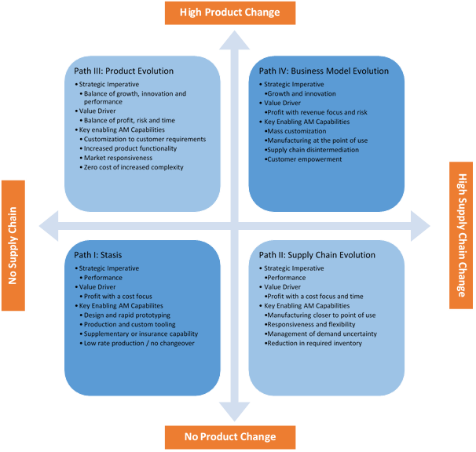
Strategic Pathways

Graphic: Deloitte University Press

For OEM’s this should raise many questions:
- What are the not so obvious applications for AM within our enterprise?
- Should AM be a key component of our strategic plan?
- What are our competitors doing with AM?
- AM will enable new competition, who are they?
- Should we wait for it to be more mainstream?
- How do we accelerate our industry knowledge?
- Should we develop a technology board for our company?
- What are the options to minimize capitalization?

We invite you to an initial consultation into the future of Additive Manufacturing and what it can mean for your company.

A group of experienced professionals organized to accelerate the implementation of Additive Manufacturing across a broad spectrum of industries. Our team consists of highly trained recognized leaders from the Additive Manufacturing world, mechanical engineering, construction manufacturing and global distribution. We are focused on bringing the right solution to our business partners helping them achieve excellence in product development and support.

Lawrence B. Kaye
CEO
(904) 838-3242
lbk@scriptintl.com

