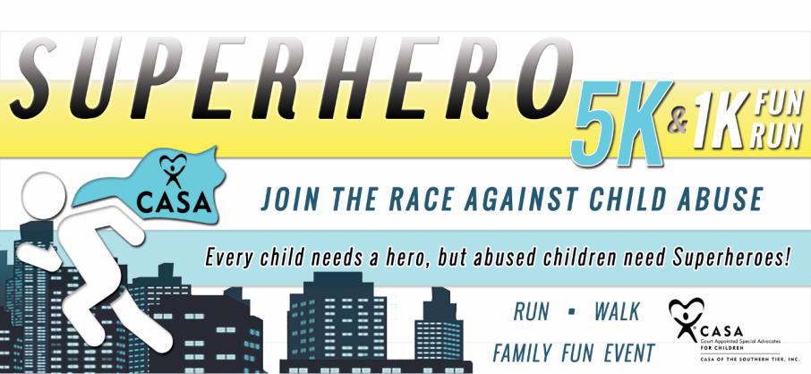
PARTICIPANT
Name: ____________________________________________
Phone Number: Email: *Registration for 12 and over: $25 pre-reg/$30 on Race Day
(If registered by 8/25/17, includes a free T-shirt!)
*Registration for Child 6 - 11 is: $15 pre-reg/$20 on Race Day
(If registered by 8/25/17, includes a free CASA Superhero cape!)
Under 5 years old: Free
(Day of event T-shirt and Cape available while supplies last)

Hosted by
CASA OF THE SOUTHERN TIER, INC.
PO Box 778
Corning, NY 14830
Sunday, September 17th, 2017
Registration @ 8:00 AM
5K Run/Walk @ 9:00 AM

1K Fun Run @ 10:00 AM

Kinsella Park
(Near HealthWorks)
Painted Post, NY
*Race participants must pre-register for the race at either casasoutherntier.org or by mail prior to 9/13/16.

Dear Potential Sponsor,

I am participating in the 2017 CASA Superhero 5K/1K Run in Painted Post, NY on September 17th, 2017. I am running in this race to advocate against child abuse and neglect for the not-for-profit organization, CASA of the Southern Tier, Inc. My goal is to raise $100 in sponsorships. All contributions are tax-deductible. If I reach my goal, I will be entered into some nice door prize drawings the day of the event! Your support in me running for this cause would be much appreciated. CASA accepts checks payable to: CASA of the Southern Tier, Inc.
Thank you!
Name of Sponsor |  | Donation Amount | Amount Collected from Sponsor
1
2
3
4
5
6
7
8
9
10
11
12
13
Any questions, please call CASA of the Southern Tier at 607-936-2272. Total Amount Collected: $

