Horses, Hats and Hope
Sunday, October 15th, 2017
Century Downs Race Track and Casino
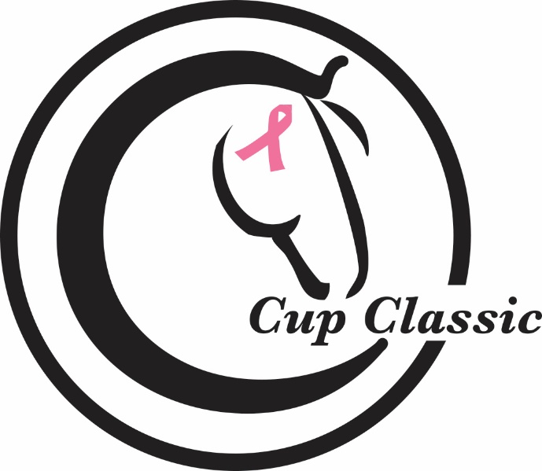
The C Cup Classic is a charity race for Horses, Hats and Hope day at Century Downs on Sunday, October 15th, 2017. The eight horse field will match Thoroughbreds and Quarter horses with experienced riders in a race of almost 4 furlongs. Funds raised will be donated to breast cancer research through the Cancer Research Institute of Northern Alberta.
Sponsorship Package for the C Cup Classic
- Ad placed in the Race Program for October 15th, 2017
- Banner with sponsor logo placed on rail for Horses, Hats and Hope day.
- On air mention of sponsor
- Video board promotion at Century Downs Race Track
- Mention on websites and social media maintained by race organizers.
- All sponsor logos listed on the back of t-shirts. (T-shirt toss for attending public and worn by riders)
- V.I.P. event hosted in the Paddock Room at Century Downs (2 people)
- $500 charitable donation to Cancer Research Institute of Northern Alberta for Breast Cancer Research (tax receipt will be issued).
- Sponsor Package cost: $1,500.00

Please contact Jean Kruse, C.T.H.S. (Alberta Division) General Manager at 403-229-3609 or JKruse@cthsalta.com for further details.

