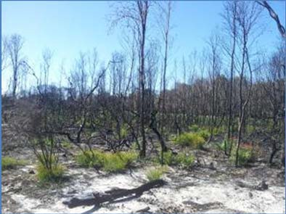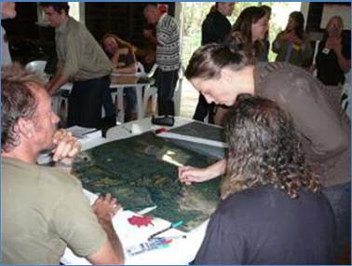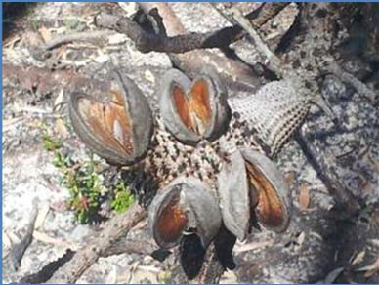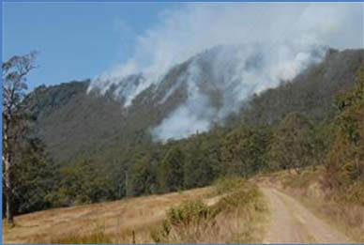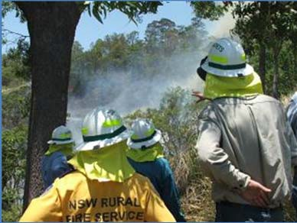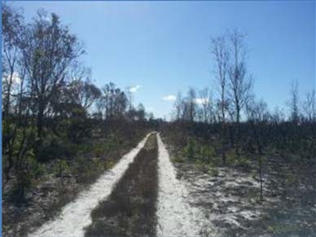

Northern Rivers Fire and Biodiversity
Consortium Strategic Plan 2014 - 2019

© Northern Rivers Fire and Biodiversity Consortium, 2014. You may copy, distribute, display, download and otherwise freely deal with this work for any purpose, provided you attribute the Northern Rivers Fire and Biodiversity Consortium as the owner and publisher.

For further information contact www.nrfabcon.com.au
or
PO Box 1124
Lismore 2480

Citation

Northern Rivers Fire and Biodiversity Consortium (2014) Northern Rivers Fire and Biodiversity Consortium Strategic Plan. Northern Rivers Fire and Biodiversity Consortium

Cover photographs

© Melanie Jackson, ©Tara Patel and ©David Milledge

Change Record

Date | Version | Change Reference
01/05/2014 | Draft 1.0 | Circulated to NRFABCON members and stakeholders for input and comments
16/05/2014 | Draft 1.1 | Open to public for comments
24/07/2014 | Final Draft 1.2 | Available to the wider public
20/10/15 | Updated Final Draft 1.3
5/11/15 | Final | Approved by NRFABCON

Contents

Acknowledgements 1
Acronyms 2
About this Strategy 3
Introduction 4
Background 4
Vision 4
Mission (shared vision) 4
Aims 4
Working Groups 5
Structure and Governance 6
Executive Management Team 6
Working Groups 7
Project Management Teams 7
Members 7
Relevant Stakeholders 7
Focus Area and its significance 8
Relevance of fire to biodiversity conservation in the Northern Rivers. 8
Legislative Framework 10
Management Challenges 11
Management opportunities 12
Strategy Objectives and Actions 13
Links to wider biodiversity objectives and plans 20
Commonwealth 20
Australia's Biodiversity Conservation Strategy 2010‐2030 20
Native Vegetation Framework 2012 20
State and Regional 20
NSW Regional Action Plan Northern Rivers 2021 20
Northern Rivers Biodiversity Management Plan 20
Border Ranges Biodiversity Management Plan 21
Northern Rivers Catchment Management Action Plan 2013‐2023 21
NSW Environmental Trust Objectives 21
NSW Biodiversity Strategy 22
Other Relevant Plans and Strategies 23
References 24

Figure 1: NRFABCON structure and governance diagram 6
Figure 2: Northern Rivers Fire & Biodiversity Consortium Focus Area 8

Table 1: NRFABCON Strategic Objectives and Actions for the 2014 ‐2019 period 13

Acknowledgements
The preparation of this Strategic Plan has been a collaborative approach with significant input from a large number of the Northern Rivers Fire and Biodiversity Consortium members and stakeholders. Funding was provided by the North Coast Local Land Services to prepare this plan. Past funding for the Northern Rivers Fire and Biodiversity Consortium coordinator position has been received from the Northern Rivers Catchment Management Authority, the Office of Environment and Heritage, Nature Conservation Council and Tweed Shire Council.

Thank you to the funding bodies, organisations and individuals that have contributed to preparing this plan.

Acronyms

BFMC | Bushfire Management Committee
DECCW | Department of Environment, Climate Change and Water
EnviTE | EnviTE Incorporated
FCNSW | Forestry Corporation of New South Wales
LN | Landcare networks
LSC | Local Shire Councils
NCC | Nature Conservation Council
NCLLS | North Coast Local Land Services
NPWS | National Parks and Wildlife Service
NRFABCON | Northern Rivers Fire and Biodiversity Consortium
NSW | New South Wales
NSW ET | New South Wales Environmental Trust
OEH | Office of Environment and Heritage
SCU | Southern Cross University
WG | Working Group

About this Strategy
This Northern Rivers Fire and Biodiversity Strategy has been prepared by the Northern Rivers Fire and Biodiversity Consortium (NRFABCON), an incorporated association and has been funded by the North Coast Local Land Services.
The aim of the strategy is to investigate options for NRFABCON long-term viability; identify NRFABCON priorities and preferred timelines; provide detail on roles and responsibilities; identify implementation leaders for priority projects or actions where appropriate; identify potential resource and funding providers; develop project plans or planning tools for key NRFABCON working groups and/or issues.
The NRFABCON consult with a broad range of stakeholders including local councils; state government agencies such as Office of Environment and Heritage, NSW Rural Fire Service, NSW National Parks and Wildlife Service, North Coast Local Land Services and NSW Forestry Corporation; research institutions; indigenous organisations; conservation groups; farmer representative groups; land management support organisations and community groups in addition to interested individuals.
This strategy is endorsed by the NRFABCON as an agreed suite of actions designed to achieve ecologically sustainable fire management for the Northern Rivers region of NSW.

Introduction
The Northern Rivers Fire and Biodiversity Consortium (NRFABCON) provides a network for public and private land managers and other community and industry stakeholders seeking a coordinated and landscape level approach, to manage fire for the maintenance and improvement of biodiversity outcomes.
Initially convened in March 2010 the Consortium was formally established in August 2011. The formation of the Consortium is a key action of the Northern Rivers Regional Biodiversity Management Plan in regard to addressing the landscape scale threat of inappropriate fire regimes on the regions biodiversity (DECCW NSW 2010).

Background
The operations and priorities of the NRFABCON have been under development since its inception. The NRFABCON conducted a Program Logic workshop in August 2011 with an independent facilitator from Environmental Evidence Australia. That workshop resulted in the NRFABCON’s program logic, vision, mission, objectives and tiered priorities. Since then the NRFABCON’s Terms of Reference and constitution have reflected a direction consistent with the workshop results. All three documents are available in Appendix 1.

Vision

“To achieve ecologically sustainable fire management for the Northern Rivers”.

Mission (shared vision)

The Northern Rivers Fire and Biodiversity Consortium (NRFABCON) promote a collaborative and practical approach to sustainable fire management, across landscapes, for healthy ecological and social communities. Through adaptive fire management actions and strategies NRFABCON empowers communities to improve their understanding of and participation in sustainable fire management practices for biodiversity conservation, whilst also recognising the importance of protecting life and property.

Aims

The NRFABCON aims to provide a forum to:
- Exchange information between stakeholders and other natural resource management and community networks regarding managing fire to optimise biodiversity outcomes
- Encourage a consistent landscape approach to managing fire for biodiversity
- Support a collaborative approach to the identification and implementation of fire-related projects and on-ground actions to improve or maintain biodiversity outcomes.

This 5 year strategic plan builds on those previous works and is intended to:

  - Provide detail and focus to the NRFABCON direction
  - Identify priorities and timelines, roles and responsibilities
  - Investigate options for the NRFABCON viability
  - Involve key stakeholders in the strategic planning process
The steps that were undertaken to develop this strategic plan were to establish a steering committee with a wide range of members, the holding of two planning workshops, one in March 2014 and the second in April 2014, with all the NRFABCON members and relevant stakeholders invited to attend. The strategy was reviewed by NRFABCON members, stakeholders and relevant stakeholders and open for comments in May 2014. Issues and comments raised in this process were considered and in many cases incorporated into this plan.

The NRFABCON strategic objectives are:
- To encourage, empower and facilitate communities to understand and participate in a consistent landscape approach to sustainable fire management for biodiversity conservation
- To develop, facilitate and implement projects that contribute to the aims and objectives of the NRFABCON
- To have the consortium model recognised as an important collaborative approach in driving regional fire management for healthy landscapes
- To encourage an appropriate legislative and planning framework that supports the implementation of ecological fire management practices.
- To support and promote research into fire and biodiversity conservation and monitoring of outcomes

Working Groups
Five working groups have so far been established under the NRFABCON, actively working on projects with on-ground and/or policy outcomes. The development of additional working groups will be determined by a needs or opportunity basis by NRFABCON. All working groups have a team leader and report back to the NRFABCON regularly. Anyone from the NRFABCON can be involved and contribute to these groups at any time. For more information on the working groups go to www.nrfabcon.org.au/Work-Groups
The current working groups are:

  - NRFABCON Bell Miner Associated Dieback (BMAD)/Forest Health Working Group
  - NRFABCON Constraints to Approval of Ecological Burning Working Group
  - NRFABCON Eastern Bristlebird Working Group
  - NRFABCON Koala Working Group
  - NRFABCON Cultural Burning Working Group

Structure and Governance
NRFABCON is a model of partnerships with collaboration across organisational boundaries with common goals regarding appropriate fire management for optimum biodiversity outcomes. On the 23rd July 2013 the Consortium became an Incorporated Association under the model rules set out by the Department of Fair Trading. Figure 1 shows the NRFABCON governance and structure, comprising of an executive management team, a coordinator, working groups, project management teams, members and relevant stakeholders across the focus area. To date only the coordinator is funded and all participation is voluntary, future projects may attract more funding.
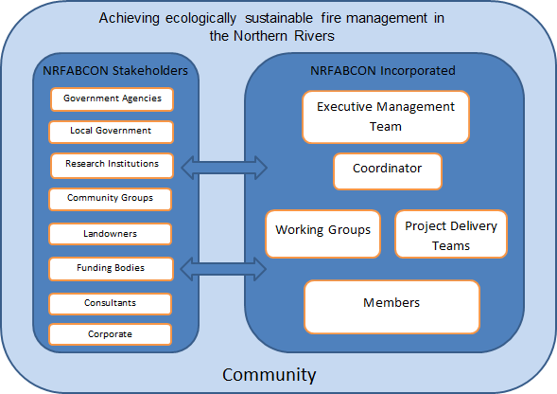

Figure 1: NRFABCON structure and governance diagram

Executive Management Team

The volunteer executive management team (the committee) run the business side of the organisation and provide sound management, direction and leadership. The committee ensures the organisations' responsibilities are met and determine the overarching framework for running the organisation. This includes the processes (policies and practices) by which NRFABCON operate within and are held to account. The committee has responsibility for group representation to the wider community, as well as administrative requirements of finance, project planning, incorporation and insurance, publicity and record keeping.

Good governance = sustainable performance

The committee pursues three elements:
- LEAD: Provide leadership, forward planning, and guidance to the organisation.
- CARE: Provide stewardship of the organisation in order to protect it for the members and the community, and to ensure it pursues its stated purposes whilst remaining viable.
- CONTROL: Provide monitoring and oversight of the management to maintain authority and accountability, ensuring good management practices.

Working Groups

Working Groups are actively developing and overseeing projects with on-ground and/or policy outcomes. These groups are made up of NRFABCON members and stakeholders. For more information about the NRFABCON working groups go to www.nrfabcon.org.au/Work-Groups/ .

Project Management Teams

Project management teams are those involved in managing and delivering a specific funded project.

Members

Members are financial members of the NRFABCON Incorporated entity and have voting rights under its constitution. They can be either individuals or organisations that have an interest in fire and biodiversity and wish to contribute to achieving the objectives of the NRFABCON Inc.

Relevant Stakeholders

Relevant stakeholders provide high level vision; provide commentary on strategic planning; act as an advisory role and a conduit to the NRFABCON. They include funding stakeholders and delivery stakeholders, each playing an important role in achieving on-ground fire management for biodiversity projects. The consortiums current Stakeholders are listed in Appendix 2.

Focus Area and its significance
The Consortium currently covers six local government areas in northern NSW as shown in Figure 2. This is a pilot model for NSW that can easily expand or be drawn from once it is established in this area. The area covers approximately 10,290km², south from the Queensland/NSW Border to just south of Evans Head in NSW and inland to the Tablelands.
The climate is generally subtropical, with warm humid summers and mild winters, a marked summer and autumn rainfall, relatively dry springs and fine sunny days with cool nights in winter.

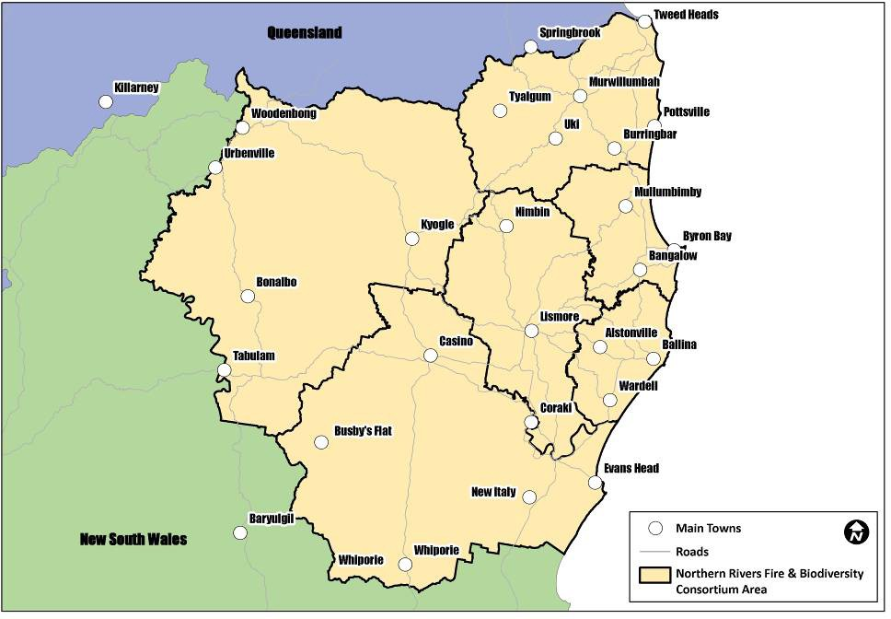
Figure 2: Northern Rivers Fire & Biodiversity Consortium Focus Area

Relevance of fire to biodiversity conservation in the Northern Rivers

This region is culturally diverse and rich in biodiversity and includes both temperate and tropical species, making it a “biodiversity hotspot”. The area includes numerous federal and state listed threatened species and Endangered Ecological Communities (DECCW 2010).
While many of the regions species and vegetation communities have developed ways of coping, adapting and thriving with fire, the inappropriate use or occurrence

of fire has been identified as a major threat to the biodiversity of the region (DECCW 2010). Inappropriate fire can be either too frequent or not frequent enough depending on the ecosystem characteristics or individual species requirements.
‘High frequency fire resulting in the disruption of life cycle processes in plants and animals and loss of vegetation structure and composition’ has been declared a 'Key Threatening Process' by the NSW Scientific Committee. In the Northern Rivers inappropriate fire has been identified in contributing to the loss of some habitats and their associated species.

Legislative Framework
The following list identifies the key legislation with regard to implementing appropriate fire management in the New South Wales. The legislative framework is highly complex and numerous other related legislative instruments, codes and policies are further identified in Appendix 4.
National Parks and Wildlife Act 1974 Threatened Species Conservation Act 1995
Environmental Planning and Assessment Act 1979

Environment Protection and Biodiversity Conservation Act 1999 (Commonwealth) Rural Fires Act 1997
Native Vegetation Act 2003 Wilderness Act 1987
Protection of Environment Operations Act 1997 Protection of the Environment Administration Act 1991 Soil Conservation Act 1938
(NSW) Aboriginal Land Rights Act 1983 Forestry Act 1916

Management Challenges
The key challenges for the success of NRFABCON include but are not limited to:

  - knowledge gaps regarding appropriate fire regimes for Northern Rivers species, ecosystems, and genetic diversity
  - balancing life and property protection with optimum fire management for biodiversity outcomes
  - coordinating cross tenure efforts across the landscape to implement appropriate fire regimes that optimise biodiversity outcomes.
  - working within current legislative constraints.
  - resourcing on-ground actions, administration and coordination costs
  - community cooperation
  - clear communication between stakeholders
  - long term monitoring of actions
  - lack of awareness by funding and managing agencies, landholders, and the community of inappropriate fire as a threat to ecosystem health and maintenance of biodiversity values and cultural values
  - community perception, inexperience and fear of fire
  - limited local research on fire and biodiversity for different ecosystems
  - limited knowledge of cultural burning practices in northern rivers
  - limited access to mapping of fire history, cultural values and ecosystems
  - complexity of legislation relevant to fire management (current reviews of Codes, Acts and Regulations)
  - recognition of cultural heritage

Management opportunities
The key opportunities for the success of NRFABCON include but are not limited to:

  - different purposes for fire management can often have mutually beneficial outcomes (e.g. hazard reduction burning primarily undertaken for the protection of human life and property can also have significant ecological benefit)
  - developing and strengthening cross tenure communications and collaboration
  - innovation in practices, technologies, methods and implementation models
  - enabling change
  - increased ability to identify and secure funding for priority actions
  - increased ability to raise profile of issues, solutions and outcomes
  - assisting communities to be autonomous
  - increased capacity to access and share key messages, latest research and legislation
  - access to and incorporation of local indigenous and non-indigenous knowledge

These key challenges and opportunities have been considered when formulating the Objectives and Actions outlined in Table 1 below for this strategy. These reflect the current priorities of NRFABCON for the period 2014 – 2019 but it is anticipated that these will be dynamic and be regularly reviewed and updated as required.

Strategy Objectives and Actions
Table 1: NRFABCON Strategic Objectives and Actions for the 2014 ‐2019 period

Objective 1. To encourage, empower and facilitate communities to understand and participate in a consistent landscape approach to sustainable fire management for biodiversity conservation.
Proposed Actions | Stakeholders | Priority | Timeframe | Resources and potential funding providers
- Develop a NRFABCON website to hold and present information on fire management, projects and events  - Maintain NRFABCON website, including relevant links with other sites and resources | NRFABCON members and stakeholders NRFABCON  Coordinator | Very high | June 2014 developed  On-going | NCLLS – secured  NRFABCON  Members and stakeholders
1.21 Support and/or apply for funding for coordinator position | NRFABCON members and stakeholders NRFABCON  Coordinator | Very high | Ongoing | Seek relevant grant funding with support from members and stakeholders  LSC, NCLLS, OEH
1.31 Develop and distribute a brochure to introduce NRFABCON, highlight the importance of fire in the landscape and promote the website as a key information resource | NRFABCON-  Coordinator NRFABCON members and stakeholders | High | 12 months | NRFABCON  Members and stakeholders
1.41Produce a minimum of 2 media release per year including the following topics within the first twelve months | NRFABCON  Coordinator NRFABCON members | High | 12 months | NRFABCON  members and stakeholders

-new website launch  -new projects as they occur | and stakeholders to promote through their networks
1.51 Develop and facilitate introductory fire | NSW RFS, NCC, LN, | Medium | 2 -5 years | Seek relevant
management workshops for landholders –Introduction | GERI, NRFABCON |  |  | grant funding with
to “fire for healthy habitats” | Coordinator, |  |  | support from
1.52 Develop and facilitate training on sustainable fire | NRFABCON members |  |  | members and
management for NRM practitioners (council NRM staff, | and stakeholders |  |  | stakeholders
Landcare Officers, bush regenerators, NRM
managers, LALC’s)
1.53 Identify at least 1 potential project per year for
consideration by the Hotspots Team.
1.54 Host an annual Fire and Biodiversity Forum to
promote a consistent landscape approach to
sustainable fire management for biodiversity
conservation in the northern rivers that is open to the
wider community
1.55 Host events such as field days and displays
promoting ecologically sustainable fire management
1.61 Case studies developed and distributed to | NRFABCON members | Medium | 2 years | Coordinator
promote successful project outcomes and NRFABCON | and stakeholders |  |  | Members and
findings and recommendations | NRFABCON |  |  | stakeholders
 | Coordinator
1.71 Request access to fire prone, fire history and | NRFABCON members | Medium | 3-5 years | NRFABCON
vegetation mapping and other relevant data | and stakeholders |  |  | Coordinator
1.72Seek to improve fire prone, fire history and | NRFABCON |  |  | Members and
vegetation mapping by identifying existing gaps | Coordinator |  |  | stakeholders
1.81Develop and facilitate a mentoring program – | NRFABCON members | low | 2 – 5 years | NRFABCON
communities working with other communities (links | and stakeholders |  |  | members and
with Firesticks Project) | NRFABCON |  |  | stakeholders
 | Coordinator

Objective 2. To develop, facilitate and implement projects that contribute to the aims and objectives of NRFABCON.
Proposed Actions | Stakeholders | Priority | Timeframe | Resources and  potential funding providers
- Review past and current relevant fire projects  - Create a NRFABCON central database of fire related projects – past, present and future | NRFABCON members, stakeholders & coordinator | High | 1-2 years | Seek relevant external grant funding with support from NRFABCON members and stakeholders
2.21 Workshop current and new regional fire related projects at annual forum | NRFABCON members, stakeholders & coordinator | High | 1-2 years | Seek relevant grant funding with support from members and stakeholders
2.31 Maintain existing NRFABCON working groups and support new working groups to form | NRFABCON members, stakeholders & coordinator | High | Ongoing | NRFABCON  members, stakeholders
2.41 Secure funding for NRFABCON working group projects | NRFABCON members, stakeholders & coordinator | Medium | 2-5 years | Seek relevant external grant funding with support from NRFABCON members and stakeholders
2.51 Encourage data sharing between agencies and individuals | NRFABCON members, stakeholders & coordinator | Medium | Ongoing | NRFABCON  members, stakeholders

Objective 3. To have the consortium model recognised as an important collaborative approach in driving regional fire management for healthy landscapes.
Proposed Actions | Stakeholders | Priority | Timeframe | Resources and  potential funding providers
- Increase the level of participation and number of stakeholders in the NRFABCON. Target local government, industry, Landcare networks and private landholders/farmers  - Encourage members and stakeholders to have multiple representatives to maximise attendance, participation and contribution to Consortium meetings | NRFABCON  members, stakeholders and Coordinator | High | 1-2 years | NRFABCON  members and stakeholders
3.21 Seek for relevant government websites to link to the NRFABCON website and request government agencies | OEH, NSW RFS, NCLLS, NSW FC, LSC, NRFABCON  coordinator | High | Within 1 year | NRFABCON  members and stakeholders
3.31Promote the benefits of the NRFABCON model as an approach to improving collaborative fire management for biodiversity conservation in the Northern Rivers area and in other regions of NSW at local, regional, and state biodiversity and/land management forums | NRFABCON  members, stakeholders & coordinator | Medium | 2-5 years | NRFABCON  members and stakeholders
3.41 Include this model in future or reviewed Regional Biodiversity Management Plans, Local Biodiversity Strategies and Management Plans | OEH, NRFABCON  members, stakeholders & coordinator | Medium | 2-5years | N/A
3.51 Investigate the viability and need to expand NRFABCON existing membership to the wider Northern Rivers region. | NRFABCON members and stakeholders in conjunction with potential members from the wider region | low | 3-5 years | NRFABCON  members and stakeholders

Objective 4. To encourage an appropriate legislative and planning framework that supports the implementation of ecological fire management practices.
Proposed Actions | Stakeholders | Priority | Timeframe | Resources and  potential funding providers
4.11 Provide input into the Native Vegetation Act – Environmental Works self-assessment code development and other relevant legislative review processes | NRFABCON  members, stakeholders & coordinator | High | 1-2 years | NRFABCON  members, stakeholders
4.21 Support relevant members to provide input as required to the identification of ecological assets and allocation of treatments through the Bushfire Risk Management Plan process. | NRFABCON reps that are on the BFMC | High | 1-2 years | NRFABCON  members, stakeholders
4.31 Contribute to discussion of regional fire thresholds versus State wide thresholds, including reviewing SEQ regimes and research and inclusion of flexibility in regimes for specified systems (scenario based not prescription). | NRFABCON  members, stakeholders and coordinator | Medium | 2-5 years | NRFABCON  members, stakeholders
4.41 Identify and advocate a streamlined, standardised and rigorous ecological burning process that is consistent with current or modified legislative approval provisions | NRFABCON  Ecological Burning Working group with support from NRFABCON  members, stakeholders | Medium | 2-5 years | NRFABCON  members, stakeholders
4.51 Investigate new options for codification that are flexible and scenario based (not prescribed), such as the building codes alternative solutions | NRFABCON  Ecological Burning Working group | Medium | 2-5 years | NRFABCON  Ecological Burning Working group

Objective 5. To support and promote research into fire and biodiversity conservation and monitoring of outcomes
Proposed Actions | Stakeholders | Priority | Timeframe | Resources and  potential funding providers
5.11 Maintain partnership/links with the universities and other research institutions | NRFABCON members and stakeholders NRFABCON  Coordinator | High | 1-5 years
5.21 Identify and pursue external funding to support research into ecological burning | NRFABCON members and stakeholders NRFABCON  Coordinator | High | 1-3 years | Seek relevant grant funding with support from members and stakeholders
5.31 Undertake a literature review of relevant research and compile and publish results | SCU and NRFABCON  members and stakeholders NRFABCON  Coordinator | Medium | 2-4 years | Potential Honours project  Seek relevant grant funding with support from members and stakeholders
- Analyse and identify research requirements through consultation with:  - the general community via online survey  - NRFABCON through direct engagement  - relevant research experts through targeted workshop/forum (including Penny Watson who | SCU and NRFABCON  members and stakeholders NRFABCON  Coordinator | Medium | 2-4 years | NRFABCON  members and stakeholders NRFABCON  Coordinator

has already identified research requirements for different vegetation types ¹of the North Coast, NSW.
5.51 Seek out local experts on fire ecology to form an independent expert scientific panel for reviewing and recommending future research projects | NRFABCON members and stakeholders NRFABCON | Medium | 2-4 years
5.61 Determine best monitoring/standard techniques NRFABCON would recommend for recording the benefits for biodiversity by implementing ecological or cultural burns | Eastern Bristlebird WG and NRFABCON  members and stakeholders NRFABCON  Coordinator | Medium | 1-3 years
5.71 Identify citizen science projects and opportunities | NRFABCON members and stakeholders NRFABCON  Coordinator | Low | 4-5 years

1 Northern Rivers sclerophyll grassy woodlands, NR dry sclerophyll shrub/grass forests, Northern Hinterland Wet Sclerophyll Forest, Northern tableland Wet Sclerophyll Forests, Northern Hinterland Wet Sclerophyll Forest, Northern tableland Wet Sclerophyll Forest, North Coast Wet Sclerophyll and Northern Escarpment Wet Sclerophyll Forests, North Coast Dry Sclerophyll Forests, Northern escarpment Dry Sclerophyll Forests and North Coast heathlands. (Source: Dr Penny Watson Hotspots Fire project Fire Frequency Guidelines and the vegetation of the Northern Rivers region Draft 2, Revised on Basis of Comments)

Links to wider biodiversity objectives and plans

Commonwealth

Australia's Biodiversity Conservation Strategy 2010‐2030

The Australia's Biodiversity Conservation Strategy 2010-2030 lists “Changing Fire regimes” as one of the six main threats to Australia’s biodiversity.
Sub-priority 2.2: Maintaining and re-establishing ecosystem functions

Outcome 2.2.3: An improvement in the use of ecological fire regimes to conserve biodiversity and protect the public

Native Vegetation Framework 2012

The Native Vegetation Framework lists inappropriate fire regimes as one of eight key threats facing all Australian native vegetation.
Action: Use strategic regional and land-use planning to manage fire and fire risk, considering both native vegetation and human needs. Relevant Goal 1, Goal 2, Goal 3, Goal 4, Goal 5

State and Regional

NSW Regional Action Plan Northern Rivers 2021

Goal 22 – Protect our natural environment
Priority Action: Work with local stakeholders to improve environmental sustainability and respond to regional environmental issues - Implement fire management strategies for national parks and reserves in the Northern Rivers region, including hazard reduction programs and wildfire suppression activities. Fire management programs will reduce the impacts of wildfire on the community, assets, biodiversity, cultural heritage and tourism values.

Northern Rivers Biodiversity Management Plan

Objective 4: To protect vegetation communities, ecosystems and habitats from inappropriate fire regimes.
Outcome 4.1: Promoted a consistent and coordinated approach to fire management
Outcome 4.2: Appropriate fire regimes are identified and implemented

Objective 19: To engage the community and private landholders in biodiversity conservation.
Outcome 19.1.1: Provide assistance to landholders in property management planning, including information and advice on the role of fire in biodiversity management.
Outcome 19.1.3: Seek partnerships between government agencies, organisations, research bodies and private landholders in integrated threat management programs (e.g. rainforest fire risk, weeds). Where possible, build on existing programs or networks.

Border Ranges Biodiversity Management Plan

Objective 6: To protect rainforest from fire and to promote the implementation of appropriate fire regimes in related vegetation
Outcome 6.1: Fire excluded from rainforest
Outcome 6.2: A consistent and coordinated approach to fire management and rainforest protection promoted
Outcome 6.3: The broader community engaged in fire management and protection of rainforest from fire
Outcome 6.4: Ecological burns undertaken
Outcome 6.5: Species ecological requirements in fire planning and hazard reduction guidelines reviewed and updated
Outcome 6.6: Research into effects of different burning regimes undertaken on species and communities

Northern Rivers Catchment Management Action Plan 2013‐2023

Strategy 1: Engage community: strategic directions, priority actions and delivery stakeholders
Strategy 2: Manage landscapes and seascapes: strategic directions, priority actions and delivery stakeholders
Strategy 3: Sustain livelihoods: strategic directions, priority actions and delivery stakeholders
Strategy 4: Enrich lifestyles and culture: strategic directions, priority actions and delivery stakeholders

NSW Environmental Trust Objectives

The objectives of the NSW Environmental Trust are:

- to encourage and support restoration and rehabilitation projects
- to promote research into environmental problems of any kind
- to promote environmental education in both the public and private sectors
- to fund the acquisition of land for the national parks estate
- to fund the declaration of areas for marine parks and for related purposes
- to promote waste avoidance, resource recovery and waste management (including funding enforcement and regulation and local government programs)

- to fund environmental community groups
- to fund the purchase of water entitlements for the purpose of increasing environmental flows for the State's rivers and restoring or rehabilitating major wetlands.

NSW Biodiversity Strategy

Objective 10: Effectively manage and control threats through cooperative partnerships with key stakeholders.

Other Relevant Plans and Strategies
Local Council Biodiversity Strategies Regional Bush Fire Management Plans Bush Fire Risk Management Plans
NSW Threatened Species Priorities Action Statement Federal recovery plans and threat abatement plans
NSW recovery plans, threat abatement plans and statements of intent. BMAD Strategy

References
Bell Miner Associated Dieback Working Group 2004, Bell Miner Associated Dieback Strategy, Bell Miner Associated Dieback Working Group and Department of Environment and Conservation, Coffs Harbour, NSW
Biosecurity Queensland on behalf of the National Lantana Management Group (2010), Plan to Protect Environmental Assets from Lantana, Department of Employment, Economic Development and Innovation, Yeerongpilly, Queensland.

COAG Standing Council on Environment and Water (2012), Australia’s Native Vegetation Framework, Australian Government, Department of Sustainability, Environment, Water, Population and Communities, Canberra

Department of Environment, Climate Change and Water NSW (2010), Northern Rivers Regional Biodiversity Management Plan, National Recovery Plan for the Northern Rivers Region, Department of Environment, Climate Change and Water NSW, Sydney.
Department of Environment, Climate Change and Water NSW (2010), Border Ranges Rainforest Biodiversity Management Plan - NSW & Queensland, Department of Environment, Climate Change and Water NSW, Sydney.

Department of Environment, Climate Change and Water NSW and Industry and Investment NSW (2010), Draft New South Wales Biodiversity Strategy 2010– 2015, Department of Environment, Climate Change and Water NSW and Industry and Investment NSW, Sydney.

Department of Premier and Cabinet (2012), NSW Regional Action Plan Northern Rivers 2021, Department of Premier and Cabinet
Natural Resource Management Ministerial Council (2010), Australia’s Biodiversity Conservation Strategy 2010-2030, Australian Government, Department of Sustainability, Environment, Water, Population and Communities, Canberra.

Northern Rivers Catchment Management Authority (2013), Northern Rivers Catchment Management Action Plan 2013-202, Northern Rivers Catchment Management Authority, Grafton
Watson, P. (2006), Hotspots Fire project Fire Frequency Guidelines and the vegetation of the Northern Rivers region Draft 2
.

