December 2016
Downunder Charters

Tips and Tricks

Did you know: Venus Tusk fish are often
referred to as “blue bone” in other parts of
Australia

Heading out on the water? Visit www.seabreeze.com.au for accurate and up
to date weather reports in your area.

For all other weather conditions see
www.bom.gov.au

Do you have tip or trick or a useful web site
you would like us to post? Email us at: admin@fishingdownunder.com.au and we
will include it in the next newsletter.

If you would like to receive an email version of
this this newsletter (so all the links work) email
us at: admin@fishingdownunder.com.au to join
the mailing list.

Tweed Heads Marina, River Terrace, Tweed Heads
www.downundercharters.com.au
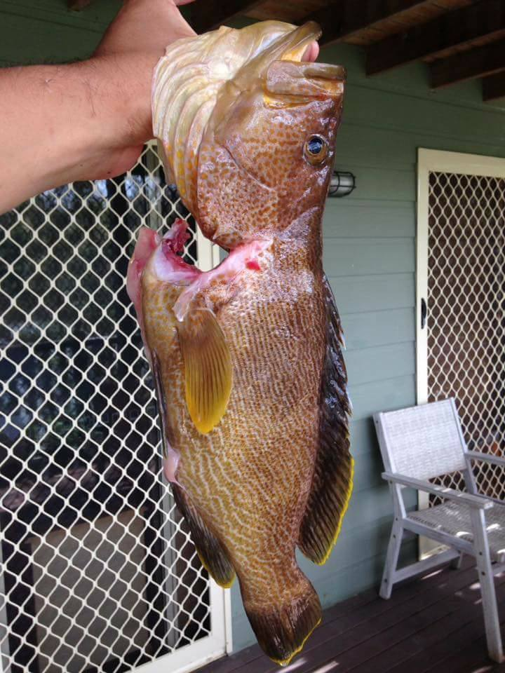
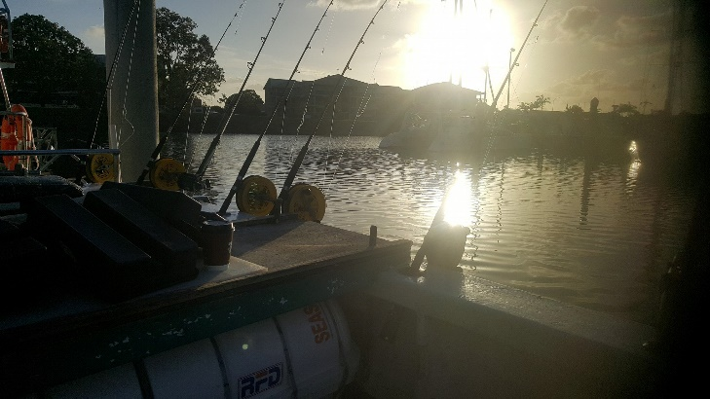
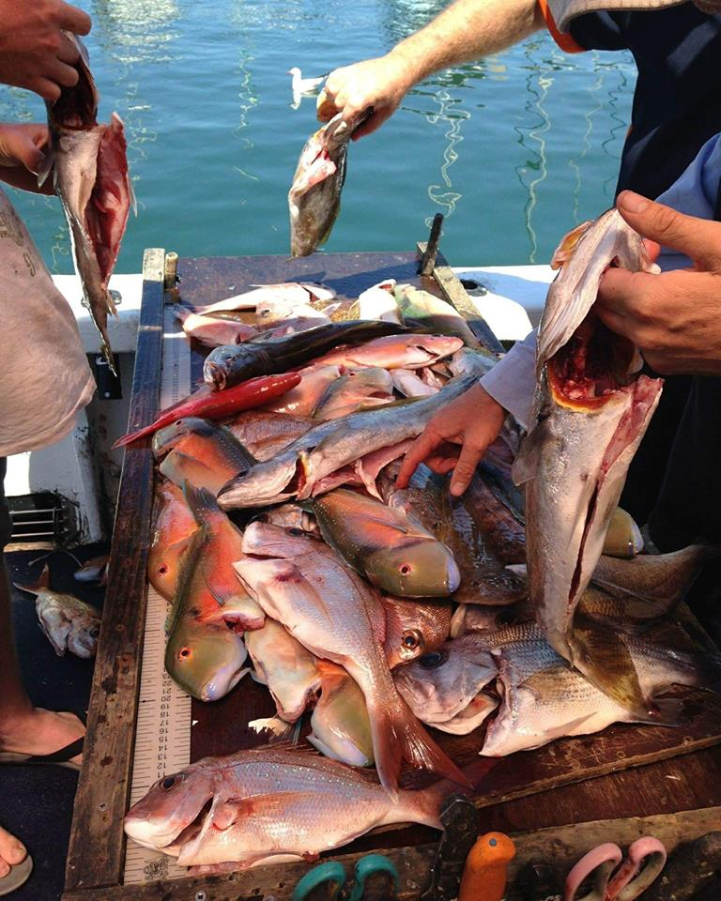
0408 753 647
Is it really Christmas time already? If I can hazard a guess, I’m sure most of you are just as surprised as I am at how fast the year has gone by.

With Chrissy just a matter of weeks away, hopefully you have all secured your spots on Santa’s nice list.

Christmas aside, what a time of the year it is! With the weather getting warmer (finally) and the fish on the bite, the fishing possibilities seem endless.

This has been apparent in recent weeks, with good numbers of Snapper, Tuskies and Pearl Perch popping up all around local spots. Noticeable also is the healthy Flathead population, which we have been finding quite a few of around the mud hole of late.

Another added bonus of the warmer weather is that game fish are now beginning to be more noticeable, especially out around the 45s.

Lastly, as some may have noticed, Downunder has begun to get a facelift, with new signs, fishing gear and wheel house equipment just the beginning - watch this space!

Until next time, we wish all a safe and happy Christmas and New Year!

The team at Downunder Charters

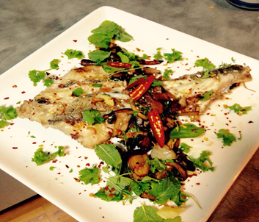
Recipe of the month – Grilled Flathead

Ingredients

- Fresh caught flathead from your charter (we will gut it for you)
- Olive oil

Method

- Descale and fillet your flathead and cut into portions of your choosing. (For smaller fish butterflied and cooked on the bone works well)
- On mid to high heat, grill flathead, skin side down.
- Turn after approximately 4 mins (longer for thicker fillets)
- Serve with pan fried garden vegetables

Cooks Tip

For extra flavor, try making a quick blue cheese sauce!

Ingredients

- 200G blue cheese
- 1 cup milk
- ½ cup corn flour (mixed to a smooth runny consistency with some milk)

Method

- Pour milk into pan and heat on medium only (otherwise it will curdle) until hot
- Stir in crumbled blue cheese
- Once cheese is melted, add corn flour and stir well until desired consistency is achieved.

Recipe courtesy Alive and Cooking
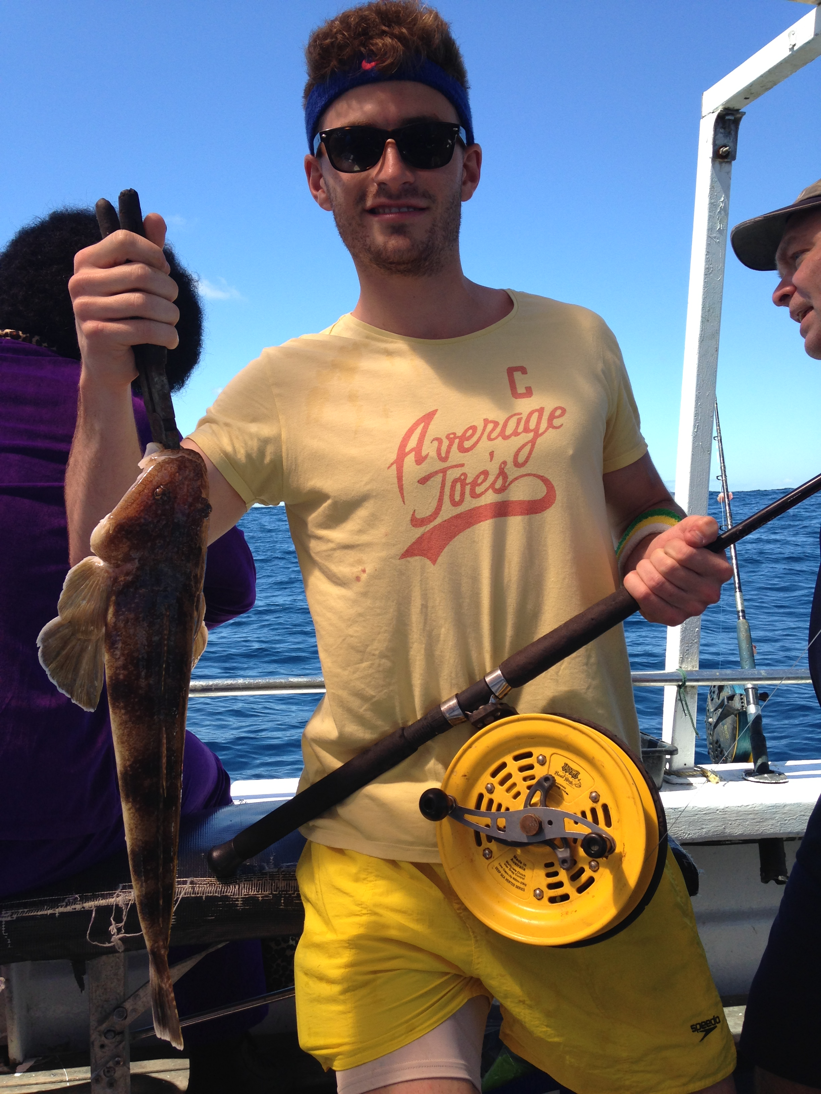
Charter fee structure

6hr individual charter
$120

8hr individual charter
$160

6hr private charter
(up to 12 people)
$1,320

8hr private charter
(up to 12 people)
$1,760

Discounts for kids under 13 and family groups

For all the info on what’s included and to make a booking 24/7:

www.downundercharters.com.au

Like and follow us on Facebook for great last minute specials, competitions and to see all the action from our Charters.

You have received this newsletter because you ticked subscribe to newsletter when you booked. To unsubscribe from this newsletter, click here and use “unsubscribe” as the subject line of your email.

Been out fishing with us? Share your pics or leave us a review. Find us on Facebook, Twitter, Instagram, YouTube and Trip Advisor.

