November 2016
Downunder Charters

Tips and Tricks

A great site with lots of info on filleting
Australian fish:
. https://www.filletfish.com.au/

For a bit of fun try this quiz, I got 9/10!
http://www.funtrivia.com/trivia-quiz/Hobbies/Australian-Saltwater-Fish-158490.htmlcies/

For all the information on recreational fishing
in NSW including fishing licenses see: http://www.dpi.nsw.gov.au/fishing/recreational/recreational-fishing-fee

Do you have tip or trick or a useful web site
you would like us to post? Email us at: admin@fishingdownunder.com.au and we
will include it in the next newsletter.

If you would like to receive an email version of
this this newsletter (so all the links work) email
us at: admin@fishingdownunder.com.au to join
the mailing list.

Tweed Heads Marina, River Terrace, Tweed Heads
www.downundercharters.com.au
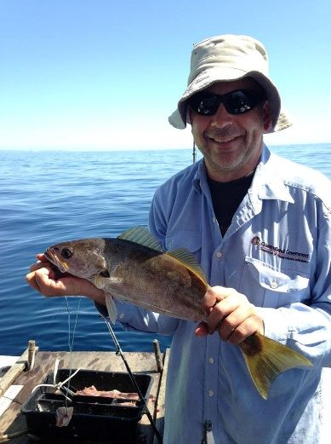
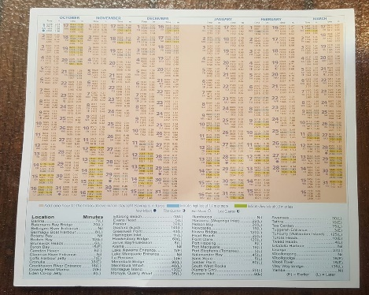
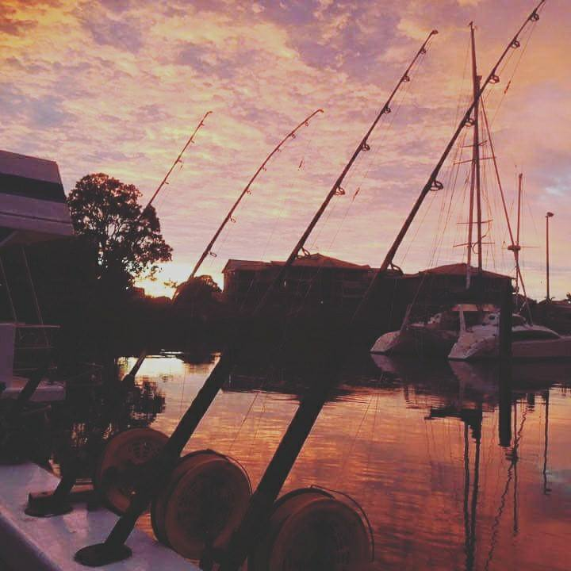
0408 753 647
Welcome to the November edition of the Downunder Charters newsletter!
The Teraglin have been on the bite lately along with the usual suspects, Snapper, Pearlies and Tuskfish. Now that the weather is really warming up and the water too, we should see the big boys start to come in, Dolphin Fish, Mackerel, Cobia etc. It will be great to give the new Ugly Stiks a run.
On the subject of new, we are progressing with updating the signage and fit out on Downunder and giving her some more TLC and attention. Most recently we have fitted a new VHF radio and GPS/sounder for increased safety and fish finding ability. Keep an eye on our Facebook page for pics of the changes.
We have also recently helped Marine Rescue NSW with sponsorship of their NSW tide charts for 2016/17. The charts are available free on the boat and from various locations around Tweed and the Gold Coast. MR NSW does a fantastic job monitoring all the boats and helping out when needed.
Time flies and that means there’s only 6 weeks until Christmas, which of course means time is running out to organize your end of year work Chrissy party/ fishing trip! Weekend spots are filling up fast for December so don’t leave it too late to book yours. Bookings can be made live 24/7 on the webpage www.downundercharters.com.au on Facebook or during business hours by telephoning us on 0408 753 647.
Until next time, happy fishing!

The team at Downunder Charters

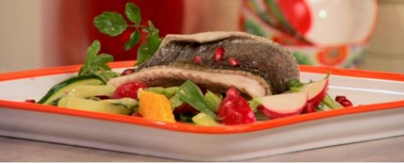
Recipe of the month

Citrus Steamed Teraglin (Trag Jew)

Ingredients

➢ 2 Teraglin fillets
➢ 1 lemon
➢ 1 orange
➢ 3 spring onions finely sliced
➢ ½ cucumber shaved into strips
➢ 5 radishes finely sliced
➢ ¼ bunch watercress
➢ 1 fresh pomegranate (seeds)
➢ 80ml red wine vinegar
➢ 2 tbs honey mustard
➢ 100ml cream

Method

➢ In a wok half full with simmering water, sprinkle the zest of both orange and lemon. Cover with a bamboo steamer and place the fish fillets inside, folded in half. Steam for 15min.
➢ In a bowl mix together the mustard, vinegar and cream.
➢ Cut the orange and lemon into segments and place them in a bowl. Mix together with the watercress, radish, spring onions, cucumbers and pomegranate seeds, then drizzle some of the mustard dressing over it.
➢ On a plate or platter, lay down a generous amount of salad, place a fish fillet on top and serve. Serves 2

Recipe courtesy Alive and Cooking
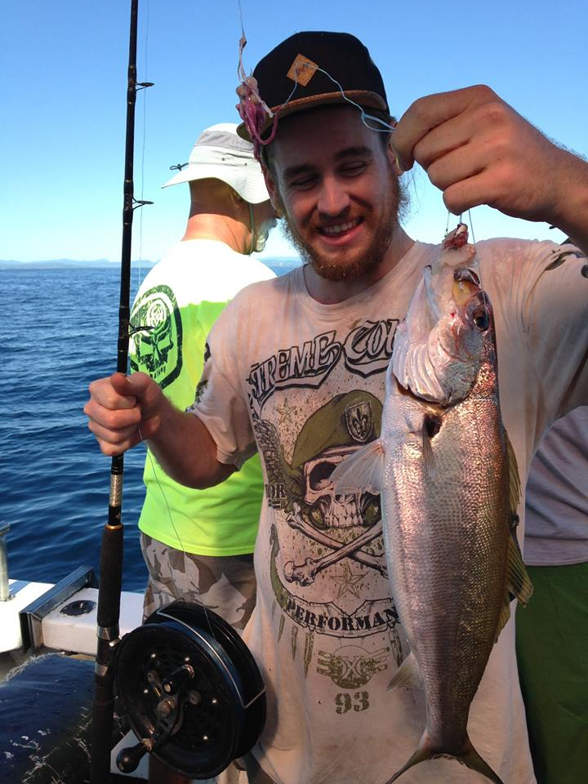
Charter fee structure

6hr individual charter
$120

8hr individual charter
$160

6hr private charter
(up to 12 people)
$1,320

8hr private charter
(up to 12 people)
$1,760

Discounts for kids under 13 and family groups

For all the info on what’s included and to make a booking 24/7:

www.downundercharters.com.au

Like and follow us on Facebook for great last minute specials, competitions and to see all the action from our Charters.

You have received this newsletter because you ticked subscribe to newsletter when you booked. To unsubscribe from this newsletter, click here and use “unsubscribe” as the subject line of your email.

Been out fishing with us? Share your pics or leave us a review. Find us on Facebook, Twitter, Instagram, YouTube and Trip Advisor.

