October 2016
Downunder Charters

Tips and Tricks

Need Bait? We recommend getting your hands on some Tweed Bait Pilchards from your local servo or corner store, especially if you’re out to target Snapper or Venus Tuskfish.

For a guide to what bait for what species check out the Tweed Bait web page
http://tweedbait.com.au/what-bait-what-species/

For marine weather conditions see http://www.bom.gov.au/marine/index.shtml

Do you have tip or trick or a useful website you would like us to post? Email us at admin@fishingdownunder.com.au
and we will include it in the next newsletter.

Tweed Heads Marina, River Terrace, Tweed Heads
www.downundercharters.com.au
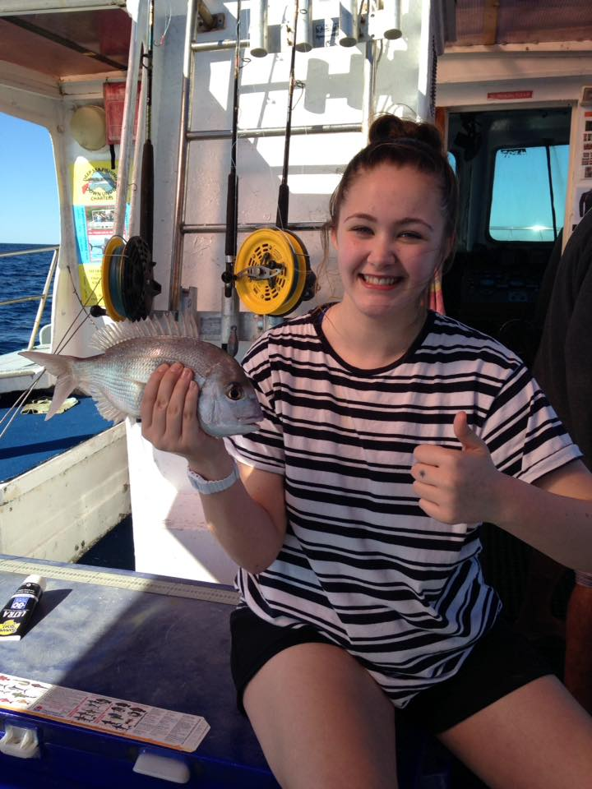
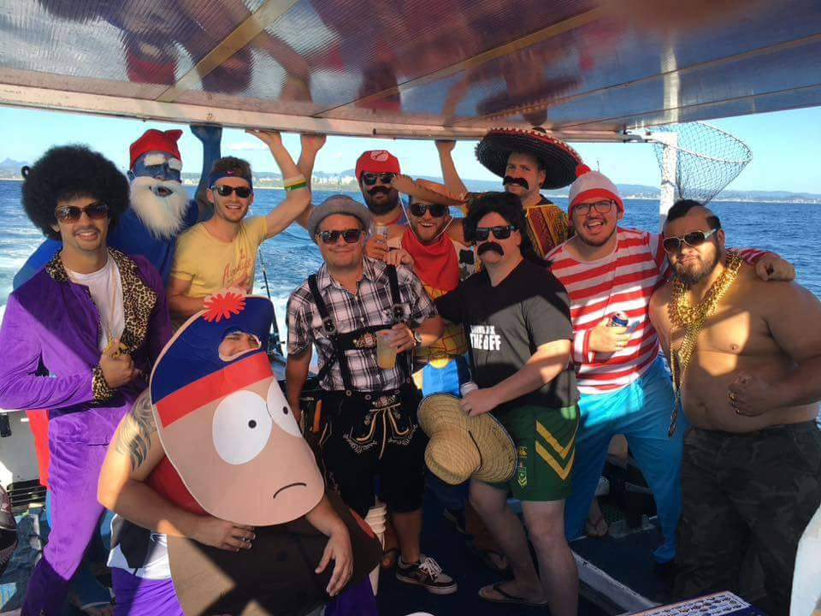
0408 753 647
Date Claimer October 16:
Gone Fishing Day 2016
Facebook page here
NSW DPI page here

Welcome to the October addition of the Downunder Charters newsletter. Hasn’t the fishing been good of late! Snapper and Tuskies (Venus Tuskfish) are out and about in abundance at the moment, with good sized fish being pulled aboard from many areas of the Tweed Coast.
In addition, the 30’s have been yielding some prime Pearlies (Pearl Perch) of late, along with Trag Jew (Teraglin) and Flathead, which are all beautiful pan fish. Here is my tip: pan fried with some butter and pepper, goes down a treat. Bonito have also been making an appearance. These powerful fish are a good bit of fun to pull in, and are great for sashimi or as strip bait, as their oily meat makes a natural burly which attracts other fish. All in all, the fishing’s been great.
Another thing that has been great to see is the amount of kids getting out and having a fish. Nothing is better than seeing a kid’s face when they land a fish. Regardless of the size, the enjoyment is priceless. So big shout out to all the Mums and Dads out there for bringing the younger members of the family along too.
Do you or someone you know have a birthday or function coming up? What better way to celebrate then with a day out on the water? Book now to get your perfect fishing experience.
Until next time, happy fishing!

The team at Downunder Charters
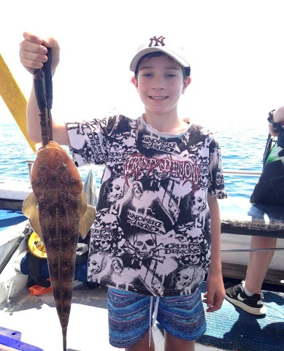

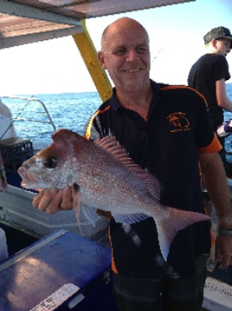

Recipe of the month
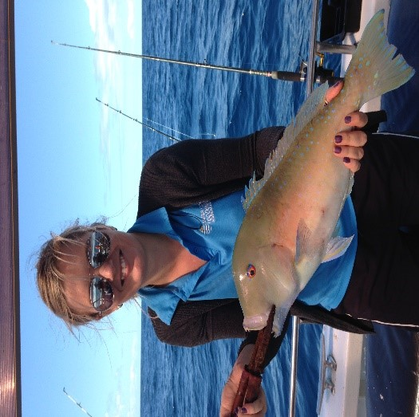
Charter fee structure

6hr individual charter
$120

8hr individual charter
$160

6hr private charter
(up to 12 people)
$1,320

8hr private charter
(up to 12 people)
$1,760

Discounts for kids under 13 and family groups

For all the info on what’s included and to make a booking 24/7:

www.downundercharters.com.au

Like and follow us on Facebook for great last minute specials, competitions and to see all the action from our Charters.

You have received this newsletter because you ticked subscribe to newsletter when you booked. To unsubscribe from this newsletter, click here and use “unsubscribe” as the subject line of your email.

Lightly Battered Tuskfish

Ingredients

- Fresh caught Venus Tuskfish from your charter (we will gut and gill it for you)
- Whole lemon

Batter

- 3 eggs
- 2 cups plain flour
- 1 cup milk
- Tbsp. each oregano, rosemary and parsley

Method

- Fillet your Tuskie and cut into portion sizes of your choosing.
- In a bowl, beat eggs and herbs until well combined
- Add small amounts of flour then milk alternately until desired consistency of batter is achieved
- Heat a pot or pan of oil to 200°C (about ¾ of the way around on the stove element)
- Dip fish in batter, place in oil. Cook for approximately 4 mins each side. (Cooking time will vary with size of fish pieces)

Cooks Tip: The longer you beat the batter mix, the more aerated it will become, resulting in a lighter batter. Serve with lemon and chips. Serves 2.

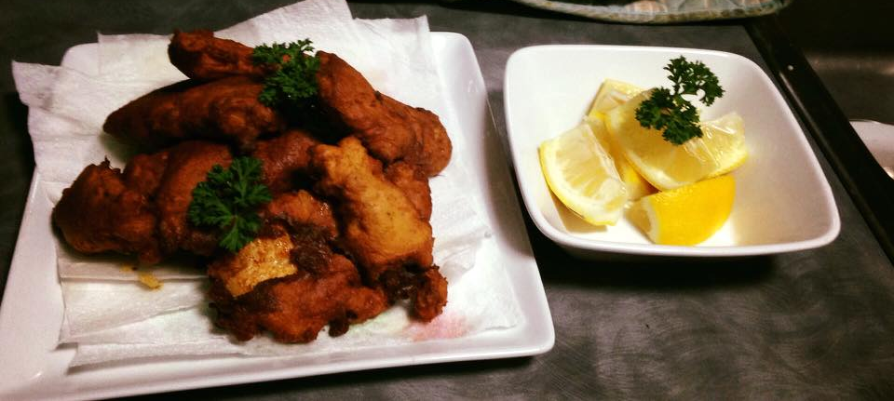

Been out fishing with us? Share your pics or leave us a review. Find us on Facebook, Twitter, Instagram, YouTube and Trip Advisor.

