STOP 34 million people have HIV
400 million have inherited HBV 210 million have transfusion HCV

CAUTION HIV, HBV and HCV
Can live in spilt blood
And infect via contact
With an open wound

USE ”Premiership Blood Hygiene”
Active plastering of all wound Gateways using gloves, then
Bleach Kill the Spill & Virus

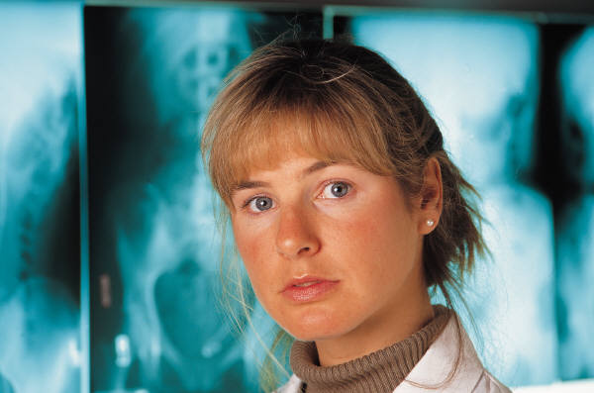
BECAUSE 1 in 10 people on Earth and
1 in 75 people in the UK
Bleed a blood virus now.
Blood Hygiene Precautions Factsheet

It is important to know your standard precautions when dealing with wounds and spilt blood. We have become aware of the threat from water viruses eg cholera, from air ones e.g. flu, from sex ones e.g. HIV, but we are nationally falling short with blood viruses from transfusion or wound.
1 Firstly, use plasters; with a blood virus it is always important to promptly plaster any flowing wound (a gateway for infection into your system). Remember one in 10 people on Earth now bleed blood viruses HBV, HCV, HIV, and use prompt plasters.
2 Secondly, watch where you bleed, it is necessary to think where spilt blood can live shared razors, shared DIY tools, and sharp milk teeth at school. Teach children, especially boys, that blood is in no way for display, a la Hollywood.
3 Thirdly, don’t fight, in Australia, risk questioning found high numbers (most) of infected co-habiters have a history of domestic violence. Fighting is proven by the International Boxing Federation to transmit at a rate of every 10 rounds, so this risk needs to be taken very seriously.

4 Fourthly, use only hot water or bleach and always wear gloves for cleaning spills. Only heat kills blood virus’s out of the body, other cleaning agents don’t work.

Facts about Hepatitis disease prevalence and danger have sparked blood hygiene globally

- globally 1 in 12 humans bleed a hepatitis blood virus and
- globally 1 in 10 of the infected die, 90 million

Education is needed to get the protections enjoyed by wealthy footballers into our schools. With at least 30% of infections having no clear cause, unhygienic blood spill, is the major suspect.

5 Fifthly, hepatitis b vaccination protects for life and is the world’s most used vaccine

