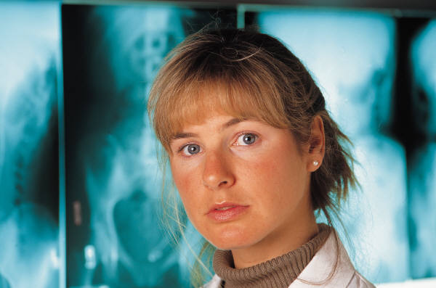

Is your job killing you?

Nurses Doctors Carers
First Aiders Morticians Tattooists
Soldiers Sports people Sex Workers
Police/Security Hairdressers Sewage Workers
Dental Assistants Beauticians Custodial Staff
Lab Technicians Cleaners Emergency Workers
Viral Hepatitis B & C
Are very real risks every year for thousands of people, including many from the professions above who come into contact with blood during their work. Hepatitis B & C can silently infect from blood and can also silently cause serious liver damage if left unchecked. It is estimated that every day one UK worker with blood dies from Hepatitis B. If you work or have worked with blood get tested and vaccinated for Viral Hepatitis.

- Remember each needle stick or blood spill to an open wound from an infected source, has a 1 in 3 high infection risk
- One in a hundred of the people in the above professions are Hep B or
- Hep C infected and don’t know
- A Hepatitis B vaccination is your employer’s responsibility if your occupation risks you coming into contact with blood
- Early vaccination and diagnosis is the best way to avoid harm

Remember to ask your GP
www.hepbpositive.org.uk Helpline 0800 206 1899 Text – Hepatitis B & C, what every family needs to know by Paul Desmond

