|  |
| --- |
| **The Tattoo/Piercing Industry and Hepatitis B** |
| Information Booklet |
|  |
|  |
|  |
| **Patient UK adapted by Paul Desmond HBV Foundation** |
| **11/28/2010** |
|  |

**Is your Is your Is**

**About The Tattoo/Body Piercing Industry and Hepatitis B Vaccination**

With ever more people dying with Hepatitis B and with approximately 80% of the infected being undiagnosed, Tattooists and Body Piercers are at increasing risk and have to be on their guard against hepatitis B infection. Traineesand short term staff are a key concern.

Vaccination Requirements

* All staff who may come into contact with blood and contaminated equipment, need vaccination and certificate of immunity before workng to be safe.
* The employer is responsible for the paid staff vaccination cost
* The employer is also responsible to ensure the staffs safety
* A Course of three injections should be administered, Boosted after 5 years
* Few Tattooists recommend HBV vaccination to clients (see Canadian Poster)

Key Risks

* Tattoo Sketching Pens, walls and tills have often been found to be infectious(unbleached) in national studies in Canada, France and the US
* Many Staff are unvaccinated, even among national organisations
* HBV Testing and booster jab usage among staff is poor
* HBV Testing of Anti body levels is often poor, leaving 10-20% at risk
* HBV lives in spilt blood for between 7 – 20 days
* HBV can contaminate areas and utensils in common use
* Staff are often unaware of the prevalance (up to 1 in 50 in some areas)
* Staff are often unaware it is a decimating carcinogen (1 in 10 undiagnosed die)

Blood Hygiene Requirements

* Gloves and scrubs and Plaster all gateway wounds also
* Bleach kill with heat all blood spill areas
* Study cross contamination opportunities (hand to tool, tool to desk etc)
* Use strict sharps hygiene and sterilisation structures

Safety Testing Requirements

* Many staff have been working unvaccinated and neglectregular safety testing
* If antibody levels have dropped over time, any riskinvolving a wound or a needlestick injury needs testing
* Late diagnosis features in most deaths
* Early diagnosis of Hepatitis B allows life saving treatment
* For Hepatitis C which has no vaccine, there is a cure

Post-exposure prophylaxis (PEP) Involves giving hepatitis B vaccine and possibly immunoglobulin too if required, even if the exposed person has received vaccine previously.

**Many large scale employers can bulk buy vaccine**

* To drive down costs
* To speed deployment
* To create counseling and advice points
* Utiliising “in house” skills
* Smaller concerns can club together or unions can buy
* Colleges can buy
* Councils and
* Nationals can all buy direct

**There are opportunities to buy vaccines direct from**

* Many pharmaceuticals selling various volumes
* Costs can be far less, best to shop around
* Sanofi Pasteur MSD <http://www.spmsd.co.uk/cat.asp?catid=392>
* Glaxo Welcome <http://www.gsk.com/products/vaccines/index.htm>

**Some companies specialise in deployment of vaccines to**

* Residential Units
* Schools
* Prisons
* Annual Company or Union Meetings
* Remote Location Staff

**Some organisations can advise you on Staff Vaccination**

* [The Hepatitis B Foundation](http://www.hepb.org.uk) - 08000 46 1911
* [The British Liver Trust](http://www.britishlivertrust.org.uk)
* [www.nhsplus.nhs.uk](http://www.nhsplus.nhs.uk)

**Publications from the Department of Health**

* The Department of Health Green Book HBV Vaccination Guide
* The Department of Health Olive Book HBV Exposure Guide

There follows 3 posters, the first poster highlights the basics of Blood Hygiene. The second Vaccination Schedules and the third the non occupational risk test chart for everyone. There is a Just Diagnosed Booklet for the infections that usually emerge when larger staff vaccinations/screenings happen. The GP Vaccination Request Letter, Risk Assessment Form and Professions at Risk Poster are on [www.hepb.org.uk](http://www.hepb.org.uk) under resources.

**STOP** 40 million people have HIV

350 million have inherited HBV 210 million have transfusion HCV

**CAUTION** HIV, HBV and HCV

Can live in spilt blood

And infect via contact

With an open wound

**USE** ”Premiership Blood Hygiene”

Active plastering of all wound Gateways using gloves, then

Bleach Kill the Spill & Virus

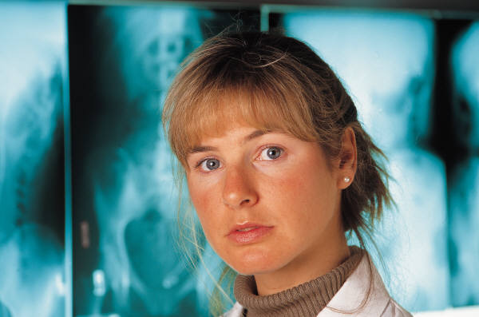

**BECAUSE** 1 in 10 people on Earth and

1 in 75 people in the UK

**Bleed a blood virus now.**

**Hepatitis B Vaccination (at a glance) Immunisation schedule**

**Source** [**http://www.patient.co.uk/doctor/Hepatitis-B-Vaccination-and-Hepatitis-B-Prevention.htm**](http://www.patient.co.uk/doctor/Hepatitis-B-Vaccination-and-Hepatitis-B-Prevention.htm)

**Immunisation schedule**

* The standard course of immunisation involves 3 injections over 6 months.
* An accelerated course over 2 months is possible - also for combined [hepatitis A](http://www.patient.co.uk/DisplayConcepts.asp?WordId=HEPATITIS%20A&MaxResults=50) and B vaccines.
* Adults who need protection very quickly can have a schedule over 21 days. The vaccine is administered intramuscularly, usually into the deltoid muscle[**3**](http://www.patient.co.uk/doctor/Hepatitis-B-Vaccination-and-Hepatitis-B-Prevention.htm#ref3). After an accelerated course, a booster at 1 year is recommended. It can be used in those who are immunocompromised, as with [HIV](http://www.patient.co.uk/DisplayConcepts.asp?WordId=HUMAN%20IMMUNODEFICIENCY%20VIRUS&MaxResults=50) infection, but a higher dose may be required or extra booster injections.

The vaccine should be given into the deltoid region or anterior thigh in babies. It is less effective if given into the buttock. It is quite possible that a course may give lifelong immunity,**[4](http://www.patient.co.uk/doctor/Hepatitis-B-Vaccination-and-Hepatitis-B-Prevention.htm" \l "ref4)** but for health professionals one further booster at 5 years* is recommended. Antibody titres should be tested in health professionals 2 to 4 months after the primary course.

* A titre above 100 mIU/ml is regarded as adequate.
* Around 10-15% of adults fail to respond to three doses of vaccine or respond poorly.[**1**](http://www.patient.co.uk/doctor/Hepatitis-B-Vaccination-and-Hepatitis-B-Prevention.htm#ref1)
* Poor responders with titres of 10 to 100 mIU/ml should have a booster and those with a titre below 10 mIU/ml should repeat the course.
* Those over 40 years old, who are obese or who smoke are more likely to fail to respond.
* Alcoholics are also reported as having lower seroconversion rates, particularly those with advanced liver disease.
* Patients who are immunosuppressed or on [renal dialysis](http://www.patient.co.uk/DisplayConcepts.asp?WordId=RENAL%20DIALYSIS&MaxResults=50) may also respond less well and require larger or more doses of vaccine.
* Failure to produce any antibody after 2 complete courses should not be seen as necessarily meaning no immunity, as immunity to the disease is largely cell-mediated rather than by antibody.

*Of a thousand people vaccinated and having no boosters 3 became infected after 10-15 years. 5 years is chosen due to safety, health care workers are not suddenly “at risk” after 5 years.

**Post-exposure management**

* Post-exposure prophylaxis (PEP) involves giving hepatitis B vaccine and possibly immunoglobulin too if required.
* Immunoglobulin is given at a different site and it does not reduce the immune response to the vaccine.
* If the status of the source is unknown assume infection.
* PEP may be indicated even if the exposed person has received hepatitis B vaccine previously.
* It should be given within 48 hours and certainly no later than 7 days after exposure.
* The incubation period of the disease is 40 to 160 days.

If the site of exposure is a needlestick injury, cut or abrasion, the site should be washed immediately with soap and water. It is indicated for babies born to mothers who are chronic carriers of hepatitis B virus or to mothers who have had acute hepatitis B during pregnancy. More details about PEP can be found in 'The Olive Book’ and ‘Guidance for Clinical Healthcare Workers from the DH.

**75% of infections are the white star non occupational risks**

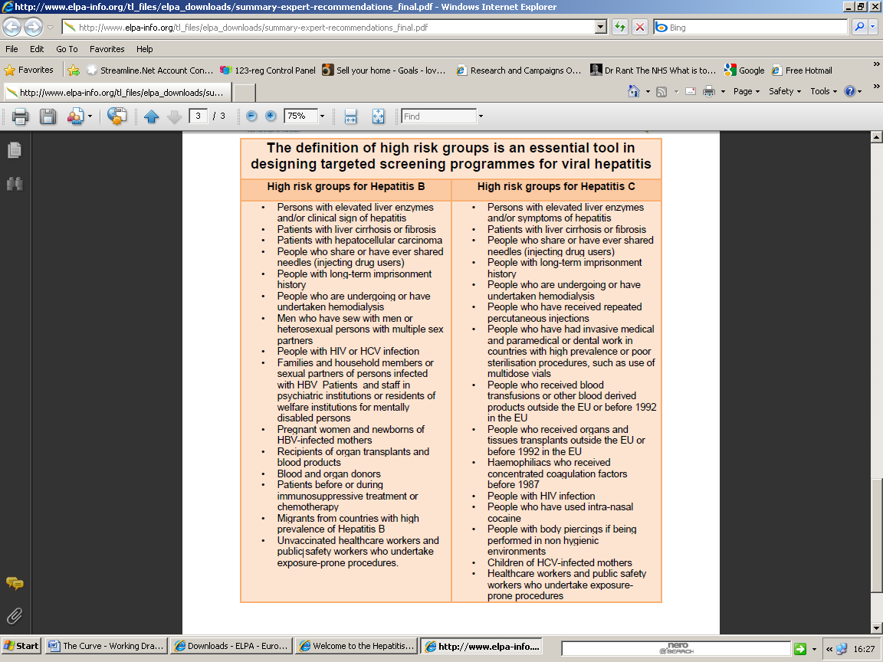

**About Hepatitis B**

**A Just Diagnosed Patient Information Booklet**

|  |
| --- |
| **Patient UK adapted by Paul Desmond HBV Foundation** |
| **11/28/2010** |

**About the Hepatitis B Virus…**

…..may or may not cause symptoms. Following infection, 5-10% of infected adults develop a persistent infection called chronic hepatitis B. Many people with chronic hepatitis B remain well, but some over 20 or more years, develop serious liver problems. The virus is mainly passed on at birth or in childhood when the immune system is weak. In adult’s sexual contact, blood spills and sharing needles to inject drugs are common causes. The Virus ultimately can cause Liver Cancer and Liver Failure.

**What does Hepatitis B do?**

Hepatitis means inflammation of the liver. There are many causes of hepatitis. For example, drinking too much alcohol, various drugs and chemicals, and also several different viruses can cause hepatitis. One virus that causes hepatitis is called the hepatitis B virus. Hepatitis B is a virus which is carried in the bloodstream to the liver. It can then affect and damage your liver. Usually killing 10-15% of the long term undiagnosed after 20-50 years.

**How common is Hepatitis B?**

In the UK about 1 in 200 people are thought to have lasting hepatitis B infection, naturally with millions migrating from Pandemic Areas without safety screening, the UK total has both grown in scale and more importantly doubled in terms of undiagnosed numbers over the last 2 decades. Worldwide, **it is very common** with hepatitis B infecting 1 in 20 humans on Earth. For example, in most of Asia and Africa more than 1 in 30 people have chronic hepatitis B infection and 1 in 3 humans catch it! In the UK 7,000,000 citizens are at high risk and recommended for safety screening and vaccination.



**What are the symptoms and how does hepatitis B progress?**

It is helpful to think of two phases of infection with hepatitis B virus. The first six months phase when you are first infected and after which 95% of adults clear and become immune and a constant infection phase when the virus is not cleared.

**New infections**

Symptoms of hepatitis b infection may develop within 1-6 months. Symptoms include: feeling sick, vomiting, abdominal pains, fever and feeling generally unwell. You may become jaundiced (go 'yellow'). With jaundice due to hepatitis your pee goes dark and your poohs may go pale. Symptoms usually go after a few weeks, as the immune system brings the virus under control this happens for 90% of adults.

However, in about half of cases symptoms are unnoticed; in particular babies infected during childbirth usually have no symptoms at first. In more than 9 out of 10 babies, the virus remains long-term.

Very rarely, a ('fulminant') hepatitis develops from these symptoms, which is life-threatening.

**Chronic Lasting infection**

A chronic hepatitis B infection is when the infection lasts for longer than six months. Of those people who develop chronic hepatitis B infection:



Ultimately 10% of the infected die,

the vast bulk of the dying will be long term undiagnosed.

Fatal damage from unsuspecting, often mild alcohol or medicine use is commonly implicated.

* 30-35% develops persistent liver inflammation (sometimes called 'chronic *active* hepatitis B'). Symptoms include: muscle aches, tiredness, feeling sick, lack of appetite, intolerance of alcohol, pains over the liver, jaundice and depression. Symptoms vary in severity and some people have liver inflammation without having any symptoms.
* 20-30% develops cirrhosis. Cirrhosis is like a 'scarring' of the liver which can cause serious problems and 'liver failure' when it is severe. Cirrhosis usually takes many years to develop after being infected with hepatitis B
* 10-15% dies from liver cancer or liver failure after 20-50 years.

**How is hepatitis B diagnosed and assessed?**

Do arrange insurances and finances before a test. A simple blood test can detect if you are infected with the hepatitis B virus. If infected, other tests may be advised to check on the severity of infection, liver inflammation and damage to the liver. For example:

* A blood test can detect various parts of the virus. This can assess how active the virus is (if it is multiplying rapidly and therefore more likely to cause liver damage).
* Blood tests called liver function tests. These measure the activity of enzymes (chemicals) and other substances made in the liver. This gives a general guide as to whether the liver is inflamed, and how well it is working.
* An ultrasound scan of the liver is recommended.
* A biopsy (optional) of the liver may be taken to look at under the microscope. This can show the extent of any inflammation and cirrhosis.
* A blood test can also be performed to show if you have immunity to hepatitis B.
* Other tests may be done if cirrhosis or other complications develop.
* There are other tests which assess the development and severity of cirrhosis.

**Just Diagnosed?**

Unfortunately in the UK, GP’s, are poorly equipped for Hepatitis discussions. No literature, no maps, no test risk posters, have been given them. GP’s often look on the Virus as a kind of Junkie & Sex Disease, as per the guidance and leaflets they have. So patients get partial or “safe injecting” advice and fail to contact experienced help lines or get important referrals to a Liver Specialist. So here is further advice from patients who’ve experienced being diagnosed and adjusting.

**General Emotional Advice**

* Try not to feel guilty, Remember 1 in 3 humans have caught this bug
* Don't feel infectious teach loved ones vaccination, safe sex and blood hygiene
* Many patients find HBV makes them live healthier lives
* Try to learn about Hepatitis B, and how it is managed.
* If your infection is new or less than 5 years or your fibrosis is under 2 you have a life of health and happiness to plan for, don't forget.

**Who to tell?**

* Do not announce your infection; some people may react badly with ignorance.
* Try to let knowledge of your infection make a few relationships stronger
* Take time to understand the virus first
* You will need to teach people what HBV is, very few know. This is the one where vaccination is far the most important precaution.

**Diet and alcohol**

Most people with chronic hepatitis B will be advised to eat a normal healthy balanced diet. Ideally patients should not drink alcohol or take street drugs. If you already have liver inflammation, both obesity and alcohol increases the risk and speed of developing cirrhosis.

Clinical studies have repeated shown that long term HBV infection and even moderate drinking can quickly result in Cirrhosis. Real caution needs to be exercised with many, many medications also, it is important your doctors consider your liver status when prescribing each and every time.

It is important to note that a large amount of HBV infections do not lead to cirrhosis or liver cancer, even after decades, this is clearly lifestyle related. For some it is only acute reactions to alcohol or medication that leads to diagnosis.

**What is the treatment of hepatitis B?**

People with chronic hepatitis B usually need treatment to stop or reduce the activity of the virus, so limiting liver damage. A liver specialist will usually advise on when treatment may be beneficial. There are two types of treatment currently given:

* **Interferon**. This drug is similar to a substance produced in your body which is also called interferon. It works to fight infections by boosting your immune system. Interferon is usually given as an injection each week.
* Antiviral drugs. These work by stopping the hepatitis B virus from multiplying in the body. They include **lamivudine, adefovir, tenofovir, telbivudine, and entecavir**. Your doctor will discuss these in more detail with you as the drug used can vary between people. A combination of antiviral drugs is sometimes used.

Drug treatment may be continued for many years.  
  
Side-effects with these treatments can occur. You will be monitored regularly while you are taking the treatment, which includes blood tests. Some people need to change their treatment, or take a lower strength, if they have troublesome side-effects. Also, in some people, resistance can develop to the treatment, which means that it does not work so well. If this happens to you then it is likely you will have to change the treatment you are taking.

**Liver transplant**

For some people with advanced cirrhosis, liver transplantation may be an option. Although this is a major operation, the outlook following a liver transplant can be very good. However, the new liver may also eventually become damaged by the persisting hepatitis B infection.

**How can you get hepatitis B?**

**During Maternity**

Worldwide, the most common way the virus is passed on is during maternity. This is very common in some parts of the world where many people are infected with this virus. However many things can be done to avoid this. All women in the UK are now tested for hepatitis B when they are pregnant.

**From Person to Person**

The main ways in which people in the UK become infected include the following:

* From infected blood, especially in childhood. You only need a tiny amount of infected blood to come into contact with a cut or wound on your body to allow the virus to enter your bloodstream, multiply and cause infection
* 8-16 million people a year are infected via re used syringes in the third world.
* Sharing needles and/or any injecting equipment (for example, spoons, filters water for injection) to inject drugs.
* NHS Patients who had a blood transfusion or blood products before 1990 were at risk of hepatitis B.
* From needlestick accidents where the needle was used on an infected person.
* Having unprotected sex with an infected person. Even having oral sex can transmit hepatitis B. (*Note*: 80% of people with hepatitis B do not know)
* There is a small risk of contracting the virus from sharing toothbrushes, razors, and other such items which may be contaminated with blood. The virus can actually live outside the body for more than one week.
* From using equipment which is not sterile for dental work, medical procedures, tattooing, body piercing, etc.
* Other bodily fluids, such as semen, vaginal secretions and saliva, contain the virus in infected people.
* A bite from an infected person, or if their blood spills on to a wound on your skin, or on to your eyes or into your mouth.

The virus is notpassed on during normal social contact such as holding hands, hugging or sharing cups or crockery. Hepatitis B is a very infectious disease, worldwide 1 in 3 catch it.

Ultimately a main reason people get infected is they forget their Vaccination, we owe it to our Species future to eradicate this disease with it.

**Can hepatitis B be prevented?**

**Vaccination**

A vaccine is available to protect against hepatitis B. This should be offered to anyone who is at increased risk of being infected with the hepatitis B virus. For example, First Aiders and Emergency Workers or persons from Pandemic areas such as Africa, Eastern Europe or Asia.

**Post-exposure prevention**

If you are not immunised and have been exposed to the virus, you should see a doctor immediately. (For example, if you are a healthcare worker and you have a needlestick injury.) You can be given an injection of antibodies called immunoglobulin as well as starting a course of immunisation. This may prevent infection from developing.

**Preventing infection in new-born babies at risk**

All pregnant women in the UK are offered a hepatitis B blood test. If the mother is infected, her baby is given injections of antibodies and also immunised straight after birth. Also elective c-section and avoiding fetal heart monitors lowers infection rate. With this treatment and some of the newer drugs arriving, there is a very good chance of preventing infection developing in the baby.

**If I am infected, how can I prevent passing on the virus to others?**

If you have a current hepatitis B infection you should:

* Avoid having sex with anyone (especially any sex without using a condom) until they have been fully immunised and have been checked to see that the immunisation has worked by a blood test.
* Make sure living companions, contact sports friends etc are vaccinated too.
* Teach blood hygiene. If any of your blood spills on to the floor or other surfaces following an accident, make sure it is cleaned away with bleach.
* Not share razors, toothbrushes, etc, that may be contaminated with blood.
* Cover any cuts or wounds with a dressing. Encourage others to do the same.
* Do not share any injecting equipment such as needles, syringes etc.
* Do not donate blood or semen or carry a donor card.

**What does the Liver do?**

In essence the liver eats your dinner and makes you and also heals you.

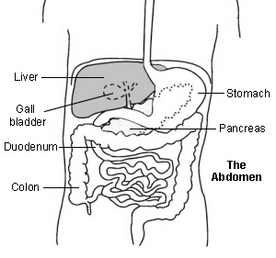

The Liver has many functions which include:

* Storing glycogen (fuel for the body) which is made from sugars. When required, glycogen is broken down into glucose which is released into the bloodstream.
* Helping to process fats and proteins from digested food.
* Making proteins that are essential for blood to clot (clotting factors).
* Processing many medicines which you may take.
* Helping to remove or process alcohol, poisons and toxins from the body.
* Making bile which passes from the liver to the gut down the bile duct. Bile breaks down the fats in food so that they can be absorbed from the bowel.

**Further help and information contact the Hepatitis B Foundation UK**

The Great Barn, Godmersham Pk, Kent, CT4 7DT Tel:01227 738279 Web: www.hepb.org.uk begin_of_the_skype_highlighting

**References**

* [**Cooke GS, Main J, Thursz MR**](http://www.ncbi.nlm.nih.gov/entrez/query.fcgi?cmd=Retrieve&db=PubMed&dopt=Abstract&list_uids=20051467); Treatment for hepatitis B. BMJ. 2010 Jan 5;340:b5429. doi: 10.1136/bmj.b5429.
* [**Management of the Viral Hepatitides A, B and C**](http://www.bashh.org/guidelines#4), British Association for Sexual Health & HIV (2008)
* [**Liaw YF, Chu CM**](http://www.ncbi.nlm.nih.gov/entrez/query.fcgi?cmd=Retrieve&db=PubMed&dopt=Abstract&list_uids=19217993); Hepatitis B virus infection. Lancet. 2009 Feb 14;373(9663):582-92. [abstract]
* [**Dienstag JL**](http://www.ncbi.nlm.nih.gov/entrez/query.fcgi?cmd=Retrieve&db=PubMed&dopt=Abstract&list_uids=18832247); Hepatitis B virus infection. N Engl J Med. 2008 Oct 2;359(14):1486-500.
* [**Pungpapong S, Kim WR, Poterucha JJ**](http://www.ncbi.nlm.nih.gov/entrez/query.fcgi?cmd=Retrieve&db=PubMed&dopt=Abstract&list_uids=17673066); Natural history of hepatitis B virus infection: an update for clinicians. Mayo Clin Proc. 2007 Aug;82(8):967-75. [abstract]
* [**Hepatitis B - entecavir**](http://www.nice.org.uk/guidance/index.jsp?action=byID&o=12046), NICE Technology appraisal (August 2008); *Entecavir for the treatment of chronic hepatitis B*

[**Hepatitis B telbivudine**](http://www.nice.org.uk/guidance/index.jsp?action=byID&o=12052),NICE Technolog Appraisal (August 2008);*Telbivudine for the treatment of chronichepatitis B*