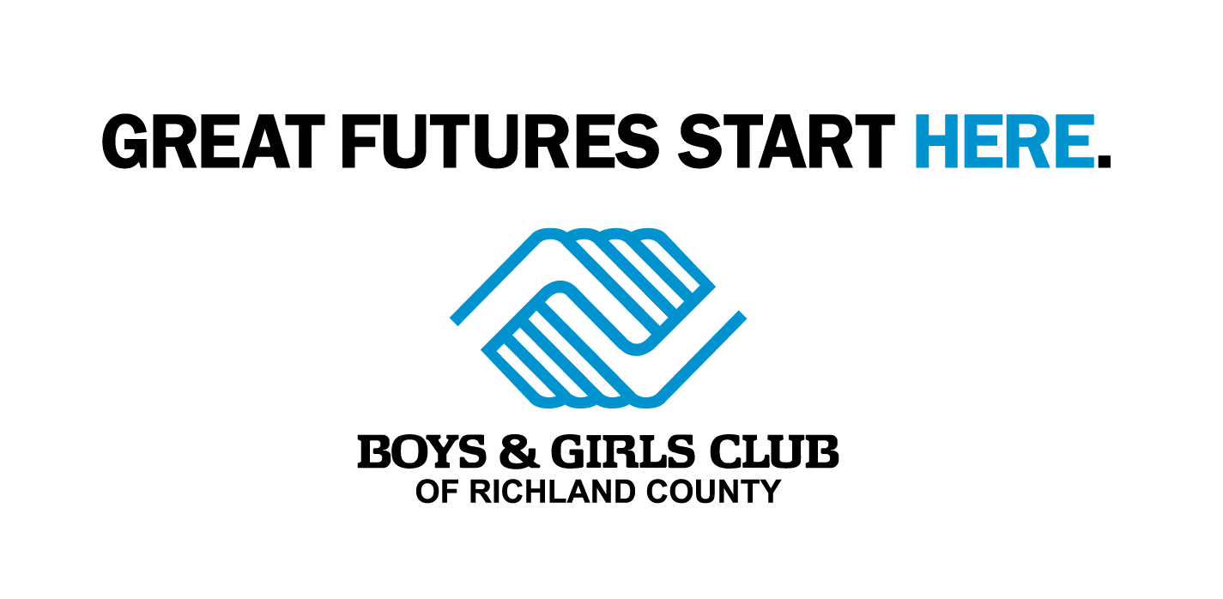

**Boys and Girls Club**

**Registration**

Central School Gymnasium:

200 - 3rd Avenue SE, Sidney, Montana

6:00 p.m.

Monday & Tuesday, July 17th & 18th, 2017



**Important Information**

Any parents that would like their kids to attend the after school program this fall MUST attend one of the mandatory parent meetings on July 17th or July 18th at Central School. Additionally:

All Outstanding Fees…..

* Must be paid in order to register for the 2017-2018 After-School-Program

Annual Membership Fees…..

* Must be paid at time of registration
* $75 for one child per family
* $125 for two or more children per family

Yearly Programming Fees…..

* $360 per school year / $180 per additional child per school year (Flat Rate of $40 per Month)
* 10% discount if program fees paid in full by September 15, 2017



Please contact:

Janelle Buxbaum

or

Elaine Stedman

at the Boys and Girls Club for more information:

406-433-6763

Call for SCHOLARSHIP information and additional payment options!