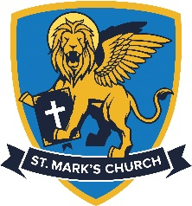
St Mark’s Church
Bedford

The Reverend Canon Charles Royden vicar@thisischurch.com
St Mark’s Church Office 01234 342613 www.stmarkschurch.com

St Mark’s Church - ,Diocese of St Albans - Part of the Worldwide Anglican Church

Baptism Registration / Application Form

Please ensure that you have read about Baptism prior to completion of this form. If there is anything you do not fully understand then please do not hesitate to speak with one of the ministers. We are quite happy to arrange to speak with you as many times as you wish prior to the service to talk through any questions which you may have. We hope that you are able to come to church as often as possible before and after the service, it is especially useful for you to attend at the Family Services which are held on the first Sunday of every month.

St Mark’s Church Date of Baptism

Please do not make any arrangements until a minister has confirmed the baptism

Details of person to be baptised (Block Capitals Please!)

Name | Date of Birth
Address | Tel  Mobile
 | Email

Name of Parent | Occupation

Name of Parent | Occupation

Names of Godparents (please choose as many as you wish)

Please send me more details about (please tick)
Chat and Play and Storybox | Sunday School
St Mark’s Church Preschool  (open 47 weeks 7.30am – 6.00pm | Messy Church – Wednesday afternoon activities
I would like further information about the church | Other (Please specify)

