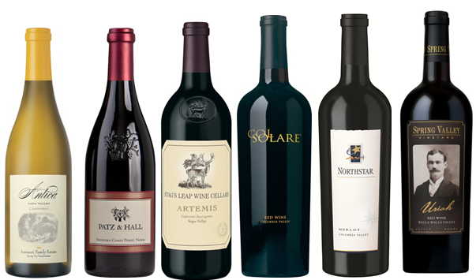
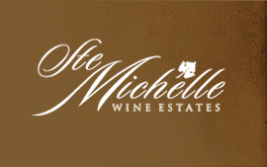
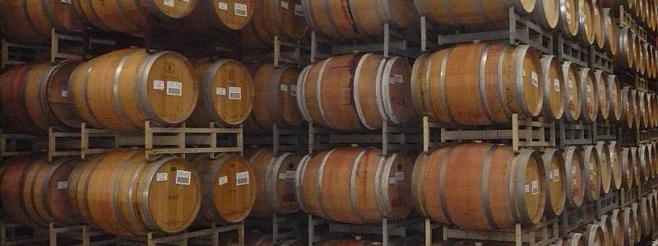
Regular Price Event Price Save Bottle Purchase
2014 ANTICA CHARDONNAY $39.99 $29.99 $10.00 ________
NAPA VALLEY, CA
2014 PATZ & HALL PINOT NOIR $44.99 $36.99 $8.00 ________
SONOMA COAST, CA
2014 STAG’S LEAP WINE CELLARS $69.99 $54.99 $15.00 ________
ARTEMIS CABERNET SAUVIGNON
NAPA VALLEY, CA
2013 COL SOLARE RED $79.99 $67.99 $12.00 ________
COLUMBIA VALLEY, WA
2011 NORTHSTAR MERLOT $44.99 $34.99 $10.00 ________
COLUMBIA VALLEY, WA
2013 SPRING VALLEY URIAH RED $54.99 $44.99 $10.00 ________
WALLA WALLA, WA
Name ______________________________ Number__________________

