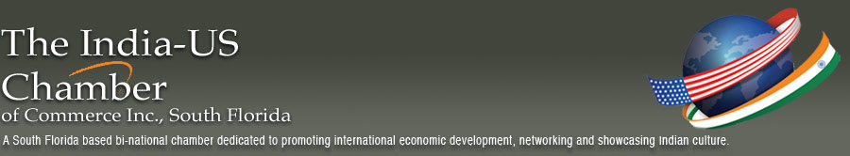

Business with the United States

Helping Indians to make local, national and international contacts.

The Chamber is pleased to include website links to the following important organizations:

Department of Commerce
Trade Opportunities for U.S. Business
www.commerce.gov/Tradeopportunities/index.htm

Exporting Basics - Helping U.S. Companies Export
www.export.gov

Government Trade Portal
U.S. Commercial Service, your Global Business Partner
www.buyusa.gov

National Association of Manufacturers
www.nam.org

Small Business Administration
www.sbaonline.sba.gov

U.S. Chamber of Commerce
www.uschamber.com

Greater Miami Chamber of Commerce
http://www.greatermiami.com

Fort Lauderdale Chamber of Commerce
http://www.ftlchamber.com

Greater Boca Raton Chamber of Commerce
www.bocaratonchamber.com

Palm Beach Chamber of Commerce
www.palmbeachchamber.com

Chamber of Commerce of the Palm Beaches
www.palmbeaches.org

Enterprise Florida
www.eflorida.com

Workforce Florida
www.workforceflorida.com

ABiCC: Association of Bi-National Chambers of Commerce in Florida
www.abicc.org

AIA The Association of Indians in America
A grassroots national organization of Asian Immigrants in the United States.
www.aiausa.org or www.aiaflorida.org

The Associated Chambers of Commerce and Industry of India
www.assocham.org

IBC: International Business Council of Florida
www.internationalbusinesscouncil.org

ITC Jay Malina Internation Trade Consortium of Miami-Dade County, Florida
www.miami-dade.gov/itc

IBC International Business Council of Florida
www.internationalbusinesscouncil.org

World Trade Center Miami
Member of the World Trade Associations
www.worldtrade.org

American Jewish Committee
www.ajc.org

Museum of Contemporary Art - North Miami, Florida
www.mocanomi.org

Broward Center for the Performing Arts
www.browardcenter.org

