Crevier’s Academy of Cosmetology Arts

Services Menu
2017

All SERVICES PERFORMED BY STUDENTS &
SUPERVISED BY INSTRUCTORS
Salon
Haircut (includes shampoo & Blow dry) $ 9.00
Bang, Neck, Mustache or Beard Trim $ 2.00
Shampoo $ 2.00
Shampoo Roller Set/Style $ 9.00
Long (Over 10 in) $14.00
Iron Set/Style $ 8.00
Long (Over 10 in) $14.00
Shampoo/Blow dry/Style $ 10.00
Long (Over 10 in) $14.00
Up do $ 20.00
Protein/oil Treatment w/ scalp massage $ 20.00

Lash Extensions
Lash Extensions (lash enhancement) $ 50.00
Lash Extension Fill $30.00

PRICES FOR THE FOLLOWING VARY ACCORDING TO HAIR LENGTH

Bleach Tips (includes Haircut & Style) $ 20.00
Tint (includes Haircut & Style) $ 30.00- $ 60.00
Bleach/Frost (includes Haircut & Style) $ 30.00- $ 60.00
Relaxer (includes Haircut & Style) $ 30.00- $ 60.00
Color Weave/blow out (includes Haircut & Style) $ 45.00- $ 75.00
Permanent Wave (includes Haircut & Style) $ 30.00- $ 60.00
Multi Braids or Cornrows /Dreads $ 25.00- $75.00
French Braid (1-2) $ 6.00
Fusion/Tape Extensions/braid or dread extensions - Please consult for pricing

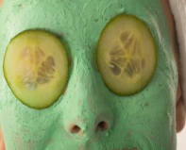
Skin & Body

Basic Facial $ 25.00
(Cleanse, Exfoliate, Massage, Mask, Hydrate)
European Facial -
Includes choice of enzymes, chemical peel or specialty mask $ 35.00
Microdermabrasion with Facial $ 40.00
Micro Current (the mini face lift) $ 25.00
LED/Facial $ 40.00
Slimming Wrap $ 25.00
Lymph drainage cupping (great to add to a Cellulite wrap) $ 10.00
Back Facial with Hot Stones $ 30.00
Salt Glow & Mud Mask $ 35.00
Brow/Lash Tint or Perm $ 12.00 each
Makeup Application $12.00

WAXING
Brow/lip/chin/nose $ 8.00 each
Underarms $ 10.00
Arms $ 15.00
Brazilian $30-$40
Bikini $ 10-$20
Full Leg w/bikini $ 30.00
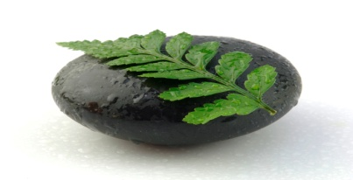
Lower Legs $ 20.00
Full Abdomen $ 10-$20
Lower Abdomen $ 10.00
Back $ 20-$30
Chest $ 10-$20

Manicure (includes massage & polish) $ 15.00
W/ Gel polish $20.00
Spa Pedicure (includes massage & polish) $ 25.00
W/ Gel polish $ 30.00
Soak & Clip Mani (soak, clip, shape only) $ 7.00
Soak & Clip Pedi (soak, clip, shape only) $ 12.00
Polish Only $ 6.00
Acrylic Nail Enhancement $ 25.00
Gel Nail Enhancement $ 25.00
Nail Fill/Rebalance $ 18.00
Soak off Acrylics (includes mini mani) $ 15.00
Gel Polish $10.00
Bling Toes $10.00
Paraffin Hand Treatment $10.00

