Animal Care Clinic of Rural Hall
Canine Tumor Map

For canine patients with multiple lumps or bumps, circle each area where a lump or bump is present please.
Top of Canine Bottom of Canine
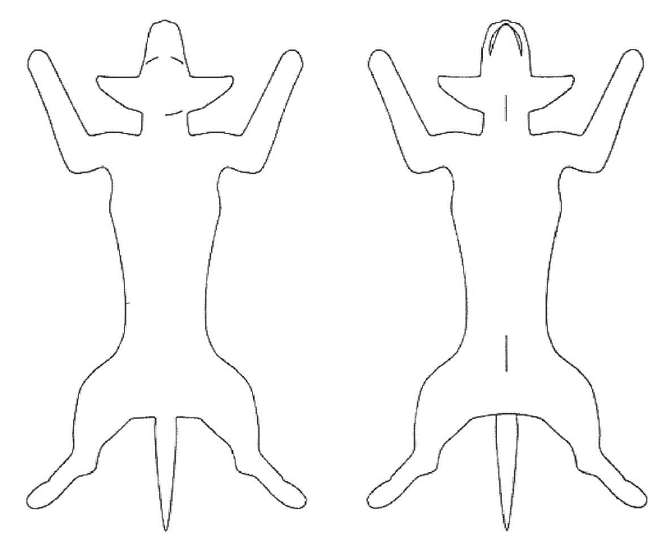

NOTES: ________________________________________________________________________________________________________________________________________________________________________________________________________________________________________________________________________________________________________________________________________________________________________________________________________
Clients Name: ___________________________________________________________________________________
Patients Name: __________________________________________________________________________________

