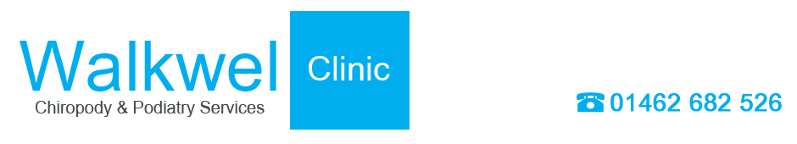

Information Sheet No. 12

Gout

Arthritis is a disease of the joints which causes them to become inflamed and stiffen. There are three types of arthritis - Rheumatoid, Osteo-arthritis and Gout.
Gout is the result of an imbalance of uric acid in the body, and affects more men than women.
The main symptom is waking up in the middle of the night with an acute throbbing pain in the big toe, which is swollen. Usually only one of the big toes is affected. The pain lasts for around three or four hours and will then subside and usually not return for a few months. It can be controlled by drugs, which your GP will be able to prescribe. The application of ice or cooling lotions will help during an acute phase.
All three forms of arthritis can benefit from chiropody care. Registered chiropodists (also known as podiatrists) work in the NHS and in private practice. They will be able to adapt your existing footwear with orthoses or other appliances, which fit easily into your shoes and help redistribute pressure away from the affected parts.
Made-to-measure shoes can also be prescribed, and registered chiropodists/podiatrists will also be able to advise you on the correct type of shoes to wear, and where to obtain them. Registered chiropodists/podiatrists can also provide protective shields for your toes, or padding to relieve pressure and reduce friction. Any secondary problems, like ulcers or corns, can also be treated. They will also refer you to a specialist for further treatment, if they consider it necessary.
Specialist teams of rheumatologists, chiropodists/podiatrists, physiotherapists and occupational therapists, along with specialist nurses, will provide the most effective care and treatment for arthritic patients, especially those with rheumatoid arthritis.

