REMOTE CONTROL INTERFACE
Installation Instructions

The interface unit can be controlled either from a Smart Wi-Fi Socket or the building management system. The unit requires a brief signal to turn it on and hence the Aqua-Steam Generator which will automatically turn off after approximately 30 minutes.
INSTALLATION
Ensure the generator and the remote interface are both isolated from the mains power supply before starting the remote interface installation.
Remove the lid. Fix the interface to a solid surface close to the generator using the two holes in the base of the interface. If using WI-FI the interface unit will need to be situated within 1.5Mtrs of a standard 13amp socket.
Connect the domestic controls 9 way plug onto the interfaces 9 way socket and the interfaces 9 way plug onto the Aqua-steam generators 9 way socket.
Wi-Fi Installation
Any commercially available WI-FI smart 13amp socket may be used, we recommend the ORVIBO Wi-Fi Smart Socket S20.
- Ensure the Wi-Fi socket is functioning correctly using a test lamp or similar item.
- Switch off and replace the test lamp with lead supplied to connect to interface.
- Turn mains on to the steam generator and check that it functions from the control in the steam cubicle.
- Turn off at the steam room control (press off on the touch pad)
- Turn the Wi-Fi socket “ON” and the generator will commence operation and remain on for 30 minutes even if the Smart Wi-Fi socket is then turned off.
- To subsequently restart the generator, turn off the Wi-Fi socket and then turn it on.
B.M.S. Installation
1. Installation is similar to the Wi-Fi installation above but does not require the mains lead which should be discarded.
2. The B.M.S. output should be a clean contact which can close for 0.5 – 2 seconds to trigger the ON condition.
3. Use a suitable 2 core cable to connect the B.M.S. to the two terminals labelled B.M.S. inside the interface.
4. Turn mains on to the steam generator and check that it functions from the control in the steam cubicle.
5. Turn off at the steam room control (press off on the touch pad)
6. Turn the B.M.S. on and the generator will commence operation and remain on for 30 minute.
NOTE 1
For correct operation of the remote interface do not plug the supplied mains lead directly into the 13 amp mains supply outlet. It must be plugged into a smart socket which is plugged into the 13 amp mains supply. See photograph below.
NOTE 2
With either type of installation the Aqua-Steam Generator timer can be re initiated (30 mins) by turning the control OFF and back ON. The Aqua-Steam Generator cannot be turned off with the remote interface.
NOTE 3
It is possible to use both B.M.S. and a Smart Wi-Fi switch to control a steam generator installation but both controls must be off for the other to function correctly.
ILLUSTRATION OF CONNECTIONS
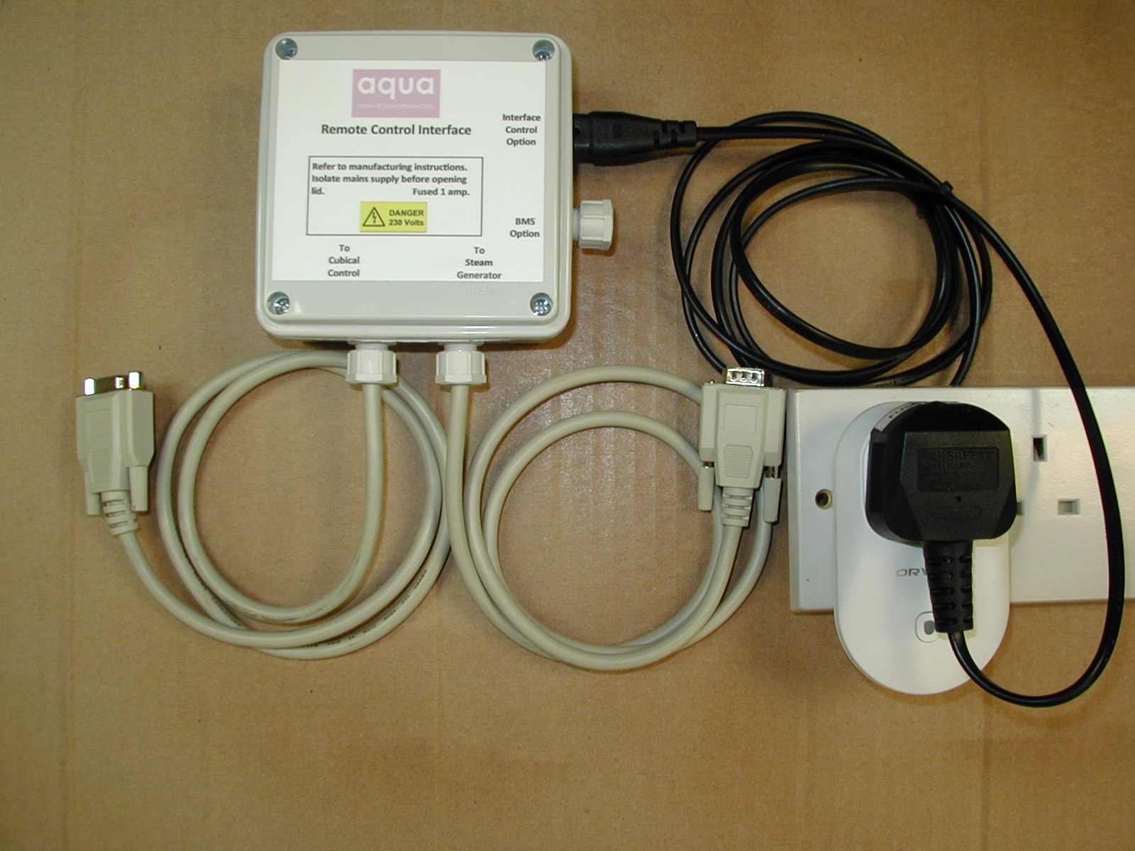
An example of a smart switch setup

