Super-powered WiFi with Hack-free Parental Controls
With this easy-to-use, web-based app and WiFi router, you have the power to control your home network & devices.

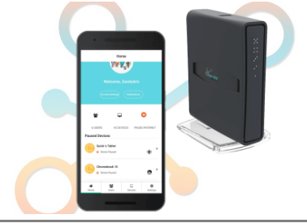

5-minute router install + web-based app helps you:
- Set hack-proof parental controls
- Improve internet performance
- Manage all connected devices
- Optimize your network

Photo of family w/ multiple devices
Manage All Your Devices
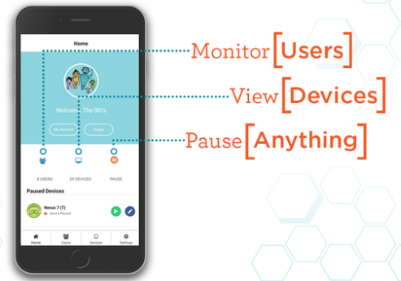
Ever feel like your devices rule you instead of the other way around? This comprehensive solution puts you back in charge by keeping you informed and in control of your home network. It’s easy to use and you don’t need to be an IT geek to get hooked up and running. No matter where you are, you’ll be able to view and monitor the people and devices connected to your home network and keep tabs on their activity. Use the web-based app to pause (disconnect) specific users and/or devices at the touch of a button. Plus, the system will notify you if new devices try to connect.

Worry Less with Hack-proof Parental Controls
Even if you’re the type who asks your kids to program the DVR, you can use this network management system to keep tabs on everyone and everything connected to your home network. It’s all managed through this revolutionary router which means you don’t have to install apps, chips or other mechanisms on your individual devices; if they use your Wi-Fi, you’ll know when they’re connected and what they’re trying to access.

This enables you to easily:
- block inappropriate content.
- initiate technology timeouts.
- automatically disconnect devices during assigned times, such as homework time and bedtime hours.

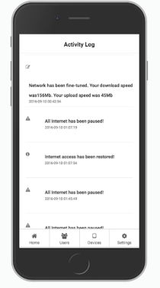
Improve Your Internet Performance
If you’ve ever been annoyed because your kid’s game time bumped you off the network or caused your movie to buffer, you’ll love the optimizing features of this system. You’ll be able to get peak performance from your WiFi by accessing the web-based app to establish priority users, set usage limit alerts, and get notifications of attempted hacks or loss of service.

No more:
- Buffering
- Router resets
- Security hacks
- Bandwidth overload

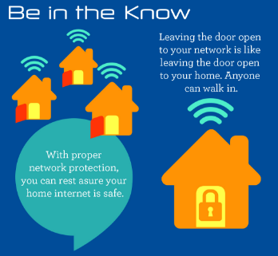
Protect Your Family
Today’s digital world has changed the way live. It has revolutionized how we communicate and although it’s amazing, it also presents new challenges, especially for parents. In addition to the easy-to-manage parental control features, this one-of-a-kind WiFi management system provides an easy way to keep browsing worry-free and safe for kids by allowing you to establish automatic filters that block intentional or accidental access to inappropriate content.

You may not be aware of the potential legal implications of having an unsecured home network. If an uninvited user jumps onto your WiFi to facilitate illegal activity (child pornography, solicitation, hacking), it could potentially be linked to your system. This whole-house solution makes it easy to safeguard your family with private access only your family can utilize and a guest network that visitors and friends can access with your password-protected permission.

To find out more about this powerful, easy-to-use system, call our office today.

