Today's Message: The Curriculum of a Disciplemaker" Date: May 1, 2016
Speaker: Alden Laird Text: II Timothy 3:10-17

Introduction:

Overview: In spite of his extraordinarily difficult circumstances, Paul exhorts Timothy, in the first chapter of his final letter, to "fan into flame the gift of God" and to "join with me in suffering for the Gospel." In chapter two the Apostle urges Timothy to remember several crucial matters that pertain to being an effective laborer for Christ and passing the spiritual baton to others. In chapter three, verses one to nine, Paul describes in detail the selfishness and unholy living that will characterize the "last days." In verses ten to seventeen Paul reviews the curriculum from which he and others taught and mentored Timothy to become an effective disciplemaker.

A. The M____________________________Prerequisite - parakoloutheo (v. 10a) "followed"

- The word "parakoloutheo" means "to study with at close quarters" –
“_________ ___________ _________________ ________________ my teaching/doctrine”

- It also means to _________________ __________________________

B. The C____________________________ Requirements - (vv. 10b-16)

1. didaskalia - _____________________________(v. 10b)

2. agoge - ________________________________(v. 10b)

3. prosthesis - _____________________________(v. 10b)

4. pistis - _________________________________(v. 10b)

5. makrothumia - __________________________ (v. 10b)

6.agape - _________________________________(v. 10b)

7. hupomone - ________________________________ (v. 10b)

8. diogmos - __________________________________ (v. 11)

9. pathema - __________________________________ (vv. 11-13)

10. manthano - _____________________________(w. 14-15)

11. pasa graphe - _______________________________ (v. 16a)

12. paideia - ________________________________ (v. 16b)

C. The C_____________________________ Objective (v.17)

- artios – means to be complete, capable, proficient in all they do

- exartizo – means to be capable of leading others to salvation and equipping them for service

Application:
1. Who are the individuals God used to lead you to Christ and mentor you in the faith? Have you thanked them recently?
2. Why do you believe teaching and conduct are the first two of this twelve-part curriculum in mentoring Timothy?
3. Explain why patience with difficult people may be more challenging than patience with difficult circumstances in the disciplemaking process?
4. Have you been trained in how to share your faith and how to disciple and counsel others? What is your plan for 2013?
5. Continue memorizing and meditating on II Tim. 3:16,17.
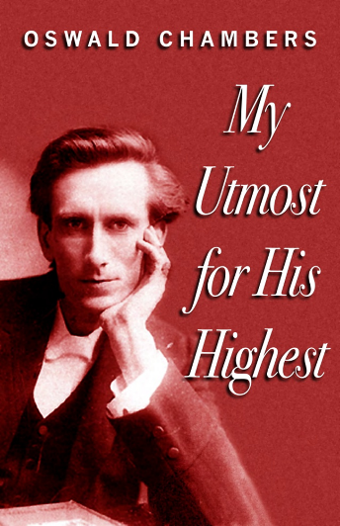

“Disciples are not manufactured wholesale –
they are produced one by one,
because someone has taken the pains to discipline,
to instruct, and enlighten, to nurture
and train one that is younger." - - Oswald Chambers

