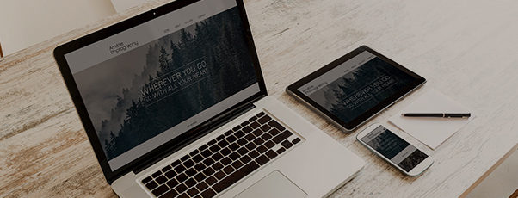

One Website, Every Device.

Hi X,

As a small business owner, you need your website to do three things
above all others:

1. Provide a beautiful, seamless experience on desktop, tablet and mobile
2. Cater to your customers’ unique needs across all device types
3. Make it easy for customers to convert with business-driving features

I’d like to help you cover all of these bases and more by working with you to create a lightning-fast website that improves your digital presence and captures more customers.

If you’d like to talk about bringing your business into the multi-screen world, simply give me a call at XXX-XXX-XXXX.

Best,
Your Name

Insert Your Name Job position
Email: name@mail.com

