Date XX/XX/XX

Dear Name of client

Welcome to Brent Bereavement Services

Following your recent assessment for counselling, we confirm:

Your counsellor is: Name of counsellor

Your first counselling session will take place on: Day & Date

The time for your session is: XX am/pm – please arrive on time, as we do not have a waiting area. If you arrive early, please wait by the door for your counsellor.

Your counselling sessions will take place at:

Brent Bereavement Services
395 Chapter Road
London NW2 5NU – map & directions are attached

You have kindly agreed to pay a donation of £XX per session
Your counsellor will give you a receipt for any cash or cheque received. Credit card donations can be made online – please contact our administration department for further information.

In addition to the agreement you will make with your counsellor, there are some policies that you need to be aware of:

- CANCELLATIONS: We ask for a minimum of 48 hrs prior to your session, if you need to cancel or change a session, please call your volunteer counsellor.
- If you fail to attend the first 2 sessions or cancel 4 of the 12 sessions, your file will be closed.
- Your volunteer counsellor will be available for the arranged appointment, and will often travel extensively to see you. If you arrive late, the remaining time can be used, but will not be exceeded.
- Please do not ask for your counsellor’s personal telephone number, email or address, as our Code of Practice does not allow counsellors to give this information.
- Please contact us if you would like any further information, if you have any special needs or if you feel our service can be enhanced in any way.
- Brent Bereavement Services is a registered charity No.296229, established since 1987. We do not receive funds to provide this service from the NHS or Brent Council.

We hope our services will help you lead a more fulfilling life.

Paulo Pimentel

Paulo Pimentel
Services Manager

How to find us

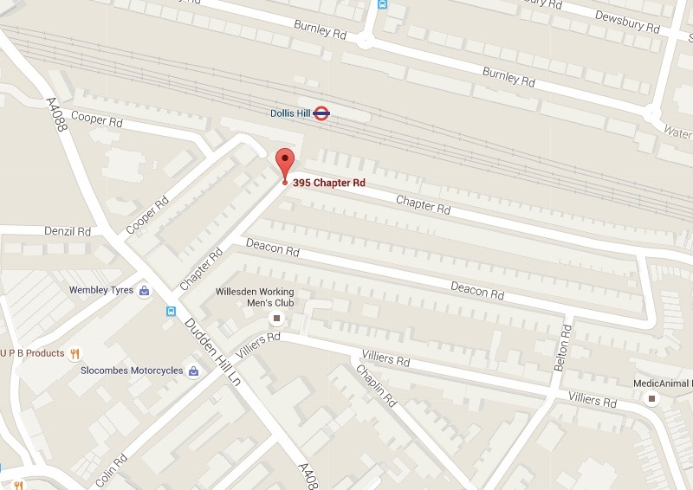

BBS – Brent Bereavement Services

395 Chapter Road
London NW2 5NU

By public transport
Buses: 226 & 302 stop on Dudden Hill Lane
Underground: Dollis Hill (Chapter Road exit)
By private transport
There is limited ‘pay & display’ street parking at the front and the back of the building.

