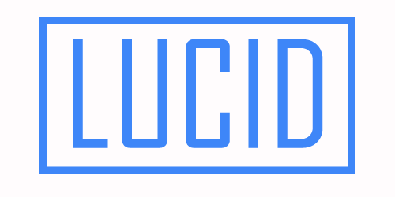

How to sell inSites

Website

Personalization – A

Boon For Businesses
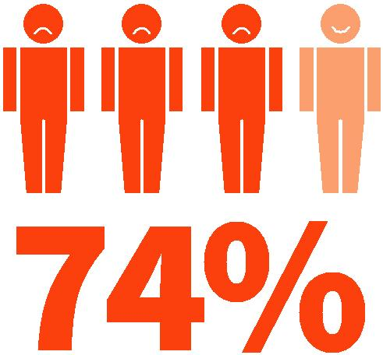
customers dig through pages of content or an elaborate navigation just to find the menu they’re looking for – but this is sadly the norm when it comes to static web pages.

Giving your clients the ability to get non-verbal feedback from their customers, gauge their needs and wants, and provide them with the content most likely to have a positive effect is a boon for any business. Not only can website personalization alter the content served to the user, but also the way in which that content reaches the user. By identifying the location and device used by the customer, for example, you can make sure they get the right information, in the right way, at the right time.
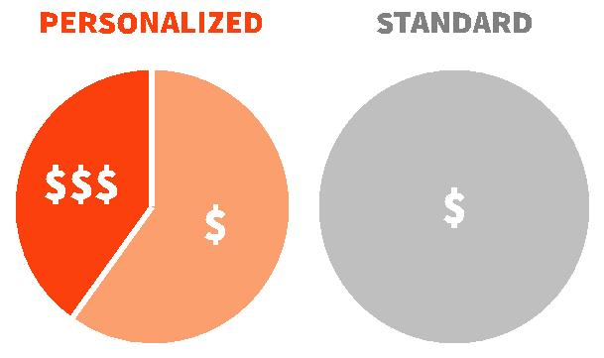

Nearly three in four (74 percent) online consumers get frustrated with websites when the content that’s displayed, such as offers or promotions, has nothing to do with their interests.

Add to that another study that shows in-house marketers who personalize their customer’s web experiences see an average 19 percent uplift in sales and it becomes clear that offering your clients dynamic, personalized web content is critical.

Not only that, offering personalized content is a tremendous opportunity for LUCID Partners to add yet another revenue stream.

Your Customers Connecting with Their Users

Let’s face it, no single message is perfect for everyone. If your client is a restaurant owner, for example, you wouldn’t want to show a dinner menu to someone looking for a quick lunch, or vice versa. Nor would you want to make their

To be sure, research has shown that 40 percent of consumers buy more from retailers who personalize their shopping experience across channels. We all want to feel special, and we buy more from companies that tailor their message to suit our specific needs.
On old-fashioned websites, the site stays the same no matter who is using it, or how. This

is a huge, missed business opportunity for your clients that not only risks losing immediate sales, but also the chance to make a great impression and earn a repeat customer. As a designer, website personalization enables you to cover more options, with less work, all while charging a premium. Static sites just don’t make sense in today’s market.

The Personalized Web Made Easy

While adding dynamic website content has traditionally been reserved for enterprise-level companies with six-figure budgets and large development teams, LUCID’s feature makes it as easy as a couple of clicks, without compromising functionality.

LUCID’s cutting-edge personalization technique analyzes a user’s behavior such as visit history, browsing patterns, proximity, time of day/week/ month, device type, etc., and can adapt the content on the websites you build to offer the most relevant information. This provides users with the best-tailored service possible, while drastically increasing conversions.

LUCID allows websites to present information most likely to turn a visit into a sale. For example, a restaurant owner can display the lunch specials and a coupon to someone visiting in the afternoon, or a business can automatically show a welcome video to a first-time visitor.

It’s easy to set up a series of personalization’s for a special promotion, sale, holiday and more. Once set, simply forget about them. The personalization’s will run perfectly all on their own. That’s all it takes to create a constantly updated site with no need to log in to your editor and make changes.

How to Make Money with inSite

As a LUCID Partner, you’re in a unique position to increase your revenue by offering small business clients a feature that simply doesn’t exist outside of enterprise-level solutions. Not only that, but unlimited access to personalization’s is already included, at

no extra charge, as a part of the LUCID Partner Program, so you can start selling premium services using the tools you already have.

In the subsequent pages of this eBook, we’ll cover some of the triggers within personalization’s and a few use cases for each. However, the sky’s the limit on what you can do with these powerful website personalization features, and you know best what your clients will and won’t find valuable.

The great thing about selling website personalization features is that you can sell them to existing and new clients alike. If there is a special event in town, reach out to existing

customers and offer to build them a personalized web experience that capitalizes on that event and can increase their business.

Do you have a client that sees a slump on a certain day of the week or time of year? Offer to implement an personalization’s that offers a special promotion to nearby website visitors at that specific time.

Maybe there are small business clients you’d like to work with, but they already have great websites and aren’t looking for a redesign. However, maybe they’re having a special promotion or sale? With LUCID, not only can you offer to build them

a landing page for their promotion, but you can offer a landing page that behaves uniquely based on each visitors specific behavior - a service your competitors likely can’t offer.

Finally, when approaching potential new clients who are in need of a site redesign, or maybe their first ever website, you’ll be able to offer

website personalization as part of an entire online customer acquisition strategy, which gives you a leg up on your competition.

In addition to offering this highly useful and unique service to your clients, you can also charge a premium for it. There are no hard and fast rules for how much you can charge to offer personalized content since prices can vary wildly from market to market and you’re the best judge of what works with

your customer base. However, it’s important to con-sider your effort, the value to the business and that enterprises pay tens, even hundreds of thousands of dollars to create personalized web experiences.

Now that we’ve covered the importance of website personalization and how it can help dramatically improve conversions on your client’s websites, all while making you money, we’ll look at a few use cases that you can use right away. While these use cases can be used immediately, the main idea is to get you thinking about ways you can specifically tailor personalized web experiences to benefit your clients.

Time is On Your Side

Whether it’s a morning greeting, a special during your customer’s slow hours or a contact form during their off hours — personalizing websites and offering the right thing at the right time can make a world of difference in increasing site conversion.

Here are a few examples of website personalization using the time of day as a trigger.

Off Hours

For the most part, all businesses have hours of operation and times they are closed. However, just because your clients physically are not there is no reason for them to lose potential business. By leveraging website personalization, you can use your client’s off hours as a trigger to display a contact form at the top of their website letting potential customers know they’re closed, but will happily follow up with them in the morning.

Happy Hour

Are any of your clients restaurants or bars? If so, they likely have a happy hour special during the times of day that are slower. However, it doesn’t make a lot of sense to include a message
on their homepage at 8 a.m. saying “come in right now for our world famous happy hour.” With personalization’s, you can use the time of day, in this case let’s say between the hours of 6 p.m. and 8 p.m., as a trigger to display that message only at the appropriate time. If you want to take it a step further, you could even combine this with the “location” trigger (which we cover later in this eBook) to offer a happy hour coupon to customers visiting the site during happy hour that are also nearby your client’s business.

Daily Specials

A lot of your clients probably have a daily special. Maybe it’s a special dish for your restaurant clients, or a discount on a particular group

of products on a given day. Using website personalization, you can add the daily special to homepage and set the day of the week as a trigger to display the right item on the right day. The best part is that once you set it up, it runs itself. A premium service all while saving time.

These are just some of the ways to use the time trigger when thinking about website

personalization. You could also list lunch specials, flash sales, eCommerce promotions, holiday promotions, etc. The sky’s the limit.

Location, Location,

Location

One of the most common phrases in advertising, sales and even in love is “be in the right place

at the right time.” Now you can offer the online version of this mantra to your clients by ensuring their visitors see the content most likely to make a sale when they’re nearby.

Here are a few examples:

Branches

If your client’s business has more than one location, then each branch has its own staff, offers, phone number, address and contact details. Why would you show all of their site visitors the same info? By personalizing the website according

to the physical location of site visitors, you can display the right info without expecting the user to navigate to the relevant section of the website that contains what they need. This avoids any confusion and allows the visitor to engage with your client’s business as quickly as possible without hunting through the entire website.

Here’s an example: Special Sale in San Francisco!

Let’s say you’ve built a site for a client who has multiple locations throughout California, but their San Francisco location is overstocked on product “A.” Since not all branches have the same merchandise, you can use website personalization to display a special sale on product “A” for their San Francisco location that will only be seen by visitors coming to the website from the Bay Area.

Nearby Offer

Part of being in the right place at the right time is to entice a potential customer when he or she is physically nearby and looking for your client’s type of business. If a visitor lands on a website you’ve built while they are close to the business, this is the perfect time to use personalization’s to close the deal by presenting an offer that will make them come in.

For example, if someone visits the site on his mobile phone, and is within six blocks of the business, display a discount coupon, a map and a note saying, “Hey, you’re just around the corner.

Come on in and enjoy this deal.” This drastically increases the chance that the digital visitor will become a real-world customer.

Take Me Out to The Ballgame (Celebrate an Event)

Who doesn’t want to support the home team or

go out to celebrate after a good game? Website personalization, based on location (and time) allows you to help the sites you build do just that, all while increasing your clients’ (and your) revenue. Just set the website to post a great offer, scheduled for after a big game, for people visiting the site from near the stadium. Add a compelling message on the site with support for the team and even add the team colors to the site’s background. The fans will be happy to come share their team spirit (and cash) with your clients.

This type of website personalization can be leveraged with any event happening near your client’s place of business, allowing you to charge a premium for adding these features and become a true marketing partner.

Handling First-

Time and Returning

Visitors

Beyond time of day and a website visitor’s physical location, how many times they’ve visited the business’ site can have a substantial impact on what their best website experience would be. For example, if a potential customer is landing on your client’s site for the first time, they may not be very familiar with their services. In this case, it’s probably best to display something on the site that would help give the visitor a good overview of who your client is and what they’re all about.

However, someone that’s a member of their loyal customer base, who visits the site time and time again, is most likely looking for something very specific and isn’t just trying to find generic

information, like Business Hours or a Map feature.

For these customers looking to take a specific option, showing off the best-selling product or an
OpenTable widget (in the case of a restaurant) is the preferred experience.

Here are a few more detailed examples of how you can use dynamic content to adjust your clients’ websites based on the number of times a visitor has landed on a site.

Welcome Video for Introductions

There are a few reasons why adding a welcome video is a great way to introduce a new visitor to your clients’ business. First, everybody likes a personal touch and showing a video of a business owner speaking directly to the viewer puts a face to a name and adds a human element to the business. Second, it enables you to direct the conversation more (and believe it or not, your client’s website is a conversation). Instead of allowing a visitor to dive in to the site and ignore critical parts of what you’re trying to communicate, it puts them into a funnel so they get a fuller, more well rounded picture of what your client’s business is all about.

Online Scheduler for the “Regulars”

If your client is the kind that has lots appointments to keep (think hairdressers, yoga studios, dentists, etc.), then serving up an Online Scheduler widget for returning visitors is a fantastic idea. After all, these are most likely previous customers who are familiar with what your client does. They’re there to take an action, and for lots of businesses the most valuable action a customer can take is to schedule an appointment.

Adding a “Welcome Back,

Customer” Message

Have you ever logged in to an online service

and there was a message right up front welcoming you back? The answer is probably yes. Sometimes it’s subtle, sometimes it isn’t, but showing a message to a visitor saying “We’re glad you’re back” is more than a friendly greeting. It shows that your client is paying attention to who his loyal customers and that he appreciates

their business.

These are only three examples of how you can use the number of previous visits to determine what kind of content is seen by visitors. However, it doesn’t have to be a case just choosing one and sticking with it. Depending on the needs of your customer, and how in-depth you want to go, you could create a personalized experience on the same site for the first, second, third, tenth or even 100th time a customer visits. It’s important to remember that each client is unique and you should find a strategy that works best for them.

Different personalization’s for Different Devices

When implementing dynamic content on a client’s site, it’s important to keep in mind that, though your client may have one site that works on all three device types; desktop, tablet and mobile are very different animals. The varying screen sizes and functionalities mean that an element or widget that works perfectly on one, may not be such a good fit on the others.

Let’s go over a few quick ideas for diversifying your personalization’s by device type.

Highlighting a Best Seller on Desktop

According to HubSpot, there’s a fair chance that a user on a desktop computer is looking to start a more complex task, like researching a product. Since these potential customers may not be looking to take immediate action, setting up an

personalization’s for visitors on a desktop that displays one of your client’s best-selling product with an in-depth description might be the way to go.

Map Feature for Mobile

If a visitor is on mobile, and in the same zip code as your client, a Map feature that displays step-by-step directions makes perfect sense. However, if they’re a little farther away, showing

an informational video about the business may be more appropriate because the potential customer is less likely to take the immediate action of coming to your client’s brick-and-mortar location.

Notification Bars for Desktops and Tablets

Showing off a special message to users is nearly always a win. It’s a fantastic way to display a special sale, wish customers a happy holiday, promote a special event, or communicate any other of the potentially millions of messages your client might want to push out to customers.

However, length can be an issue. What looks short and easy to read on a desktop or tablet, may look overbearing and wordy on mobile. If that’s the case, it’s best to reserve your rendition of “The Iliad” for the larger screens and maybe go for more of a haiku on mobile.

It may take a little bit of extra thinking through, but ensuring that each personalization you create for your clients is appropriate for each device will go a long way to increasing their customer conversion and boosting loyalty to you.
Putting It All

Together

Though it may seem like a lot, we’ve really only scratched the surface of what is possible by using dynamic, personalized content to better your clients’ websites. With LUCID’s unique personalization feature, you can create all kinds of personalized experiences that maximize customer conversion and enable you to charge a premium for your service.

