Service & Cost Comparison Guide
Keep your customers informed.
LUCID LLC | (210) 570-2379 | www.luciddms.com

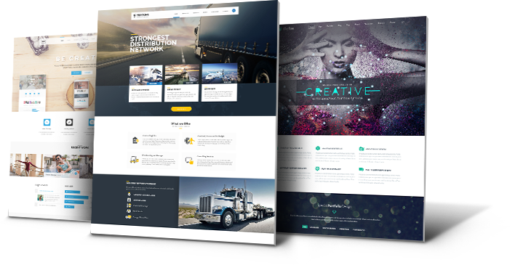

Why LUCID?
When you choose LUCID, you save a ton of money and you’ll also get a higher level of service and customer support. Our goal is to always treat you with the highest level of professionalism and to help you turn visitors into paying customers.

Service Assessment
Here’s how our services stack up against our competitors.
 | LUCID | Competitor 1 | Competitor 2 | Competitor 3
Web Design | √
Personalized Experience | √
Website Analytics | √
Search Engine Optimization | √
E-Commerce | √
Website Management | √
CRM | √
Email Marketing | √

Costs Assessment
Here’s how our average prices stack up against our competitors.
 | LUCID | Competitor 1 | Competitor 2 | Competitor 3
Web Design | $3,000
Personalized Experience | $99.99
Website Analytics | $99.99
Search Engine Optimization | $1,499
E-Commerce | $1,999
Website Management (annual) | $719.00
CRM | $1,999
Email Marketing (monthly) | $9.99

Reviews
We take great pride in serving our customer. Here are some of our reviews.
“LUCID is a pure joy to work with! They have an uncanny way of reading what I was looking for in my website design and created something that far surpassed anything I could have designed. The Functionality and the cleanliness of the design and format is purely wonderful. I have designed websites in the past but I could not have done anything close to what LUCID has done for me.... thank you so very much!!!” Patti Asman - Empowering Alaska
“LUCID created my web page very professionally and assisted in taking my business to the next level. I am very pleased with LUCID and their design of my website. The AFL website is now averaging over 1000 hits a month due to Matt and his team's hard work.” Abe Hernandez - Alaska Football League
“Love the fast, efficient and kind folks here. You will not go wrong by choosing them to do your website. LUCID is very helpful and got right on my site, way ahead of schedule. Thank you guys!” Edie Flygare - Tutan Recovery Services
“The LUCID team is detailed oriented and professional. I recommend his services to anybody who has a need for website management and/or design!” John Nelson - Liberty First
“I was very pleased with the help I received. I was struggling with a WordPress issue and it took them no time at all to identify and fix my problem.” – Anne Barnett
“LUCID created my web page very professionally and cost effective. I am very happy with LUCID and their design of my website. The creation of this website, has propelled my business to a higher level of success.” Nate Jackson - AK Home Repair

