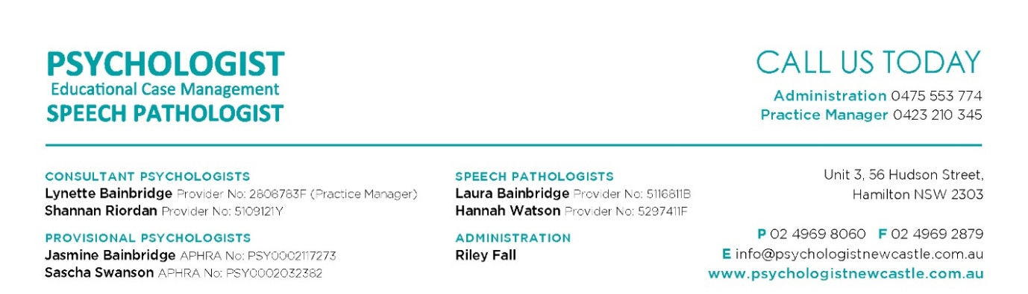

Privacy Policy for Management of Personal Information

At Educational Case Management Pty Ltd, we respect your privacy. We have developed our Privacy Policy in line with the Privacy Act 1988 and the Australian Privacy Principles when collecting, storing and disclosing personal and sensitive information of individuals (participants / clients).

This document describes the privacy policy of Educational Case Management Pty Ltd for the management of clients’ personal information. The psychological service provided is bound by the legal requirements of the Australian Privacy Principles set out in the Privacy Act 1988 (Cth).

Client information
Client files are held in a secure filing cabinet and on electronic document management systems which is accessible only to authorised employees. The information on each file includes personal information such as name, address, contact phone numbers, medical history, and other personal information collected as part of providing psychological and / or speech pathology service.

How clients' personal information is collected

A client's personal information is collected in a number of ways during psychological and / or speech pathology consultation / therapy with Educational Case Management Pty Ltd, including when the client provides information directly to Educational Case Management Pty Ltd using hardcopy forms, correspondence via email, when the client interacts directly with Educational Case Management Pty Ltd, such as with receptionist (contractors), clinicians (contractors), and when other health practitioners provide personal information to Educational Case Management Pty Ltd, via referrals, correspondence and medical reports.

Purpose of collecting personal information
In order to provide services and supports and to conduct our business activities effectively and efficiently including, but not restricted to, early intervention support, specialized individual therapy, third party consultations, behavioural management, support co-ordination, the following processes are required:
- required to collect personal information, such as contact details, date of birth
- gain background information of participant / family
- history of supports and intervention and current goals
- copies of past assessments by professionals
- General Practitioner contact details and other medical professionals
- contact and emergency details of a relevant family member / carer / advocate or guardian

If this information i not provided, we may not be able to supply you with the services you request.
We take reasonable steps to ensure the personal information we collect about you is accurate, complete, up-to-date, relevant, secure and that it is not accessed or disclosed to anyone without authority. We will only disclose your information to people who may need to know that information to provide you with the best services (new referral form). We can only do this in ways that comply with the Australian Privacy Principles.

Consequence of not providing personal information

If the client does not wish for their personal information to be collected in a way anticipated by this Privacy Policy, Educational Case Management Pty Ltd may not be in a position to provide the psychological service to the client. Clients may request to be anonymous or to use a pseudonym, unless it is impracticable for Educational Case Management Pty Ltd to deal with the client or if Educational Case Management Pty Ltd is required or authorised by law to deal with identified individuals. In most cases it will not be possible for the client to be anonymous or to use a pseudonym, however if the Educational Case Management Pty Ltd agrees to the client being anonymous or using a pseudonym, the client must pay consultation fees at the time of the appointment.

Purpose of holding personal information
A client’s personal information is gathered and used for the purpose of providing psychological and / or speech pathology services, which includes assessing, diagnosing and treating a client’s presenting issues. The personal information is retained in order to document what happens during sessions, and enables the psychologist and /or speech pathologist (contractors) to provide a relevant and informed psychological and /or speech pathology service.

Disclosure of personal information
Clients’ personal information will remain confidential except when:
- It is subpoenaed by a court; or
- Failure to disclose the information would in the reasonable belief of the Educational Case Management Pty Ltd place a client or another person at serious risk to life, health or safety; or
- The client’s prior approval has been obtained to:
  - provide a written report to another professional or agency, e.g., a GP or a lawyer; or
  - discuss the material with another person, e.g. a parent, employer or health provider; or
  - disclose the information in another way; or
- you would reasonably expect your personal information to be disclosed to another professional or agency (e.g. your GP) and disclosure of your personal information to that third party is for a purpose which is directly related to the primary purpose for which your personal information was collected; or
- disclosure is otherwise required or authorised by law.

A client's personal information is not disclosed to overseas recipients, unless the client consents or such disclosure is otherwise required by law. Clients' personal information will not be used, sold, rented or disclosed for any other purpose.

Requests for access and correction to client information
At any stage clients may request to see and correct the personal information about them kept on file. The psychologist and/or speech pathologist may discuss the contents with them and/or give them a copy, subject to the exceptions in the Privacy Act 1988 (Cth). If satisfied that personal information is inaccurate, out of date or incomplete, reasonable steps will be taken in the circumstances to ensure that this information is corrected. All requests by clients for access to or correction of personal information held about them should be lodged with Practice Manager or Clinician (contractor). These requests will be responded to in writing within 30 days, and an appointment will be made if necessary for clarification purposes.

Concerns
If clients have a concern about the management of their personal information, they may inform Practice Manager or Clinician (contractor). Upon request they can obtain a copy of the Australian Privacy Principles, which describe their rights and how their personal information should be handled. Ultimately, if clients wish to lodge a formal complaint about the use of, disclosure of, or access to, their personal information, they may do so with the Office of the Australian Information Commissioner by phone on 1300 363 992, online at http://www.oaic.gov.au/privacy/making-a-privacy-complaint or by post to:
Office of the Australian Information Commissioner, GPO Box 5218, Sydney, NSW 2001.

If you have any enquiries in relation to privacy or personal information please contact:
Practice Manager Lynette Bainbridge MAPS Unit 3, 56 Hudson Street Hamilton 2303 NSW
info@psychologistnewcastle.com.au or lynette@psychologistnewcastle.com.au Ph: 02 49698060

For more information about the Australian Privacy Principles please visit the website www.oaic.gov.au.
If you wish to change how you receive communications from Educational Case Management Pty Ltd (via mail, phone or email) please email us at Ph: 02 49698060

