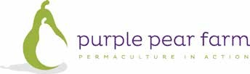
What is Community Supported Agriculture?
Community Supported Agriculture (CSA) is the production of high quality foods using ecological, organic or biodynamic farming methods. A network or association of individuals pledge to support this farm, with growers and consumers sharing the risks and benefits of food production. CSA subscribers pay at the onset of the growing season for a share of the anticipated harvest and receive a weekly share of produce in a vegetable box scheme. — Wikipedia
Community Supported Agriculture comes in many forms, but there are three main types:
A Community Owned Farm is owned by the community and employs a farm manager. The community group takes responsibility for set up and running costs of crop development and participates in production under the direction of a farm manager. This is the best opportunity to see the real cost of food production.
In a Subscription Farm, the farmer owns the farm. Subscribers buy an annual share in the produce and contribute some labour to the running of the operation. A lump sum payment is made upfront for the years supply of food. This method allows for the grower to set up the garden and survive the initial period before full production is reached.
With the Relationship Marketing Model, the farm is wholly owned by the farmer who also does all the work. The farmer delivers the produce directly to committed supporters.
These approaches can eliminate marketing risks and costs for the producer and save an enormous amount of time. It allows farmers to do what they should be doing, focusing on producing healthy, safe, quality nutritious food.

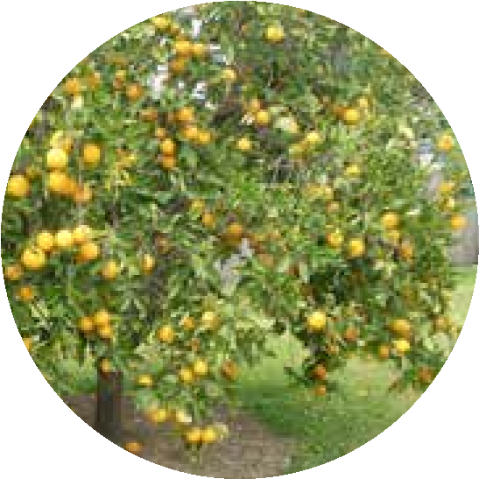
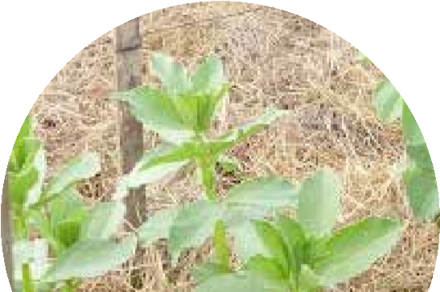
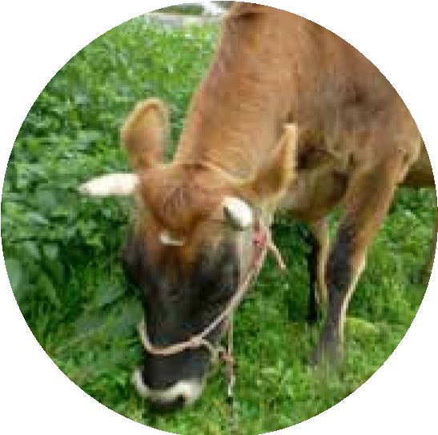
purplepearfarm.com.au
131
Anambah Road, Anambah
02 4932 0443
kate@purplepearfarm.com.au
www.purplepearfarm.com.au
‘Like’ us on Facebook
–
Purple Pear Farm
CSA at Purple Pear Farm
At Purple Pear Farm, we practise the Relationship Marketing Model of CSA. On our property at Anambah near Maitland, we have a mandala market garden and mixed farm.

What members receive
Members commit to a weekly box of vegetables as seasonally available. The box price is fixed and the value fluctuates according to food available from the garden. This means that during lean times or when weather has been bad, there may be less produce or variety. Conversely, during times of abundance there will be more and diverse produce. We have faced drought, hail, storms and flooding and our subscribers face some of this risk with us through occasional lack of variety or volume.
The focus at Purple Pear Farm is on providing everyday food to fill basic family requirements. Exotic food can take the same effort to grow and give you higher returns, but good food is important and carrots, cabbage and potatoes are needed each week by families.
How does it work?
Members pay quarterly or annually for a small or large box.
Delivery is made to a central point (Linuwel School, East Maitland) or can be picked up from the farm.
As subscribers, Farm Tours are free and a discount applies for courses.

Contact us
We welcome all enquires regarding our produce and are only too happy to answer any questions you may have. We appreciate feedback about the Farm Food Boxes and farm visits are always welcome. Please contact us.
Application form
To register your interest in joining the Purple Pear Farm CSA, please complete the below form and return to:
Purple Pear Farm
131 Anambah Road, Anambah, 2320 or email to Kate at kate@purplepearfarm.com.au
We will add you to our waiting list and inform you when a vacant spot becomes available.
Name:
Email:
Phone:
Address:
How many people in the household:
Preferred collection location:
Purple Pear Farm
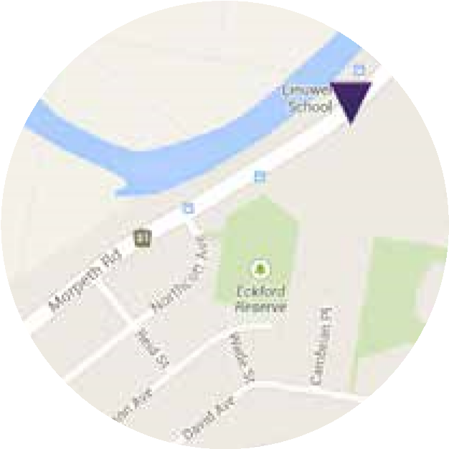
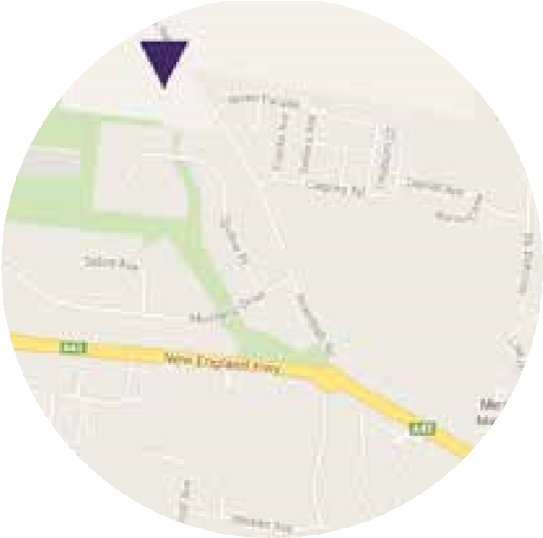
Linuwel School
Pick up times and locations
Purple Pear Farm CSA subscribers can collect their boxes from the below locations.
Purple Pear Farm
131
Anambah Road,

Anambah 2320
After 12pm on
Wednesday
Linuwel School
133
Morpeth Rd,

East Maitland 2323
Between 2.30–3.30pm
Wednesday
Please add me to the mailing list to keep me informed about upcoming events and courses at
Purple Pear Farm.
What size box would you like:

Do you want eggs included?
Small
Large
Preferred collection day: Wednesday is delivery day.

