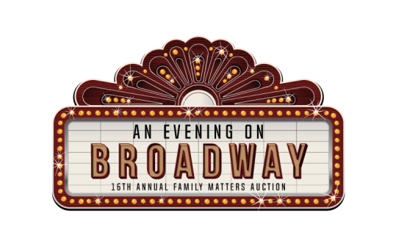
Thursday, November 9, 2017

Producer Level - $4,000
Limited to one sponsor

- Logo positioned on auctioneer’s podium
- First Position - Business name and link posted on Family Matters Auction website
- Business name and link on social media pages
- Prominent business logo on all Auction promotional materials, merchandise and favors
- Complimentary table for 10

Director Level - $2,000
- Business name and link posted on Family Matters Auction website and social media pages
- Prominent business logo on all Auction promotional materials
- Business name and link on social media pages
- 4 Complimentary tickets

Corporate Fund a Family
- 1 Family $250
- 3 Families $750
- 5 Families $1250

Actor Level - $1,000
- Business name and link posted on Family Matters Auction website
- Business name and link on social media pages
- Prominent business logo on all Auction promotional materials, merchandise and favors
- 1 Complimentary ticket

Supporting Cast - $500
- Business name and link posted on Family Matters Auction website and social media pages
- Prominent business logo on all Auction promotional materials
- Business name and link on social media pages
- 1 Complimentary ticket

Curtain Calls
- Individual Ticket $ 55
- Table of Ten $550
- Digital Ad $100
(website & Facebook)

Thursday, November 9, 2017

Company Name exactly as it should appear on all materials:

Yes! We will sponsor The Upper Room’s 16th Annual Family Matters Auction at the following level:

Sponsorship Levels
Producer Level $4,000
Director Level $2,000
Actor Level $1,000
Supporting Cast $ 500
Fund a Family ___1 ___3 ___5
Casting Calls
Individual Tickets $55 Qty _______
Table of Ten $550
Digital Ad $100

Enclosed is a cash donation of $______
I will use the complimentary tickets provided with my sponsorship
I regrettably cannot use the complimentary tickets

Silent Auction Donations
We would like to donate an item(s) to the auction.

Item Description: _____________________________

Item Value: ________________
Item Restrictions: _____________________________
Item is enclosed.
I will deliver my item(s) to TUR by Oct.1, 2017
Please call me to arrange a pickup time

Contact Information: Name: _______________________________ Title: _____________________________

Phone number: (_______) ________________ Email Address: __________________________________________

Company website URL: _________________________________________________________________________

Mailing Address: ________________________________________________________________________________

I have enclosed a check in the amount of $ __________________ made payable to The Upper Room.

Please charge my credit card $ __________________ MC Visa Disc AmEx

Card # ____________________________________ Exp. Date ______________________

Name on Card _________________________________________________________________________________
Billing Address of Card __________________________________________________________________________

Please return forms with payment to: The Upper Room, Attn: Auction, 36 Tsienneto Rd, PO Box 1017, Derry, NH 03038
The Upper Room is a 501(c)(3) nonprofit organization. Email Kate Briggs at kbriggs@urteachers.org with any questions.

Office Use Only:
Date Received
Received By
Date Entered
Catalog #

Location
Tagged YES NO
Thank you Sent
Action Required

Location
Tagged YES NO
Thank you Sent
Action Required
Office Use Only:
Date Received
Received By
Date Entered
Catalog #

