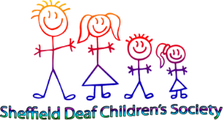
SDCS Coach trip
Booking form

Please list the names of the people attending the trip.
Name | Adult/Child (Children are age 16 and under)
 | Total adults |  | £5 each
 | Additional children |  | £5 each
 |  | Total to pay

Parent/Guardians name:
Contact telephone number:
Emergency contact telephone number:

Terms and Conditions
- You are agreeing to attend the coach trip on 26th August 2017
- Please arrive at least 15 minutes early for departure and return
- We will be leaving The Spires promptly at 7.30am and returning promptly at 4.30pm
- WE WILL NOT WAIT FOR ANYONE ARRIVING LATE
- Adults are £5 each. Deaf/Hearing impaired children are free and one sibling is free. If you have chosen to bring additional siblings. We are asking for a £5 contribution each.
- We will require payment for your place at the time of booking. This can be done by card payment on our website www.sheffielddeafchildrenssociety.co.uk
- If you cancel or do not attend refunds will not be given.
- Parents/guardians must stay for the duration. Children are the responsibility of their parents/guardians at all times. They must be supervised at all times.
If you agree to these terms please sign and date below (This can be typed in) then return to: sheffielddeafchildrenssociety@gmail.com
Signed:
Date:

