Sony 2016 Microphone Remote Instructions – Android TV

The Sony Android Smart TV’s are capable of searching for videos, weather, movies, & pictures with voice commands. The process is very simple and straightforward. You do not have to enter any menus to activate or use this feature. See below for the step by step instructions for this.

- How do I search for something when watching a program on TV?
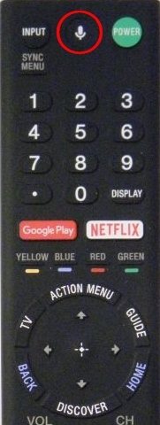
When watching TV with a picture on the screen, take the Sony TV remote with a microphone button at the top center of the remote and push the white microphone button.

- When you push the microphone button, a Google search bar will appear at the top of the screen with a red microphone at the top left of the picture. You may also see the word “Listening” when you press the microphone button. The TV screen will appear like the picture below, or instead show the word “Listening” at the top. When you see one of these speak your request into the top of the remote. PLEASE NOTE: When you talk to the remote, make sure all background noise and any others are quiet. If there is background noise the remote may not hear you correctly.

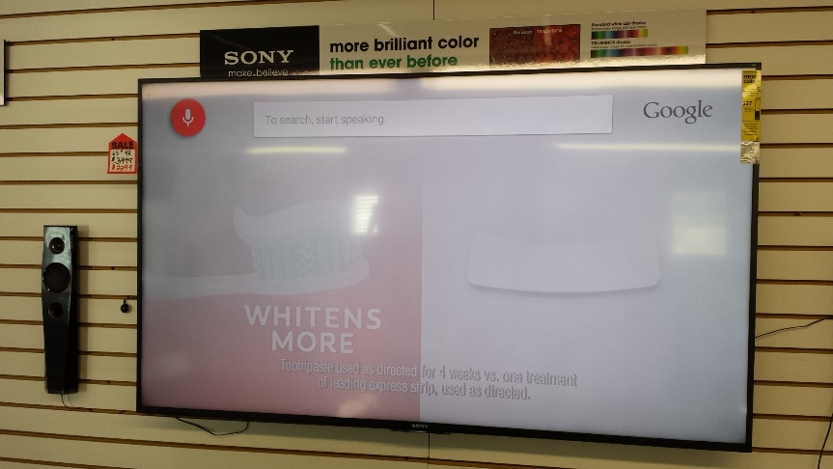

- If you searched correctly you will see the words you searched for appear in the search bar, the microphone will turn blue, and your results will appear below the search bar. See the picture below that shows a successful search.
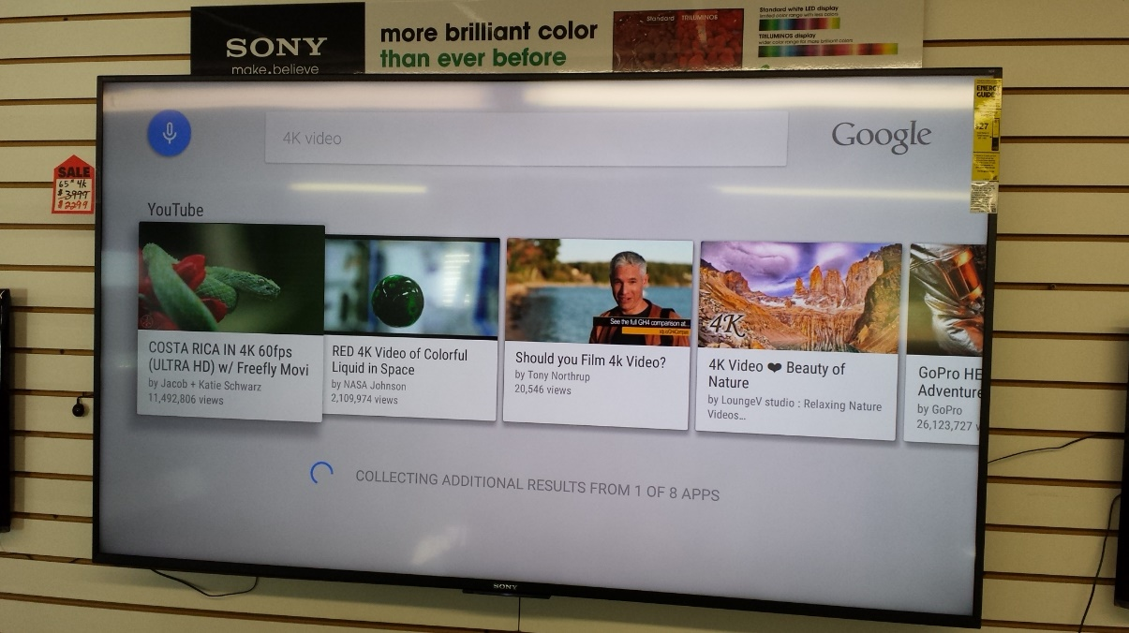

- IF YOU DID NOT SEARCH CORRECTLY, YOU MAY SEE A MESSAGE THAT SAYS “CAN’T REACH GOOGLE AT THE MOMENT”, or “DIDN’T CATCH THAT”. If this happens, don’t worry, just start the search over again by repeating steps 1 through 3.
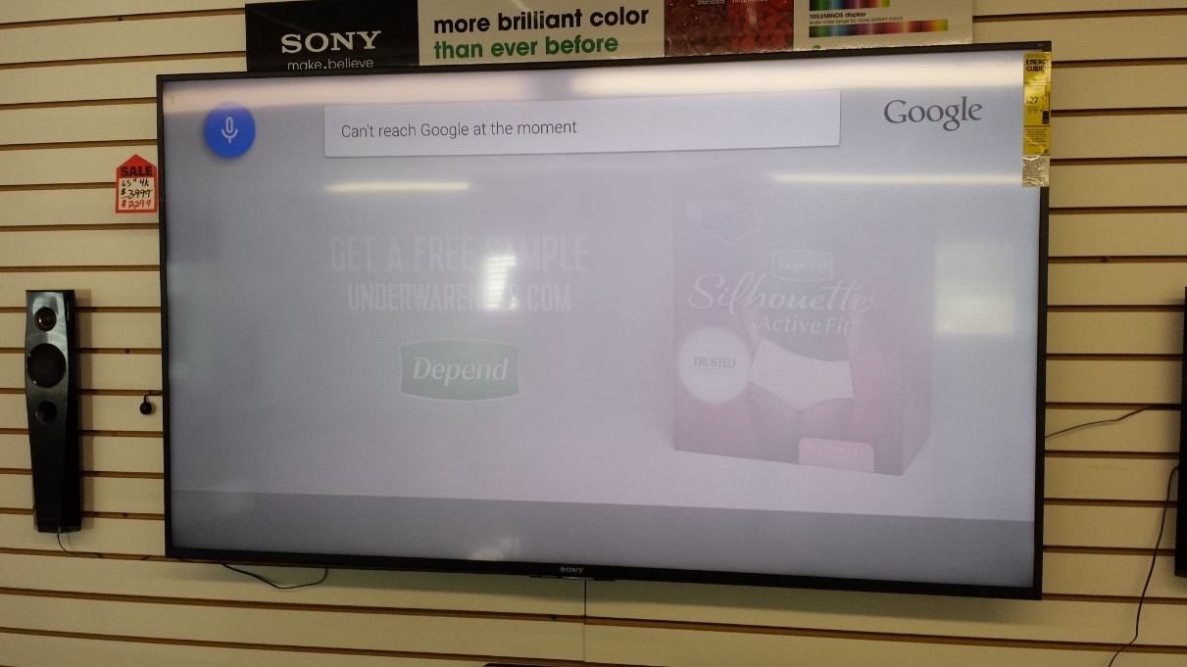

- When you search correctly you will see the TV look like the picture below. Use the remote to select the video you would like to watch by using the left, right, up & down arrows. See the remote picture below. To select a video, push the white cross button between the arrow buttons.
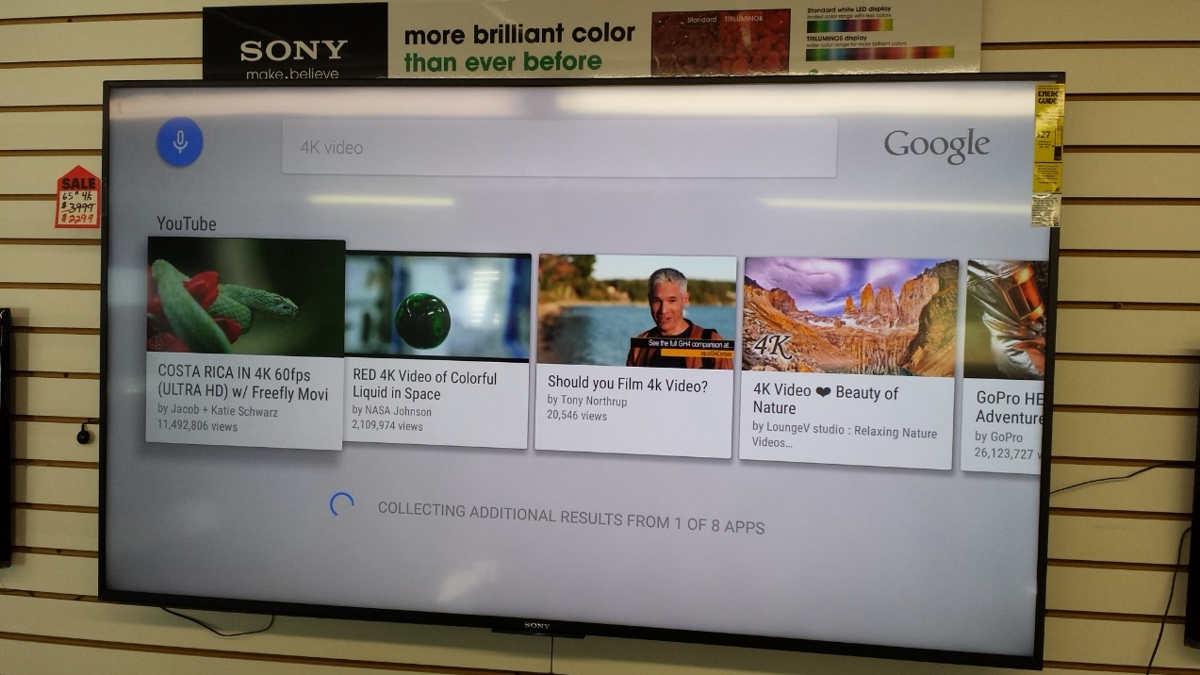

- After I search, how do I find & watch more videos related to what I searched for?
While you are watching the video you searched for press the down arrow repeatedly until you see “Suggestions” with related videos appearing on the screen. See the picture on the next page showing what your TV screen should look like. These are more videos related to what you searched for. Then use the left or right cursor arrows to move to the video you would like to watch, and press the center cursor to watch it.

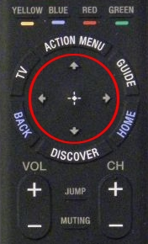

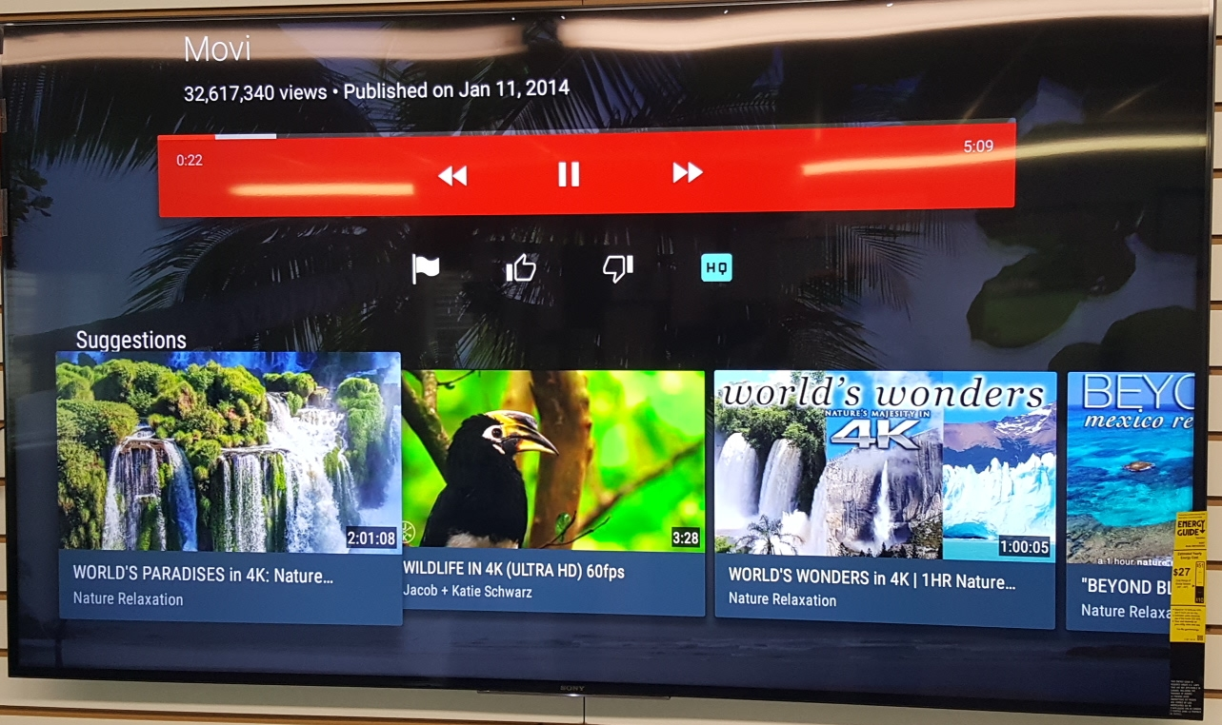

- How do I return to TV programming when I am done searching?
Simple. Regardless of where you are at in your searching, by pressing the TV button at the center left side of the remote, the TV will return to the cable or satellite input. Just press the TV button and your TV channels will return. See the picture below which shows the TV button. After you do this and your TV picture returns, then if you have cable or satellite use your Cable or Satellite remote to change channels and control your volume. If you press this and have a blank screen saying “No signal” make sure your cable or satellite box is turned on. If you have an antenna system use the Sony remote to operate your TV.

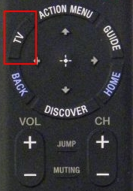

- Remember, you can search for more than just videos. If you would like to know the weather, you can ask “what is the weather today?’ Or ask about the weather for a certain city. You can also search for specific movies, movie types, or even pictures of certain things.

Using Netflix with your Sony TV

- How do I use Netflix on my Sony TV?
On the Sony TV remote, press the white and red “NETFLIX” Button. It is circled in red below on the remote control. When your account is setup and logged into, you will go straight into your movies, or be able to select someone’s Netflix account. Then use the up, down, left and right arrows, with the center cross to move and access accounts, or movies.
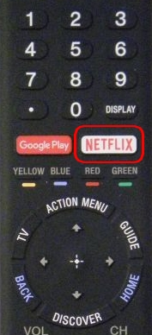

- When I am finished with Netflix, how do I get back to my TV channels? Press the White “TV” button located to the left, and below the Netflix button. It is circled in red in the picture below. Your TV will return to your cable, satellite or Antenna channels. If you are using Cable or Satellite, use the cable or satellite remote to change your channels.

