Positive vs. Negative Adoption Terminology

The word adoption can have many various connotations to different people. It is very helpful and encouraging to others for us to think of altering the way we talk about adoption. Historically, negative words have been used without much thought about how they come across. For example "to give up" or "to give away" may have the association of something one does not want. This is NOT true. Birth moms make the sacrificial, brave choice to place their baby with a family whom they have chosen out of love for their child.

Positive | Negative
Deciding to place for adoption | Giving away the baby
Deciding to place in an adoptive home | Gave up the baby
Deciding to parent | Keeping/kept the baby
Making an adoption plan | Putting up for adoption
Made an adoption plan | Adopted out
Birth Mother/Birth Father | Real Mom/Real Dad
Born to unmarried parents | Illegitimate
Birth parent/ relative | Real parent/relative parent
Parents/Mom/Dad | Adoptive parents/Adoptive Mom/Dad
My child | Adopted child/own child

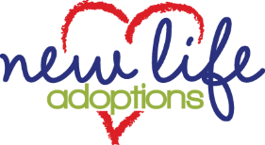
281-955-1001
www.newlifeadopt.com
New Life Adoptions @NewLifeAdoption

