PRESS INFORMATION
(Prospect 2017)

CaP.CULT
Pia Leydolt-Fuchs & Carina Kurta

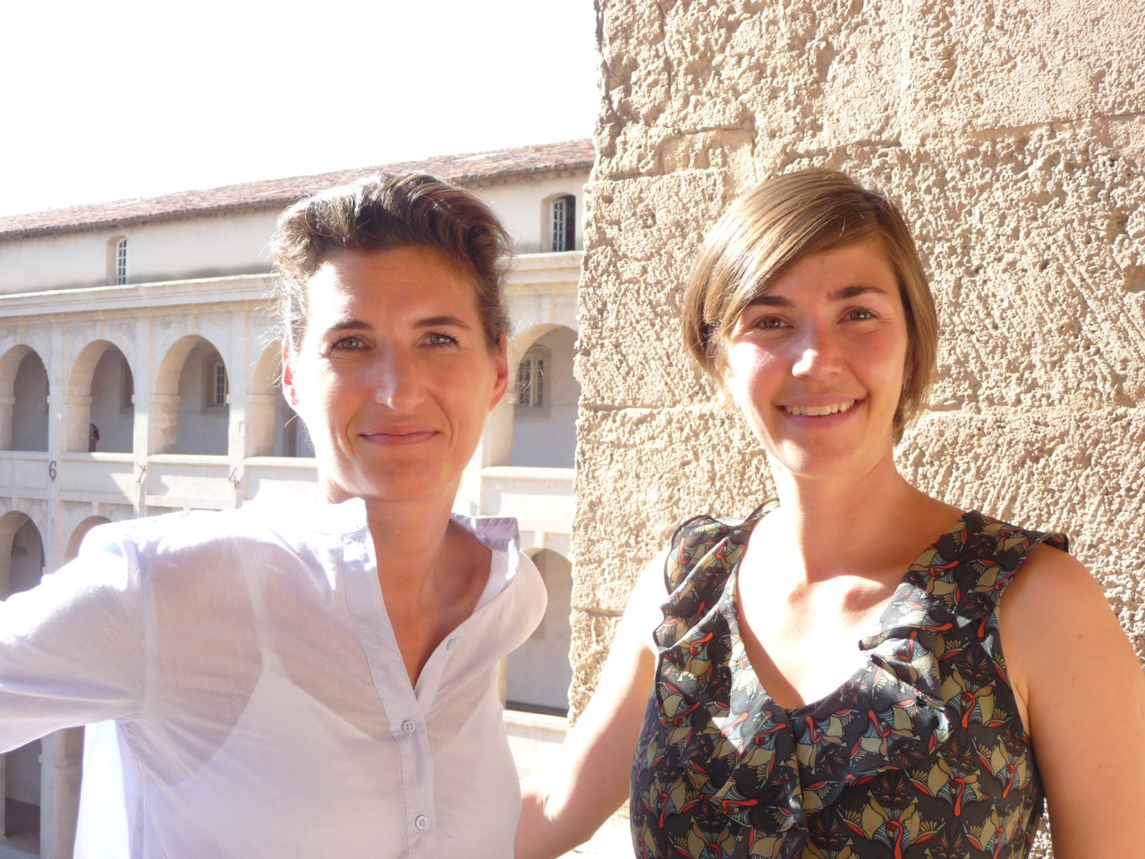
Photo: CaP.CULT, Pia Leydolt –Fuchs & Carina Kurta;

MEDIATION for ART, CULTURE and EUROPEAN CAPITAL OF CULTURE
AARHUS 2017 (Denmark) & PAFOS 2017 (Cyprus)

As well as
WROCLAW 2016 // DONOSTIA-SAN SEBASTIÁN 2016 // MONS 2015 // PLSEN 2015 // RIGA 2014 // MARSEILLE-PROVENCE 2013

Mediation for art, culture and European Capital of Culture – that means discovery of various European cultural centres, accompanied and organised by experts.
Since 2013 Pia Leydolt-Fuchs and Carina Kurta, both former employees in several European Capital of Culture-Organisations (Linz09 and Istanbul 2010), have experienced Capitals of Culture first-hand: They offer in-depth and exciting insights into the successful project of the European Union and the local art and culture scene – in AARHUS 2017 (Denmark), PAFOS (Cyprus) and still also in MARSEILLE-PROVENCE 2013 (France), RIGA 2014 (Latvia), PILSEN 2015 (Czech Republic), MONS 2015 (Belgium), DONOSTIA-SAN SEBASTIÁN 2016 (Spain) and WROCLAW 2016 (Poland)!

Acting as the (missing) link between the official European Capital of Culture- Organisation and visitors, CaP.CULT offers the discovery of the city by means of individual circuits, personally assisted cultural programmes (for one or several days – off the beaten track), workshops and meetings with local culture project managers!

The aim of Carina Kurta and Pia Leydolt-Fuchs is to help navigate through the cultural diversity of European Capitals of Culture. They both act as cultural mediators, personal assistants and partners in-situ for individual visitors and groups, school and student excursions as well as delegations of the economic, political and cultural sector.

With regards to the (urban development) project ”European Capital of Culture” (ECOC) cities change: public places get redesigned, revitalized or even newly created by means of very high investments. Consequently, new museums, exhibition- and concert halls as well as theatres are opened. ECOCs are defined by a strategic process of structural and cultural change. This is also the reason why they often become a popular and interesting tourist destination; not least because of their cultural as well as the artistic diversity which now is splendidly displayed.

The activities of ECOCs are both culturally rich and ground-breaking. Our aim is to combine the cultural offer with the personal interest of visitors and to supply them with practical experience, profound knowledge and background information.

Aarhus 2017
Aarhus, situated in the region of Mitteljütland, is the second biggest and “youngest” city of Denmark – THE students’ city of the country! As the European Capital of Culture 2017 Aarhus calls under the motto “LET'S RETHINK“for reflection about the future and the past at the same time as for finding new collaboration and to establish old ones. One year long the city provides art and culture in high quality, from and by Danish and international artists within 12 full moon-events and more than 160 artistic projects: values like democracy, sustainability and the 500 anniversary of the Protestant Reformation are also part of the program as a focus on children, nature and first-class gastronomy!

Also in respect of architecture Aarhus 2017 offers many interesting sites: the so-called “Iceberg”, a huge housing complex located next to the harbour, impresses with its’ courageous architecture; the new library DOKK1 (opened in 2015) stands for the transformation from an old education institution to a multiple venue for culture and events; the ARos Museum for Contemporary Art attracts with the “Your rainbow panorama” of Olafur Eliasson, an accessible installation on the roof top and the Moesgaard Museum of Henning Larsen Architects combines culture, nature and architecture in an extraordinary way.
www.capcult.org

Pafos 2017
The whole harbour city of Pafos is UNESCO heritage listed. Of course the archaeological places are must-seen-sights, but in spite of the touristic attractiveness Pafos stays a part of a divided island: located in the eastern Mediterranean Sea, geographically belonging to Asia, politically to Europe, split into a Turkish northern and a Greek southern part. Under the motto „LINKING CONTINENTS – BRIDGING CULTURES“ Pafos wants to overcome borders through culture and brings continents closer again to each other. One of the main projects is the „Open Air Factory“ - with its more than 300 local and international art and culture events in public space where inhabitants and visitors should participate in common. In times like ours this seems more important than ever!

To use the historical sights of Pafos in a new and modern way the European Capital of Culture will transfer many projects to extraordinary venue: concerts to the ancient royal grave, breakdance to the ruin of the ancient city or theatre and performances to the beach …
It seems to become a critical discussion about the current situation of the city and the island – the Cypriot “plays” with the title of European Capital of Culture, partly in a creative and ambitious way but also with subtle irony.

Have a look at a reportage about the challenges and the current situation of the city (in German and French language): http://sites.arte.tv/metropolis/de/paphos-de-chypre and for further information at our website: www.capcult.org

Marseille and the Provence
Massive urbanistic changes already put Marseille forward to the public attention in 2013 when the city successfully hosted the European Capital of Culture. Marseille is a city of diversity: Busy markets, welcoming café, multicultural everyday life and colourful street art enrich the streetscope. Yet social disparities, poverty versus wealth and the handling of generations of immigrants are a big challenge for the city. Marseille has a unique atmosphere: Urban ambience, architectural and urbanistic progress as well as a multifaceted artistic and cultural offer – in combination with the reality of everyday life as a seaport – next to the Mediterranean Sea, only a stone's throw away from the Provence.

Regarding contemporary architecture Marseille stands out for its newly constructed cultural buildings at the seashore, the “Villa Méditerranée” by Stefano Boeri and the national museum “MuCEM” by Rudy Ricciotti. They are part of the huge urban planning process Euroméditerranée, reinterpreting the ancient industrial harbour in a new way.

Marseille after the year of European Capital of Culture …
Like no other former European Capital of Culture (ECoC) Marseille gives proof
of the chance of the ECoC-year as a catalyst for development, change and news:
Under the influence of the large-scale cultural urban development project the Vieux Port (Old Harbour) was redesigned by British architect Norman Foster and several new cultural buildings were realised: amongst others the MuCEM – Museum for European and Mediterranean Civilisations (Arch. Rudy Ricciotti) and the Villa Méditerranée (Arch. Stefano Boeri).

Since the year 2013 Marseille made enormous steps forward in respect to architectural and urban development: The new skyline of Marseille will be build until 2018 – including skyscraper by Jean Nouvel, Yves Lion, Roland Carta and Jean-Baptiste Pietri. The former industrial harbour district „La Joliette“ becomes a bright neighbourhood because of the rededication of „Les Docks“ and the opening of the square around the cathedral. Due to those projects the historical city centre and the new district have been connected. Also the area around the central train station will be restored as a new university campus.

Also in the artistic and cultural field many things happened since the ECoC-year 2013: New collaboration between different cultural institutions arose, the Friche Belle de Mai, a former tobacco factory, nowadays an art and culture centre, invested in the development of its area but also its content. Another proof of the change of citys’ image is the decision that the “Manifester 13”, the European Biennale for Contemporary Art, will take place in Marseille in 2020.

It seems that the city became a fertile ground for creative projects!
http://www.capcult.org/en/architecture-marseille-provence-120.html

ARCHITECTURE in MARSEILLE and PROVENCE //
Study trips and individual tours
for architects and people interested in architecture

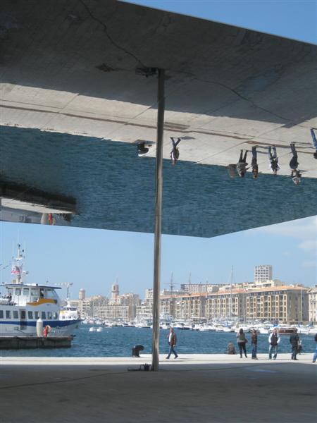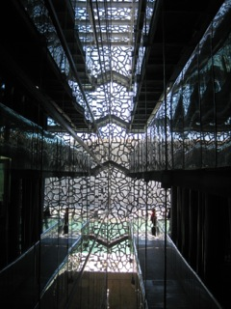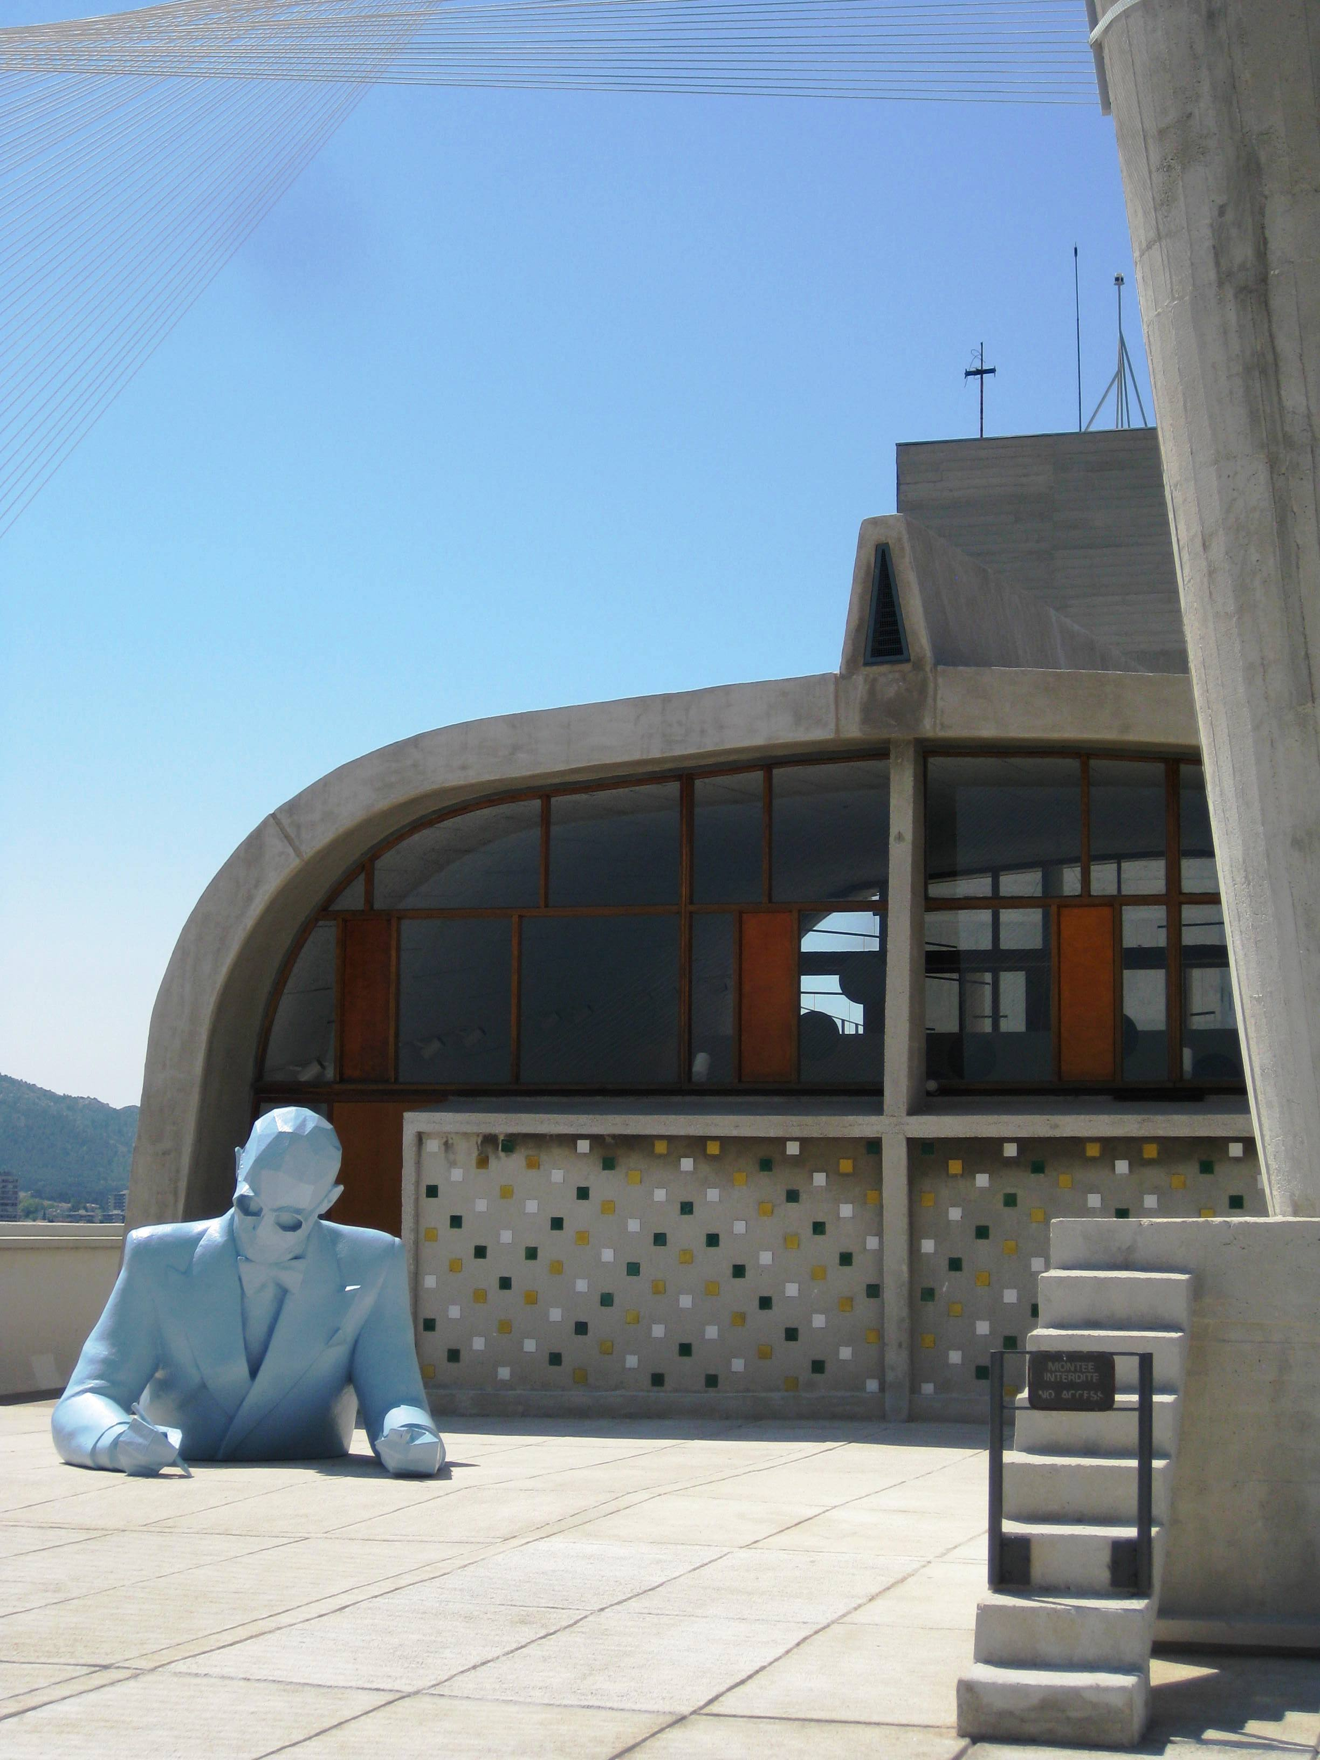
Ombrière, Vieux Port: Norman Foster, 2013 MuCEM: Rudy Ricciotti, 2013 Cité Radieuse: Le Corbusier

Since Marseille-Provence was chosen to be the European Capital of Culture in 2013, the Mediterranean harbour city has become a very attractive travel destination on the architectural map of the world. Besides new spectacular cultural buildings along the seashore, the city has already for a long time been in a comprehensive process of urban transformation due to Euroméditerranée, the large urban development project.

In regards to the recent development of Marseille linked to the European Capital of Culture, Pia Leydolt-Fuchs and Carina Kurta in 2013 founded their agency CaP.CULT, specialised in mediation for architecture, art and culture. Both Neo-Marseillaises with Austrian roots propose differentiated and profound insights into the city by means of individual circuits, personally developed and assisted cultural programmes for one or several days and meetings with local architects, urban planners and culture project managers - for architects and all those interested in architecture, students as well as delegations of the economic, political and cultural sector.

Under the influence of the large-scale cultural urban development project "European Capital of Culture" in 2013 the Vieux Port (Old Harbour) was redesigned by British architect Norman Foster and several new cultural buildings were realised: amongst others the MuCEM – Museum for European and Mediterranean Civilisations (Arch. Rudy Ricciotti), the Villa Méditerranée (Arch. Stefano Boeri) as well as the FRAC – Regional Collection of contemporary Art (Arch. Kengo Kuma), all of which are today are regarded as flagship projects of the city.

These projects stand in the line with the construction site of the urban renewal project "Euroméditerranée", which for 25 years has been in the process of transforming, under the participation of Yves Lion, large, former port and inner-city areas into new cultural, business and residential districts.

Marseille has found herself in a structural transformation process despite of or because of numerous political, economic and social difficulties. Through innovative art, cultural and urban development projects the city is attempting to change her negative image.

To show the city in her complexity, CaP.CULT highlights various facets of Marseille, explores different districts of the city, discusses problem areas, potential as well as actual development and thus provides interesting encounters, with the focus on architecture, urban planning and urban development, on history as well as on the social, sociological, political, and cultural backgrounds, approached by Pia Leydolt-Fuchs and Carina Kurta in a critical and varied way.

INDIVIDUAL INTERESTS of the VISITORS are of HIGHEST PRIORITY

Private persons & private groups
Individual programmes, adapted to the clients’ personal interest, can be booked for some hours, for one or even several days: off the beaten track, personally accompanied by CaP.CULT, with background information about the city.
During these promenades, the visitors encounter architectural and cultural projects in public space all around the city to get an impression of the dynamics of the city, modified with regard to its authentic background.

Furthermore, CaP.CULT provides a variety of practical advice for the stay and offers the planning and the organisation of the ECOC-visit all-the year.

Groups (e.g. Architecture offices and chambers, museum associations, cultural and artistic associations as well as delegations from the economic, political and cultural sector)
Groups can rely on the individual organisation of their stay – from arrival to departure, for up to several days or just for several hours as well as personal assistance during a stay (excluding the organisation of the means of transport on arrival and departure and accommodation). This offer also includes the group reservation for exhibitions and museums, special visits and current projects.

CaP.CULT is glad to organise meetings with local project managers, architects, curators, cultural protagonists or participants of cultural politics to improve the development of international networks.

Student groups
CaP.CULT organises student excursions, including cultural mediation programmes (e.g.: Exile Literature in the 1940ies in the Provence, Architecture & Design) as well as creative workshops (e.g.: drawing classes, photography, literature, graffiti etc.) in cooperation with local cultural institutions and project managers as well as meetings with local contacts from architecture, urban development and city planning can be arranged.

CaP.CULT offers all this in three languages: German, French and English.

****************************
Rates
The rates of the individual programme combinations vary according to the length of stay, group size and the density of the programme (e.g. arts and cultural activities subject to charge, excursions in the region incl. shuttle, boat trips, wine tasting etc.)

The offer does not include the organisation of the means of arrival and departure and accommodation: nevertheless, CaP.CULT is happy to help with additional information and provide recommendations.

Children under 12 years: free of charge; reductions for students.

**********************

SHORT BIOGRAPHY

Carina Kurta (*1984 in Fürstenfeld, Austria, lives in Marseille)
Studied European Studies, Art History and Museology at the École du Louvre in Paris and the University of Heidelberg. She is specialised in architecture and cultural heritage and started working for several cities chosen to be European Capital of Culture, from Linz 2008-2009 to Istanbul 2010. Living in Marseille since 2012, she started to investigate the European Capital of Culture Marseille-Provence 2013 and focused on urban development, architecture and transformation of the city. Besides, she is working regularly on international youth exchange programmes around the Mediterranean.

Pia Leydolt-Fuchs (*1979 in Vienna, Austria, lives in Marseille)
Beside her successfully completed academic studies of Economics at the Vienna University of Economics and Business, specializing in public management, Pia Leydolt-Fuchs completed a course for PR in Art, Politics, and Economy. In addition to a number of years of professional experience in different art and culture institutions, e.g. as press officer and person in charge for the entire range of the press at the Linz 2009 European Capital of Culture Programme-Organisation (2007-2010), she also has been responsible for Press, Marketing and Sponsoring of the Wiener Secession, Association of Visual Artists, as well as freelancer in the field of public relations for several architectural projects and exhibitions for several years, she studies a certified, continuing education of Culture and Media Management at the University for Music and Theatre in Hamburg, Germany.

CaP.CULT
Carina Kurta & Pia Leydolt-Fuchs
7, Square Protis
F-13002 Marseille
T: +33 (0)6 95 77 45 31 // +33 (0)6 95 77 43 89
E: info@capcult.org

Web: www.capcult.org
Facebook: https://www.facebook.com/CaP.CULT.MarseilleProvence
guiding architects: http://www.guiding-architects.net/de/architecture-tour/marseille/

