PRESS INFORMATION
(Prospect 2018)

CaP.CULT
Pia Leydolt-Fuchs & Carina Kurta

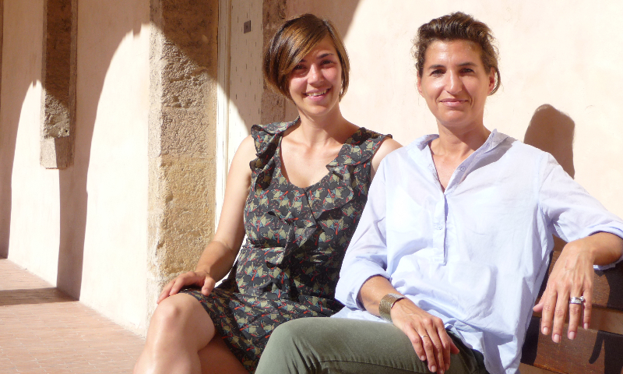

Photo: CaP.CULT, Carina Kurta & Pia Leydolt –Fuchs

CaP.CULT is celebrating its 5th birthday!

At the same time as the opening of the European Capital of Culture Marseille-Provence in 2013, Carina Kurta and Pia Leydolt-Fuchs went online - with an idea both still find convincing: to act as a (missing) link between the organisation of the "European Capital of Culture" and the visitors and to mediate the content of this European project in general as well as in particular, specially in the European Capitals of Culture!

In doing so, Kurta and Leydolt-Fuchs always follow their mission statement: Culture as a key factor in long-term urban and regional development with a European dimension.

Over the past few years, both have been able to work intensively on the respective Capitals of Culture project on the one hand and, on the other, to continuously and successfully expand their offer: In addition to city tours in European Capitals of Culture, Carina Kurta and Pia Leydolt-Fuchs organise study tours and architectural tours on a high level, take part in presentations and round tables inland and abroad, consult potential Capitals of Culture, work on European projects (Creative Europe) and give trainings for Capital of Culture-guides as part of their specially developed ECOC-tourism-workshop.

Further information about the activities you may find on our website www.capcult.org or we will send it to you by request under info@capcult.org

MEDIATION for CULTURE and EUROPEAN CAPITAL OF CULTURE in
LEEUWARDEN 2018 (Netherlands) and VALLETTA 2018 (Malta)

As well as
Aarhus 2017 (Denmark) - Pafos 2017 (Cyprus) - Wroclaw 2016 - Donostia-San Sebastián 2016 - Mons 2015 - Plsen 2015 - Riga 2014 - Marseille-Provence 2013

Mediation for architecture, culture and European Capital of Culture (ECOC) – that means discovery of various European cultural centres, accompanied and organised by experts.
Since 2013 Pia Leydolt-Fuchs and Carina Kurta, both former employees in several teams for the organisation of the European Capital of Culture (Linz09 and Istanbul 2010), have experienced this European project first-hand: They offer in-depth and exciting insights into the successful project of the European Union and the local architectural and culture scene – in the following Capitals of Culture since 2013:

Aarhus 2017 (Denmark), Pafos 2017 (Cyprus)
Wroclaw 2016 (Poland), Donostia-San Sebastian 2016 (Spain)
Plsen 2015 (Czech Republic), Mons 2015 (Belgium)
Riga 2014 (Latvia)
Marseille-Provence 2013 (France)

Acting as the (missing) link between the official ECOC-Organisation and visitors, CaP.CULT offers the discovery of the city by means of individual circuits, personally assisted cultural programmes (for one or several days – off the beaten track), workshops and meetings with local culture project managers!

The aim of Carina Kurta and Pia Leydolt-Fuchs is to help navigate through the cultural diversity of ECOCs. They both act as cultural mediators, personal assistants and partners in-situ for individual visitors and groups, school and student excursions as well as delegations of the economic, political and cultural sector.

With regards to the (urban development) ECOC project cities change: public areas get redesigned, revitalized or even newly created by means of high investments. Consequently, new museums, exhibition- and concert halls as well as theatres are opened. ECOCs are defined by a strategic process of structural and cultural changes. This is also the reason why they often become a popular and interesting tourist destination; not least because of their cultural as well as the artistic diversity which now is splendidly displayed.

The activities of ECOCs are both culturally rich and ground breaking. Our aim is to combine the cultural offer with the personal interest of visitors and to supply them with practical experience, profound knowledge and background information.

LEEUWARDEN 2018
Leeuwarden, the capital of the province of Friesland in the northwest of the country with 100,000 inhabitants, shows a different side to what we are used to from the European Capitals of Culture of the past: no spectacular new buildings, no big names in arts and culture, no lighthouses. Leeuwardens' most famous children are the spy Mata Hari and a painter of optical illusion, M.C. Escher.
Under the slogan "Iepen Mienskip" ("Open Society"), chosen confidently in the Frisian language, the entire province is the venue of the Capital of Culture. The population was and is strongly involved in the organization and artistic matters. There is a strong sense of belonging together. Important themes in the Capital of Culture year are furthermore: the public space, sustainable forms of life, "water" (close to so much sea, lakes, channels and canals), nature in general and the city palaces from the 18th century with their currently very different usage.
The city is in the middle of a process of remodeling: Old and new architecture are sometimes in vigorous confrontation. Various projects have been developed, such as the rededication of old city palaces in exhibition and project rooms, a prison became a hostel in which one sleeps in cells, a church with its movable altar, which becomes a concert location, or a former post office and an abandoned bank that get transformed into a hotel and a grand café.
Leeuwarden has not been selected as "European Capital of Culture 2018" due to a multitude of museums and theatres, but because of a thematically and sustainably oriented cultural program - thus the city could successfully prevail against the competitors Eindhoven and Maastricht.
Official homepage: https://www.friesland.nl/de/kulturhauptstad-2018; contact: info@capcult.org

VALLETTA 2018
6.000 inhabitants per square kilometre – Valletta is the smallest European Capital of Culture since ever.
But: The Capital of Culture concept of Valletta 2018 includes all Maltese islands, with the capital serving as a hub.
The focus of the Capital of Culture program is on promoting the European idea, strengthening international relationships, sustainable social, economic and cultural development in Malta, and actively involving the population. About 1,000 local and international artists and culture actors have developed the approximately 140 art and cultural projects and 400 events.

The focus in the Capital of Culture year is on combining historical and traditional with contemporary as well as highlighting the peculiarities of Malta: for example, the Maltese opera "Anna Refugjati" by the composer Mario Sammut, which addresses the refugee drama in the Mediterranean.
In addition to the cultural program, a large number of architectural and infrastructure projects have been developed and, most of them, already realised: The star architect Renzo Piano has replaced the old City Gate with two cool concrete blocks. Also the new parliament building goes back to a design by the Italian architect as well as the reconstruction of the opera destroyed in the Second World War into an open-air theatre.
Other projects for the renewal and preservation of some of Valletta's architectural treasures include the roofed market (Suq I-Antik tal-Belt) or the former abattoir, now home of the Valletta Design Cluster.
Official homepage: http://valletta2018.org; contact: info@capcult.org

MARSEILLE and the PROVENCE
Massive urbanistic changes already put Marseille forward to the public attention in 2013 when the city successfully hosted the European Capital of Culture. Marseille is a city of diversity: Busy markets, welcoming cafés, multicultural everyday life and colourful street art enrich the streetscope. Yet social disparities, poverty versus wealth and the handling of generations of immigrants are a big challenge for the city. Marseille has a unique atmosphere: Urban ambience, architectural and urbanistic progress as well as a multifaceted artistic and cultural offer – in combination with the reality of everyday life as a seaport – next to the Mediterranean Sea, only a stone's throw away from the Provence.

Regarding contemporary architecture Marseille stands out for its newly constructed cultural buildings at the seashore, the “Villa Méditerranée” by Stefano Boeri and the national museum “MuCEM” by Rudy Ricciotti. They are part of the huge urban planning process Euroméditerranée, reinterpreting the ancient industrial harbour in a new way.

Marseille after the year of European Capital of Culture …
Like no other former European Capital of Culture (ECoC) Marseille gives proof of the chance of the ECoC-year as a catalyst for development, change and news:
Under the influence of the large-scale cultural urban development project the Vieux Port (Old Harbour) was redesigned by British architect Norman Foster and several new cultural buildings were realised: amongst others the MuCEM – Museum for European and Mediterranean Civilisations (Arch. Rudy Ricciotti) and the Villa Méditerranée (Arch. Stefano Boeri).

Since the year 2013 Marseille made enormous steps forward in respect to architectural and urban development: The new skyline of Marseille will be build until 2018 – including skyscrapers by Jean Nouvel, Yves Lion, Roland Carta and Jean-Baptiste Pietri. The former industrial harbour district „La Joliette“ becomes a bright neighbourhood because of the rededication of „Les Docks“ and the opening of the square around the cathedral. Due to those projects the historical city centre and the new district have been connected. Also the area around the central train station will be restored as a new university campus.

Also in the artistic and cultural field many things happened since the ECoC-year 2013: New collaboration between different cultural institutions arose, the Friche Belle de Mai, a former tobacco factory, nowadays an art and culture centre, invested in the development of its area but also its content. Another proof of the change of citys’ image is the decision that the “Manifester 13”, the European Biennale for Contemporary Art, will take place in Marseille in 2020.

It seems that the city became a fertile ground for creative projects!
http://www.capcult.org/en/architecture-marseille-provence-120.html

ARCHITECTURE in MARSEILLE and PROVENCE //
Study trips and individual tours
for architects and people interested in architecture

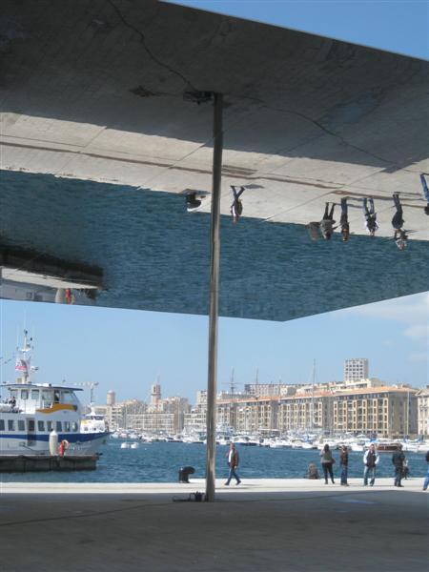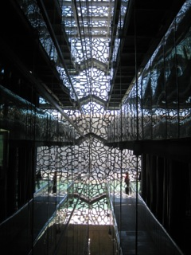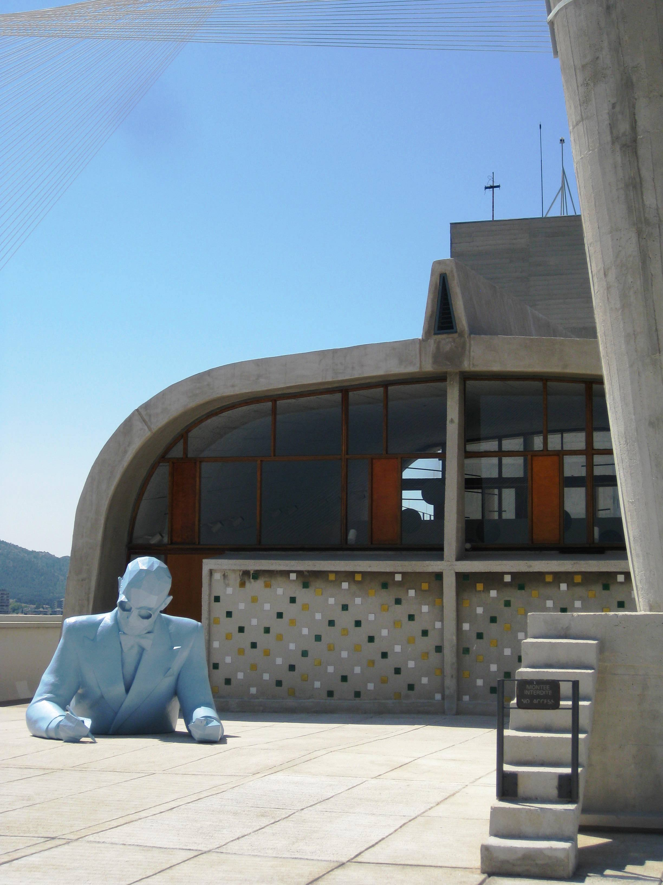
Ombrière, Vieux Port: Norman Foster, 2013 MuCEM: Rudy Ricciotti, 2013 Cité Radieuse: Le Corbusier

Since Marseille-Provence was chosen to be the European Capital of Culture in 2013, the Mediterranean harbour city has become a very attractive travel destination on the architectural map of the world. Besides new spectacular cultural buildings along the seashore, the city has already for a long time been in a comprehensive process of urban transformation due to Euroméditerranée, the large urban development project.

In regards to the recent development of Marseille linked to the European Capital of Culture, Pia Leydolt-Fuchs and Carina Kurta in 2013 founded their agency CaP.CULT, specialised in mediation for architecture, art and culture. Both Neo-Marseillaises with Austrian roots propose differentiated and profound insights into the city by means of individual circuits, personally developed and assisted cultural programmes for one or several days and meetings with local architects, urban planners and culture project managers - for architects and all those interested in architecture, students as well as delegations of the economic, political and cultural sector.

Under the influence of the large-scale cultural urban development project "European Capital of Culture" in 2013 the Vieux Port (Old Harbour) was redesigned by British architect Norman Foster and several new cultural buildings were realised: amongst others the MuCEM – Museum for European and Mediterranean Civilisations (Arch. Rudy Ricciotti), the Villa Méditerranée (Arch. Stefano Boeri) as well as the FRAC – Regional Collection of contemporary Art (Arch. Kengo Kuma), all of which are today are regarded as flagship projects of the city.

These projects stand in the line with the construction site of the urban renewal project "Euroméditerranée", which for 25 years has been in the process of transforming, under the participation of Yves Lion, large, former port and inner-city areas into new cultural, business and residential districts.

Marseille has found herself in a structural transformation process despite of or because of numerous political, economic and social difficulties. Through innovative art, cultural and urban development projects the city is attempting to change her negative image.

To show the city in her complexity, CaP.CULT highlights various facets of Marseille, explores different districts of the city, discusses problem areas, potential as well as actual development and thus provides interesting encounters, with the focus on architecture, urban planning and urban development, on history as well as on the social, sociological, political, and cultural backgrounds, approached by Pia Leydolt-Fuchs and Carina Kurta in a critical and varied way.

INDIVIDUAL INTERESTS of the VISITORS are of HIGHEST PRIORITY

Private persons & private groups
Individual programmes, adapted to the clients’ personal interest, can be booked for some hours, for one or even several days: off the beaten track, personally accompanied by CaP.CULT, with background information about the city.
During these promenades, the visitors encounter architectural and cultural projects in public space all around the city to get an impression of the dynamics of the city, modified with regard to its authentic background.

Furthermore, CaP.CULT provides a variety of practical advice for the stay and offers the planning and the organisation of the ECOC-visit all-the year.

Groups (e.g. Architecture offices and chambers, museum associations, cultural and artistic associations, bidding cities for ECOC as well as delegations from the economic, political and cultural sector)
Groups can rely on the individual organisation of their stay – from arrival to departure, for up to several days or just for several hours as well as personal assistance during a stay (excluding the organisation of the means of transport on arrival and departure and accommodation). This offer also includes the group reservation for exhibitions and museums, special visits and current projects.

CaP.CULT is glad to organise meetings with local project managers, architects, curators, cultural protagonists or participants of cultural politics to improve the development of international networks.

Student groups
CaP.CULT organises student excursions, including cultural mediation programmes (e.g.: Exile Literature in the 1940ies in the Provence, Architecture & Design) as well as creative workshops (e.g.: drawing classes, photography, literature, graffiti etc.) in cooperation with local cultural institutions and project managers as well as meetings with local contacts from architecture, urban development and city planning can be arranged.

CaP.CULT offers all this in three languages: German, French and English.

****************************
Rates
The rates of the individual programme combinations vary according to the length of stay, group size and the density of the programme (e.g. arts and cultural activities subject to charge, excursions in the region incl. shuttle, boat trips, wine tasting etc.)

The offer does not include the organisation of the means of arrival and departure and accommodation: nevertheless, CaP.CULT is happy to help with additional information and provide recommendations.

Children under 12 years: free of charge; reductions for students.

**********************

SHORT BIOGRAPHY

Carina Kurta (*1984 in Fürstenfeld, Austria, lives in Marseille)
Studied European Studies, Art History and Museology at the University of Passau, the École du Louvre in Paris and the University of Heidelberg. With a focus on architecture, cultural heritage and European Capital of Culture, she worked in the organization of the Cultural Capital Linz 2009 and Istanbul 2010.
Since 2012 in Marseille, Carina Kurta has specialized extensively on the European Capital of Culture Marseille-Provence 2013 and since then works on cultural urban development, architecture and urban planning. Since 2015 she has been part of the international organization team for the mediation of the work of the Austrian artist Ceija Stojka. In this context, she co-ordinated an exhibition project in the Friche la Belle de Mai / Marseille 2017 and the maison rouge /Paris 2018, with which she is actually working on compiling the artist's catalog raisonné.

Pia Leydolt-Fuchs (*1979 in Vienna, Austria, lives in Marseille)
Beside her successfully completed academic studies of Economics at the Vienna University of Economics and Business, specializing in public management, Pia Leydolt-Fuchs completed a course for PR in Art, Politics, and Economy. In addition to a number of years of professional experience in different art and culture institutions, e.g. as press officer and person in charge for the entire range of the press at the Linz 2009 European Capital of Culture Programme-Organisation (2007-2010), she also has been responsible for Press, Marketing and Sponsoring of the Wiener Secession, Association of Visual Artists, as well as freelancer in the field of public relations for several architectural projects and exhibitions for several years, she studies a certified, continuing education of Culture and Media Management at the University for Music and Theatre in Hamburg, Germany. Since 2017 Pia Leydolt-Fuchs is member of the EU-expert panel for the European Heritage Label (EHL) and consultant of the German bidding city for ECOC "Kassel 2025".

CaP.CULT
Carina Kurta & Pia Leydolt-Fuchs
7, Square Protis
F-13002 Marseille
T: +33 (0)6 95 77 45 31 // +33 (0)6 95 77 43 89
E: info@capcult.org

Web: www.capcult.org
Facebook: https://www.facebook.com/CaP.CULT.MarseilleProvence
https://www.facebook.com/CaP.CULT.architecturetoursmarseille/

