
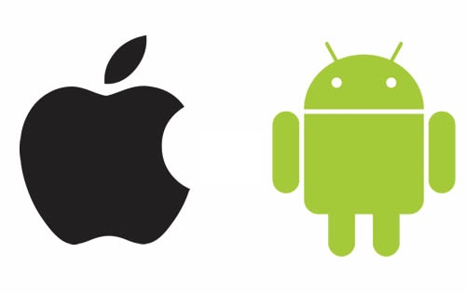
COMPLETE APPS
IN 5-15 DAYS FOR

$_____________

Monthly Maintenance Fee

YOU GET:

- Progressive Web App
- Unlimited Push Notes
- Unlimited Features
- Back Office Access & Training
- Analytics & Statistics
- Quarterly Feature Updates
- Phone & Email Support
- Promotion Materials
- Mobile App Hosting
- Annual App Redesign

$_____________

One Time Set-Up & Design Fee

=
$_____________

Down

+
$_____________

Upon Completion

We accept:

