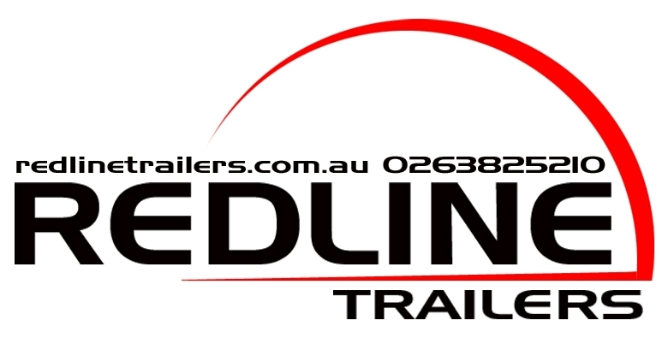

Operators Manual
Flat Top Tipping Trailer
600 Models

94 Old Temora Rd, Young
Phone 02 63825210 Fax 02 63824727
Email: sales@redlinetrailers.com.au

Thank you for purchasing a Redline Trailer.

We Take Pride in our product.

To ensure safe and trouble-free towing, please read this manual and become familiar with the operation and maintenance of your trailer before setting out.

Your trailer is fitted with a VIN plate containing relevant information regarding maximum loads and tyre requirements. Please familiarise yourself with the information in this manual before operating, maintaining or adjusting the trailer.

Safety

You are responsible for the safe operation and maintenance of your Redline tipping trailer. You must insure that you and anyone else, who is going to operate, maintain or work around the trailer be familiar with the operating and maintenance procedures and related safety information contained in this manual. This manual will take you step by step through using your tipping trailer and alerts you to good safety practises that should be adhered to while working with your Redline tipping trailer.

Remember you are the key to safety. Good safety practises not only protect you but also the people around you. Make these practises a working part of your safety program. Be certain that everyone operating this equipment is familiar with the recommended operating and maintenance procedures and follows all the safety precautions. Most accidents can be prevented. Do not risk injury or death by ignoring good safety practises.

- Redline trailer owners must give operating instructions to operators or employees before allowing them to operate the trailer.
- The most important safety device is a safe operator. It’s the operator’s responsibility to read and understand all safety and operating instructions in the manual and to follow these. All accidents can be avoided.
- A person who has not read and understood all operating and safety instructions is not qualified to operate machinery. An untrained operator exposes himself and others to serious injury or death.
- Do not modify the equipment in any way. Unauthorized modification may impair the function and/or safety and could affect the life of the equipment.
- Think safety! Work safety!

General safety

- Read and understand the Operator’s Manual and all safety signs before operating, maintaining or adjusting the tipper trailer.

- Only trained competent persons shall operate the tipper trailer. An untrained person is not qualified to operate the machine.

- Have a first aid kit available for use should the need arise and know how to use it.

- Place all controls in neutral, wait for all moving parts to stop before servicing, adjusting or repairing.

- Review safety related items annually.

Warning
Ensure Electric Brake Control Unit conforming to statutory requirements is fitted to tow vehicle before attaching to and towing this trailer

Warning
While installing safety strut never position yourself or others under the body, should tray unexpectedly drop serious injury or death may result. Position yourself to the side

Warning
Never move trailer while safety strut is supporting tray, as structural damage, serious injury or death may result

Warning
Never position yourself or others under a raised body. Serious injury or death may result

Warning
Do not attempt to operate this tipping trailer without first receiving full instruction and reading the operator’s manual

Caution
Raised height 4.20m

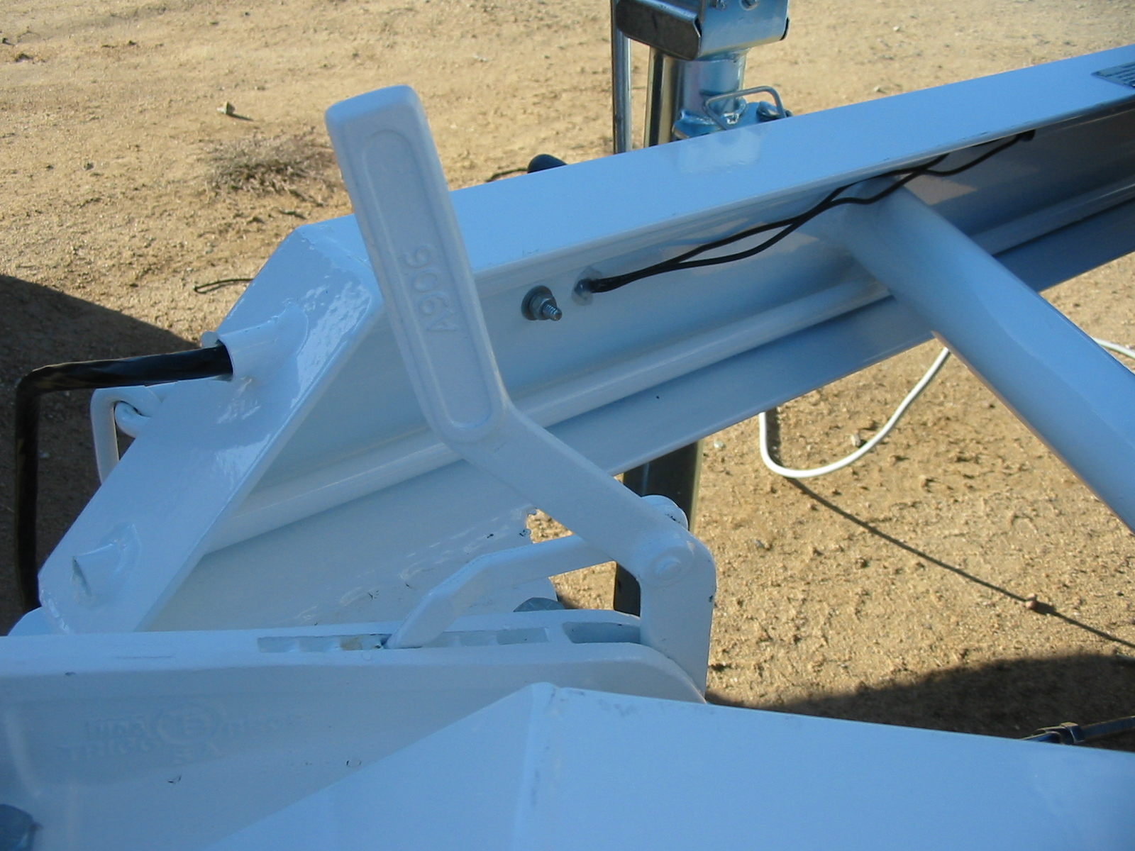
Figure 1
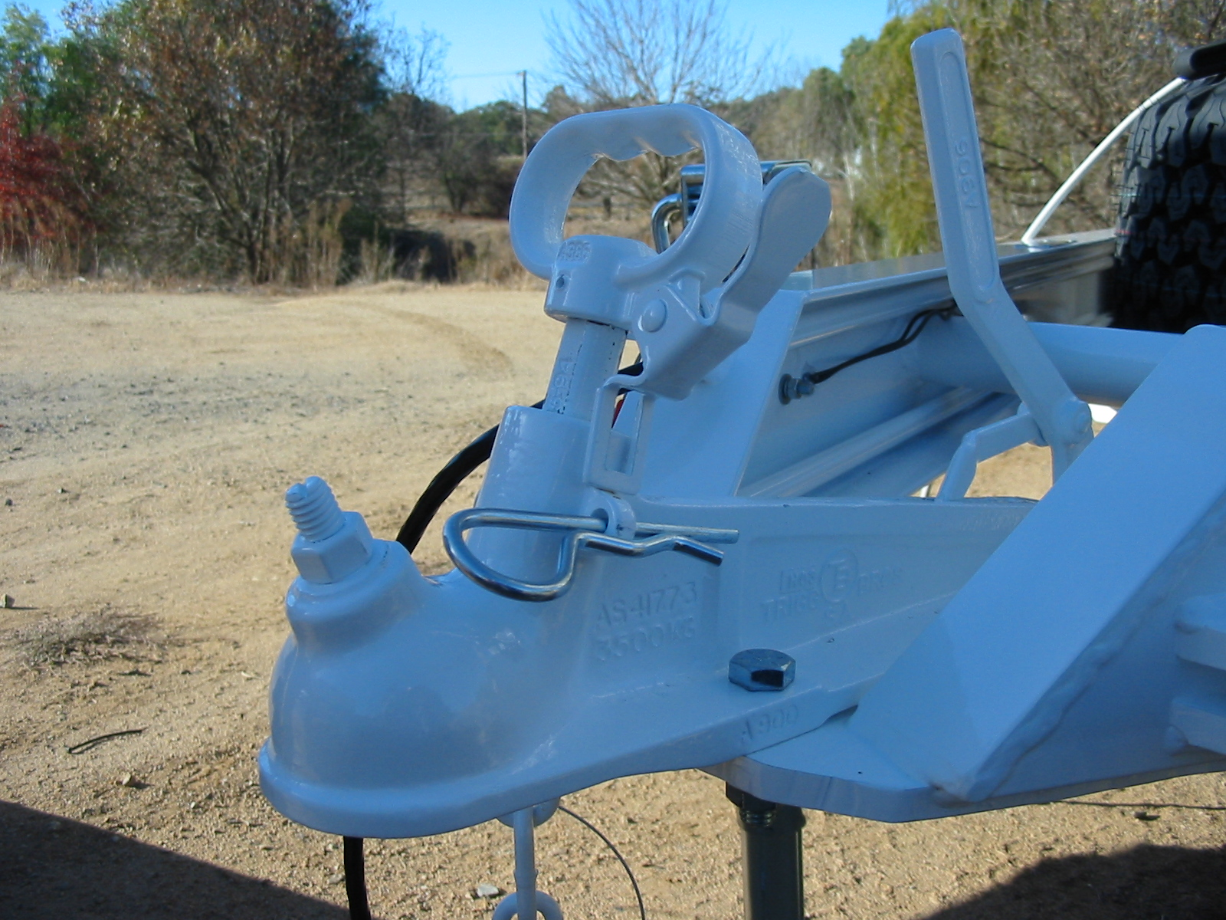
Figure 2
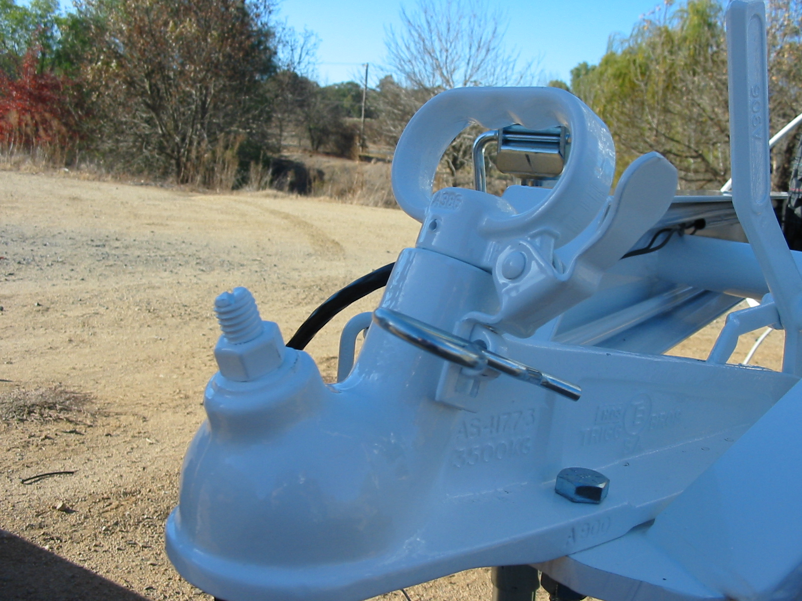
Figure 3
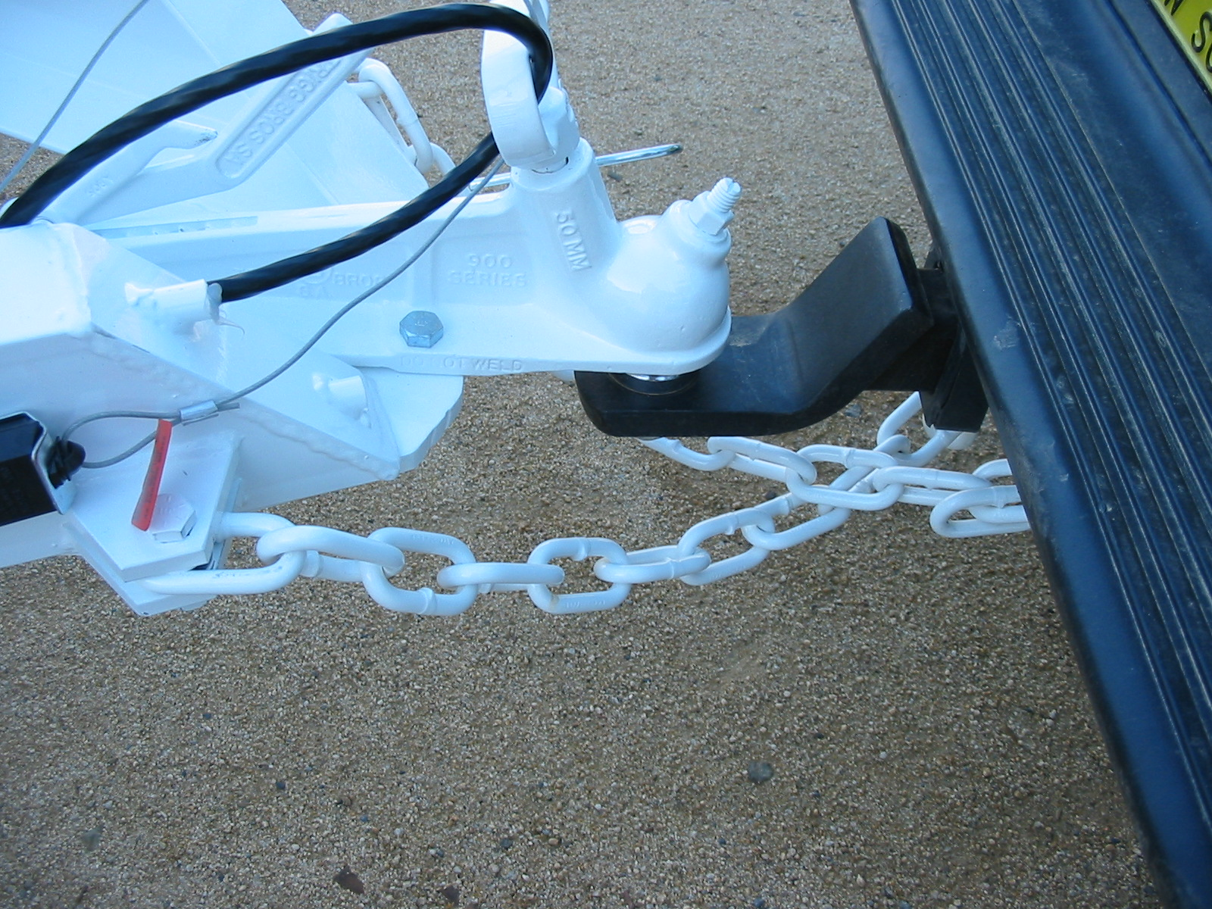
Figure 4

Attaching your trailer
(50mm tow ball)

- Ensure the trailer parking brake is engaged. (Figure 1)

- Check that the coupling lock is raised in the release position. (Figure 2)

- Reverse vehicle positioning the 50mm tow ball directly underneath the trailer coupling.

- Lower coupling engulfing the tow ball.

- Lower coupling lock fully and install R pin (optional padlock) into coupling lock. (Figure 3)

- Secure safety chain/s. If two safety chains are in use it’s recommended that they cross underneath the tow ball. (Figure 4)

- Shorten chain/s to allow the trailer hitch to be held above the road surface should the trailer become uncoupled.

- DO NOT shorten the chain to the extent that it comes under any strain load while turning the trailer to the extremities. Allowances must be made for approach and departing angles.

- Any damaged or worn D shackles should not be used and replaced immediately.

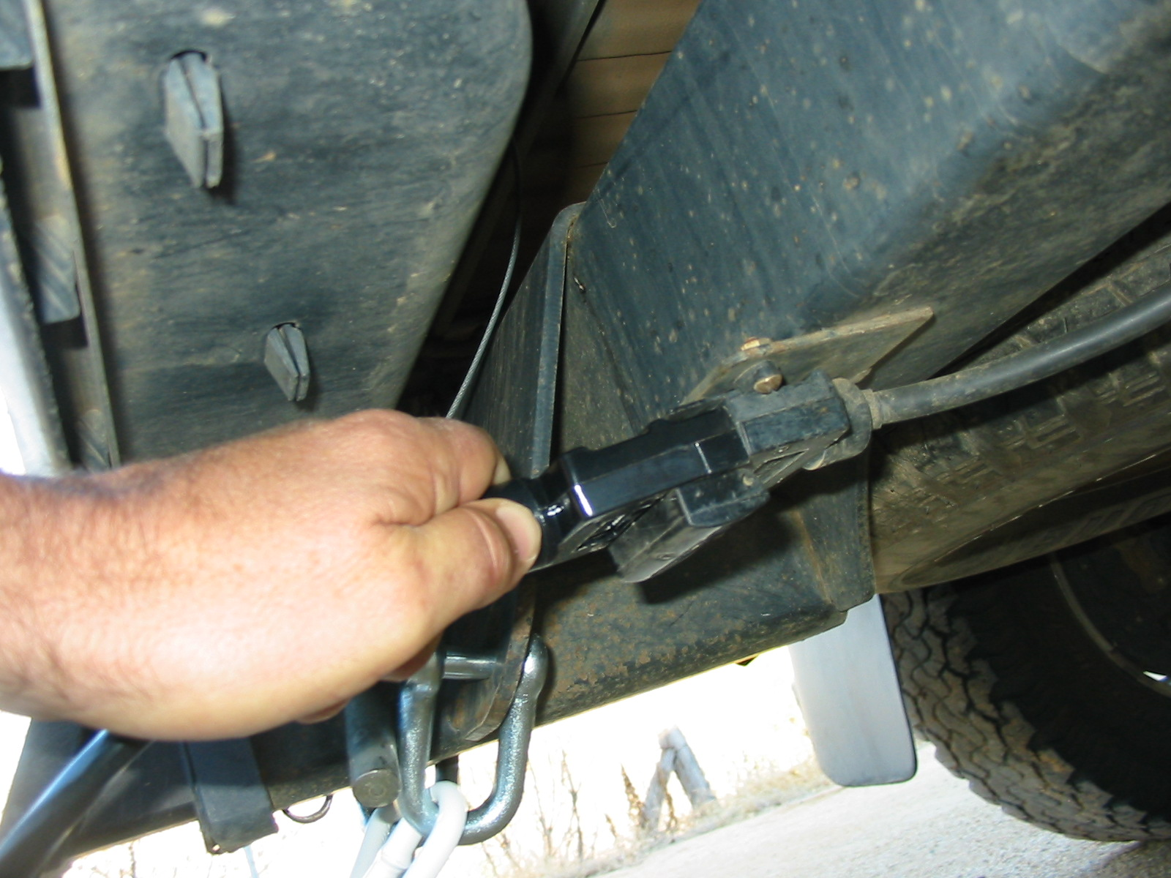
Figure 5
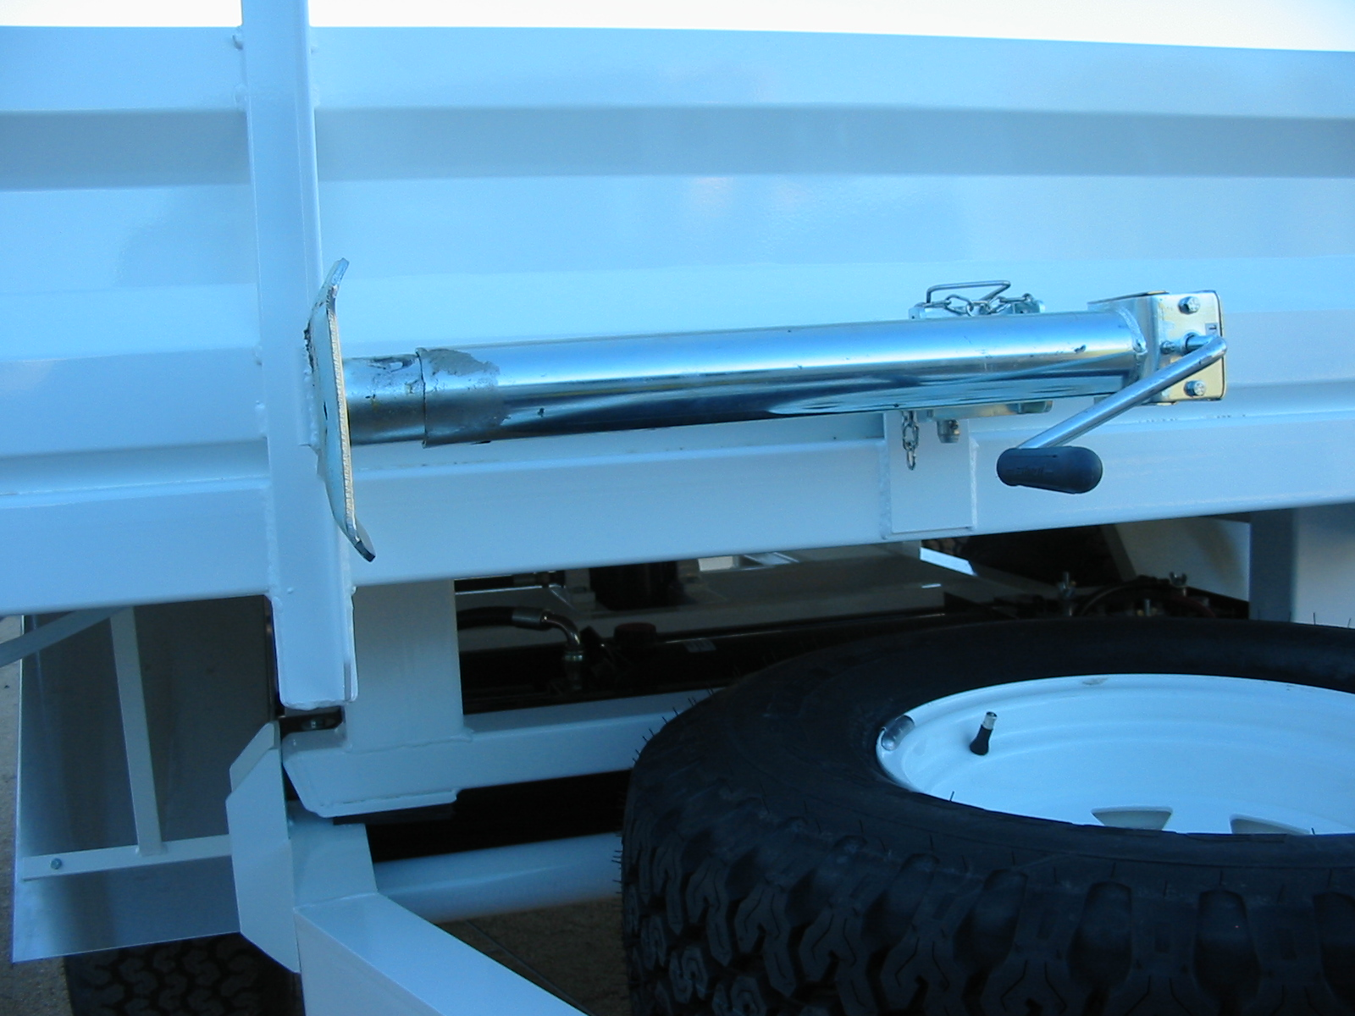
Figure 6
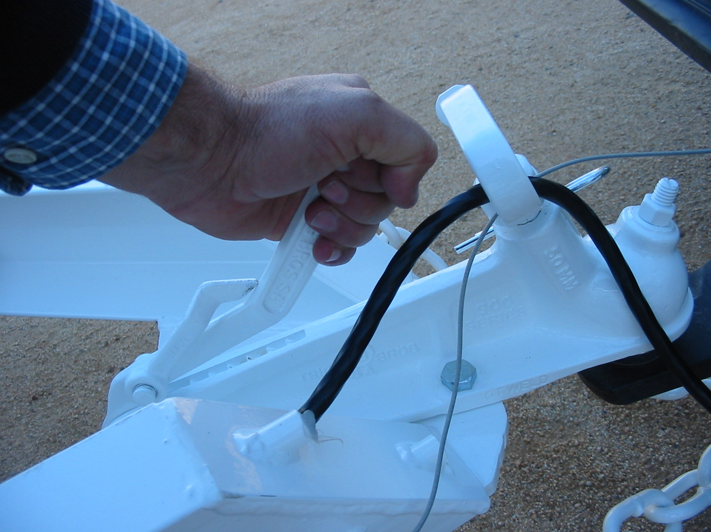
Figure 7
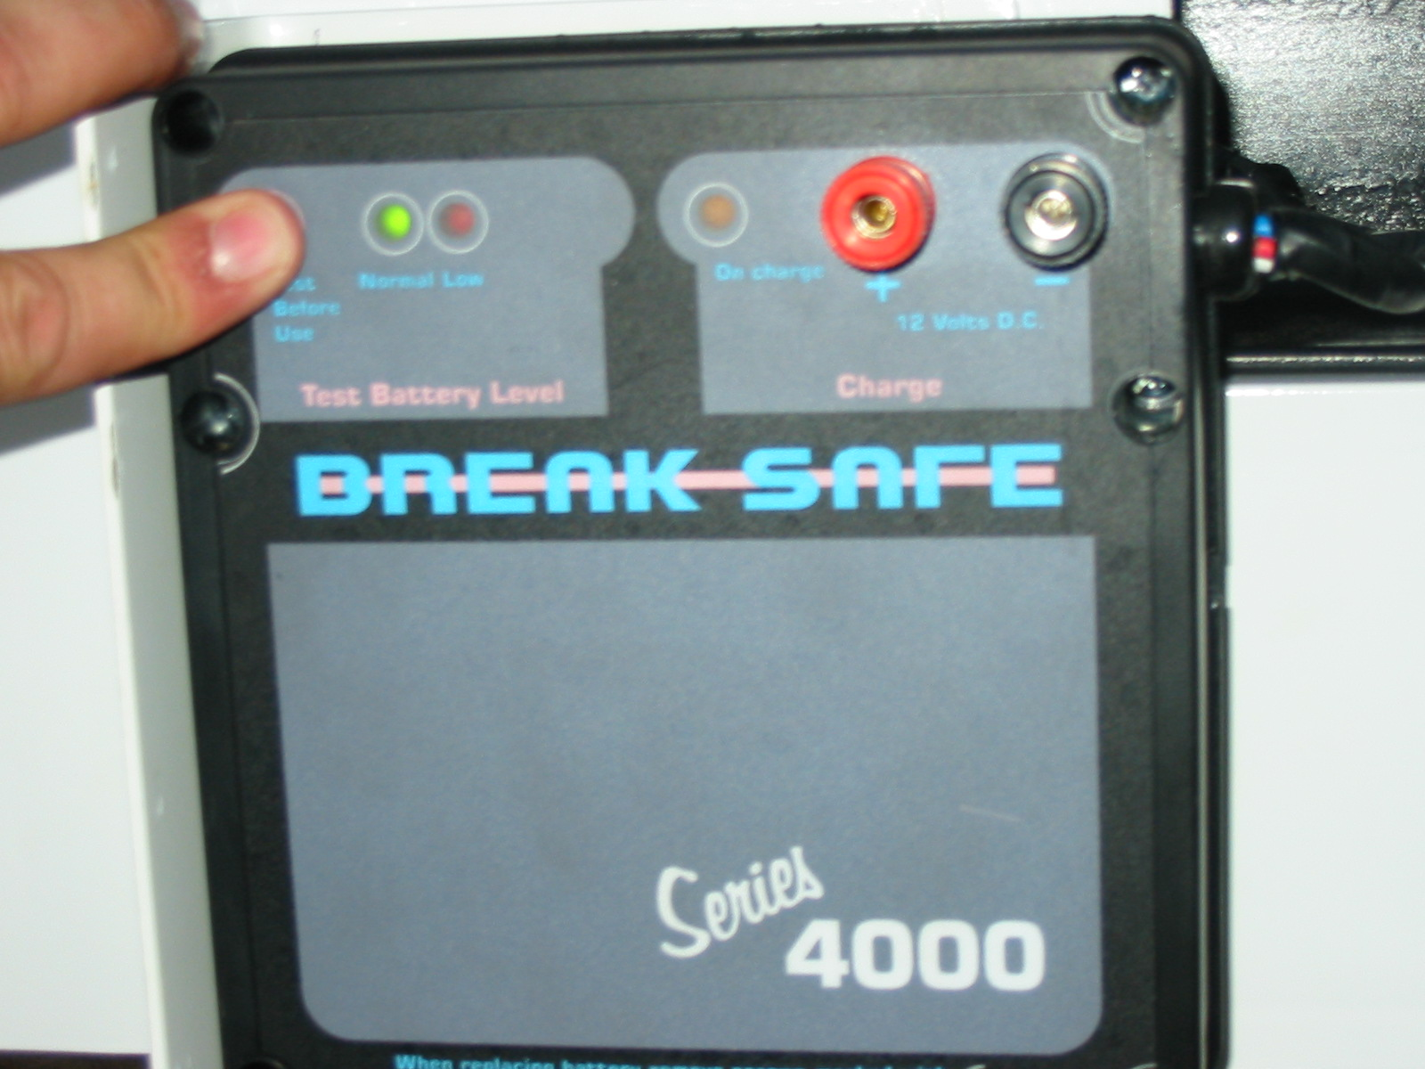
Figure 8
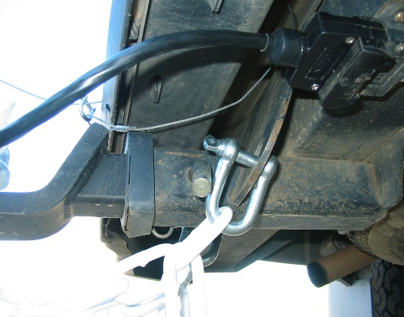
Figure 9

- Connect trailer electrical connector. Secure connector by locking the cover of the towing vehicle connector over the trailer plug. Check secure attachment by applying light force on lead. (Figure 5)

- Check function of all lights and brake activation.

- Install parking jack in its transport position. (Figure 6)

- Release park brake. (Figure 7)

Note:
All trailers over 2000kg ATM and those under 2000kg fitted with a brakesafe unit.

- Check the condition of the brakesafe battery and circuit by pushing the “test” button on the unit. (Figure 8)

- Green light LED indicates safe operating conditions.

- If red LED light is displayed charge battery in brakesafe and re-test.

- Connect brakesafe wire cable to tow vehicle, preferably not to the towbar, but to a separate part of the chassis. (Figure 9)

- VIB06 NSW/ACT special requirements avove VSB1 National code requires that the break away monitor and brake unit both charge from the tow vehicle. 1 of 2 options are fitted to your trailer.
- 2 Pin weather pack connector & std 7 pin plug
- 12 pin trailer plug

Checks during a trip

Soon after starting each day’s travelling with the trailer, stop and check:

- The coupling and safety chains, to make sure they are properly fastened

- The tyres, to make sure they are still inflated correctly and are not rubbing the mudguards, suspension, trailer body, etc.

- Make one or two test stops from low speed to confirm that the trailer brakes operate properly
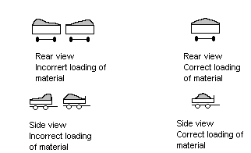

Loading your trailer

Your Redline tipping trailer is designed to transport and tip off free flowing solid products such as soil, sand and gravel. The standard floor is of 3mm construction and is not designed to withstand the impact of course materials or those with a density greater then 1.8. Likewise, while the powder coated surface has superior adhesion and abrasion resistance it should not be exposed to corrosive substances. The payload capacity of your trailer is approximately the ATM weight minus the tare weight. The volumetric capacity at water level for a 3.6mx1.8m trailer is 2.0m3.

- Always centre load laterally and longitudinally within the tipping body. This allows a desired 5% increased loading of the tow vehicle. Do not exceed D = 250kg load on 50mm ball coupling.

- Avoid loading products of different densities or moisture contents that could arise in different flow characteristics in the same load.

- Cover the load.

Safe Tipping

- Never attempt to tip trailer without it being connected to a suitable towing vehicle.
- Select a level, firm surface to tip.
- Check for powerlines or overhead structures that may restrict a tip height.
- NEVER tip under powerlines; this may result in serious injury.
- Do not tip across a slope. If it is absolutely necessary to tip on a slope, face the trailer combination up the slope.

Back view of incorrect
position on slope
- Check hydraulic circuit for signs of damage. If damage is evident instigate repairs immediately, DO NOT proceed with tipping.

- Apply the vehicle parking brake and trailer parking brake.

- Remove any transport covering.
Correct tipping
Positioning

- Remove the rear tailgate

- Attach tip control unit

- Stand clear of trailer; use the 3m radius of the control cable as a guide to locate a safe point to observe the tip. (Figure 10)
Incorrect tipping position

- Never position yourself or others under a raised body. Serious injury or death could result from the body dropping unexpectedly.

- Commence tip.

- While a smooth flow of product may not be achieved with all material types, it is highly desired, if material discharges from only one side of your trailer do not continue raising body, lower body to rest and manually remove product to complete.
Correct position when
Tipping on a slope

- After safe discharge lower body completely, re-install tailgate, remove and stow control unit and release park brake.

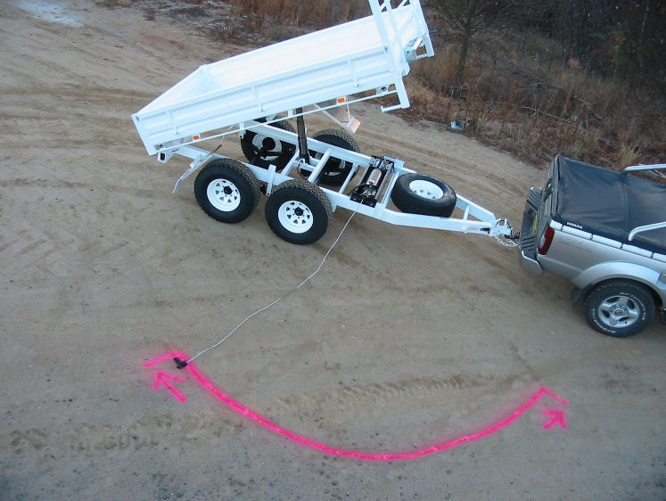

Top view of safe standing tip zone
Hitch
3m
Figure 10

Maintenance of your trailer

Weekly
- Lubricate all suspension points, more often in wet or dirty conditions.
- Check tyre pressure. Adjust to specifications on tyre pressure/load for your tyres and load kg.
- Tyre Pressure/ Load 195/50R13
- Axle Load kg Recommended Pressure
- 1000kgs (80 psi) 550kpa
- 1500kgs (85 psi) 600kpa
- 1700kgs (90 psi) 650kpa
Monthly
- Adjust anti rattle Bolt on ball. Contact ball only, do not apply downward pressure onto ball.
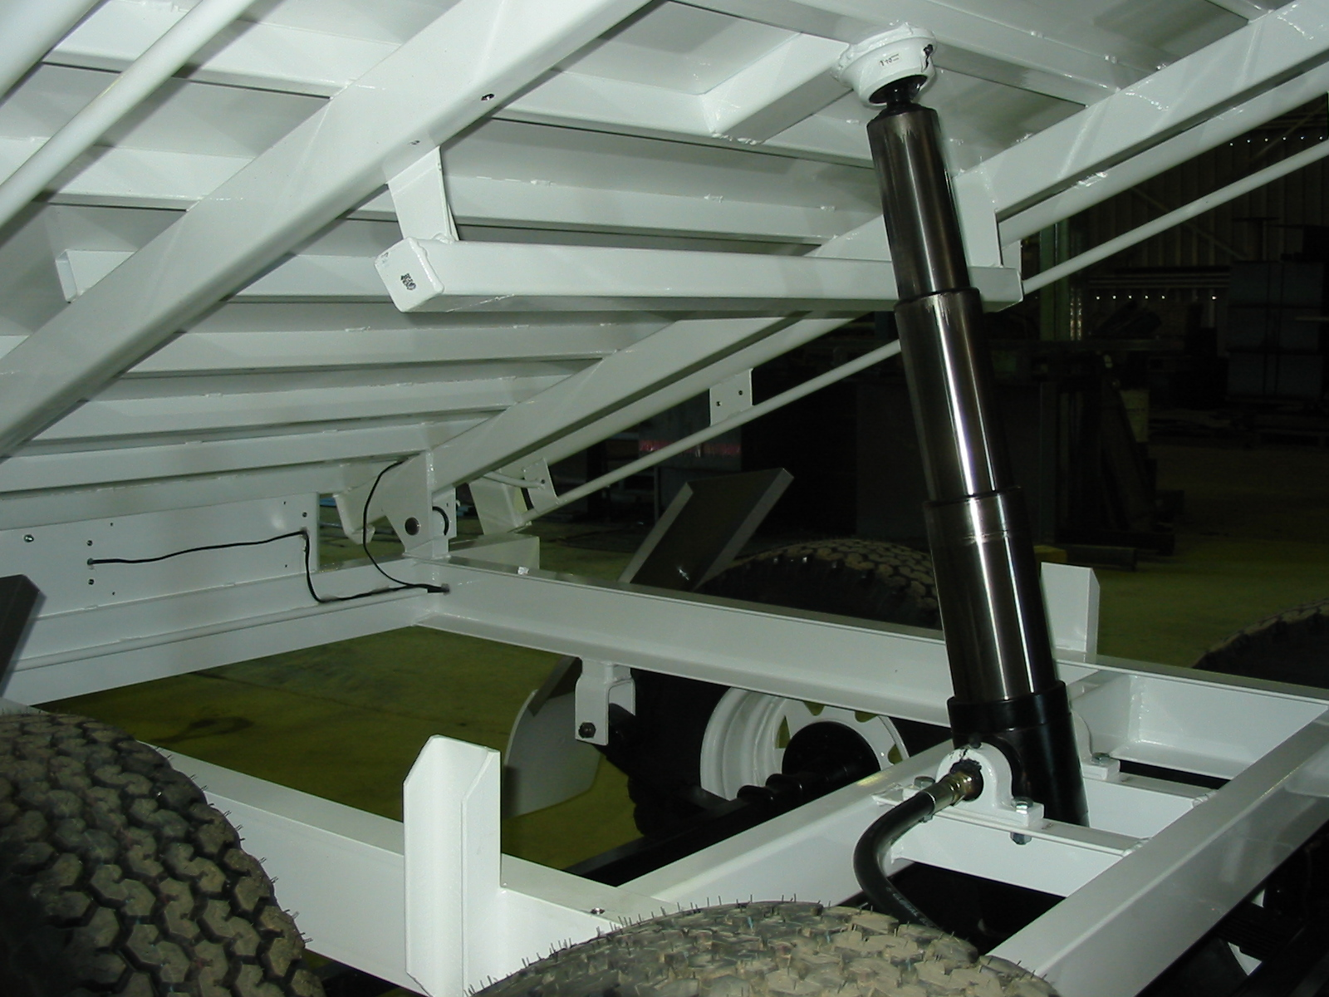
Figure 1a
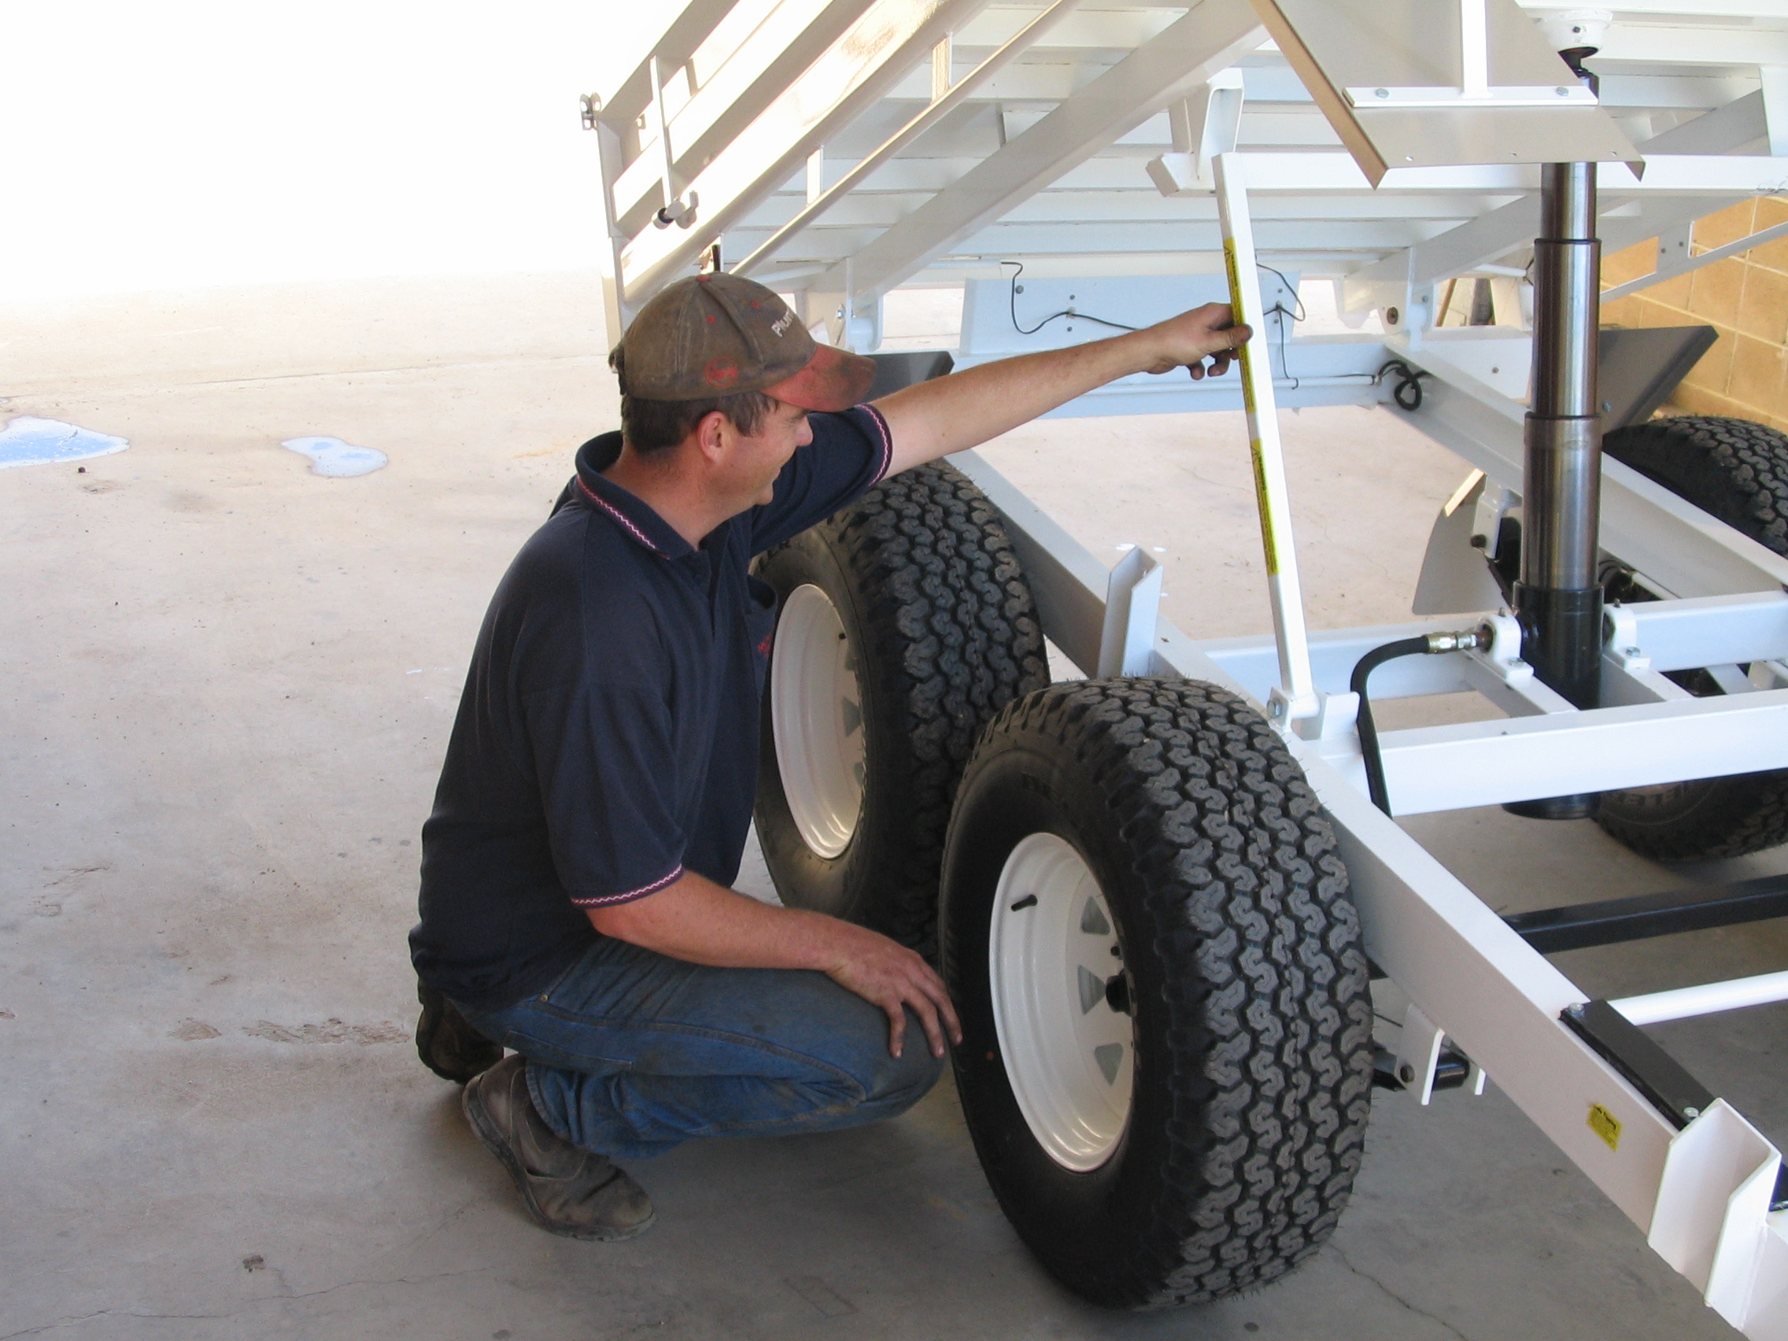
Figure 2a

- Adjust wheel bearings.
- Adjust brakes then adjust parking brake.
- Check condition of hydraulic circuit.
- Check Axle U bolt torque. Torque to 141 ft/lbs.
- Lubricate hinge pins, ram rocker bushes, and ram rod ball.
- After 20 tips or monthly (whichever occurs first) charge battery. Use a 6 amps or greater charger, making sure not to overcharge.

The next steps in maintenance necessitate that the safety strut to be installed.

Safe installation of the safety strut

A) Raise unladen trailer bed to the third ram stage. (Figure 1a)

WARNING- While installing the safety strut never position yourself under the body should tray unexpectedly drop serious injury or death could result. Position yourself to the side. (Figure 2a)

B) Lift Pivot Strut. (See figure 2a)
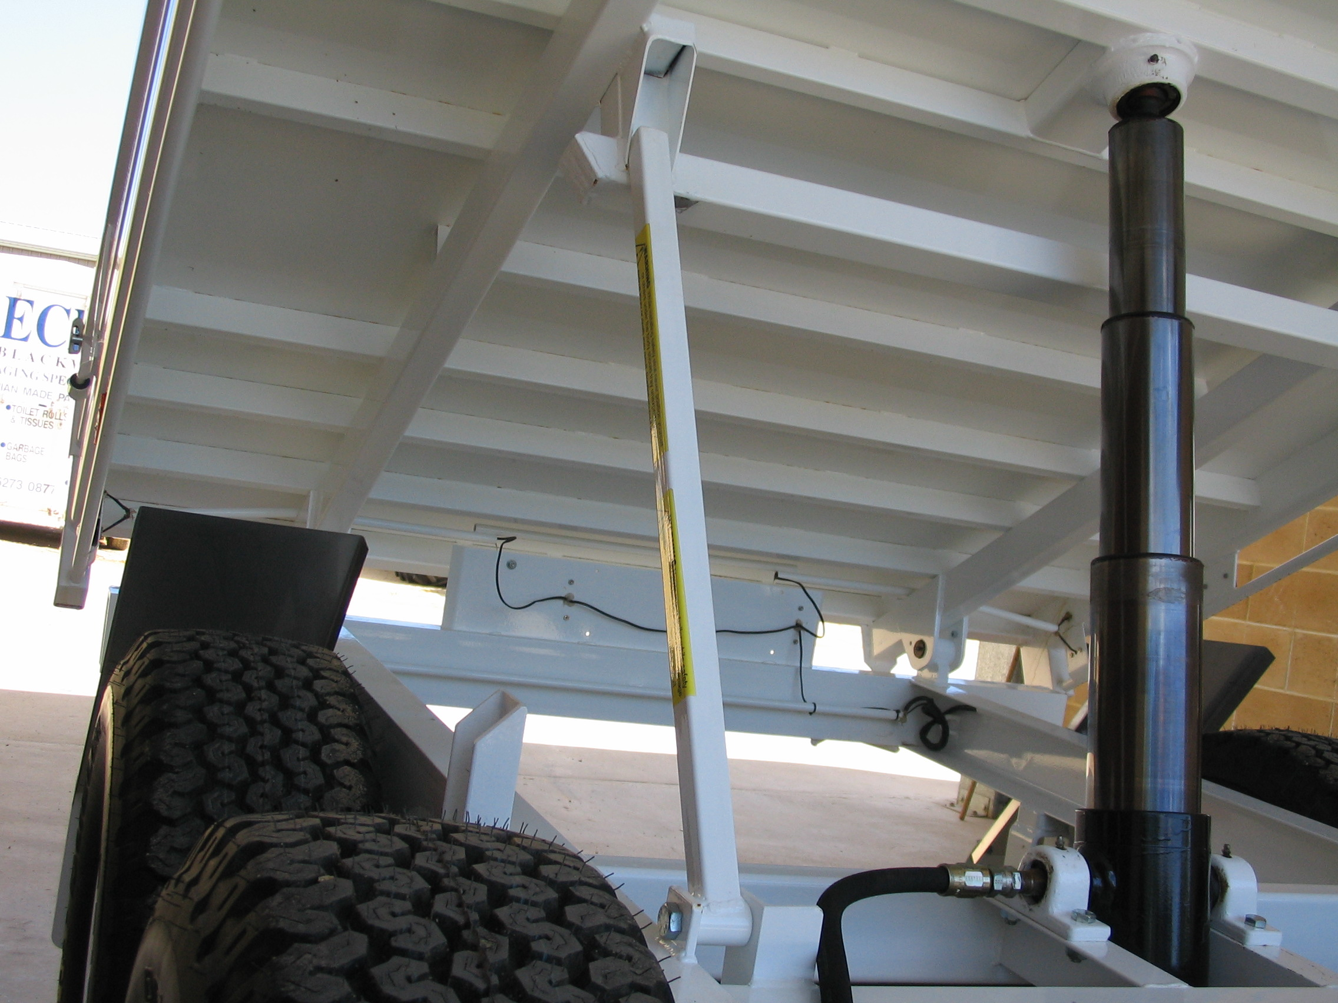
Figure 3a
Figure 4a

C) Locate in retainer socket ( See Figure 3a)

D) Lower hydraulic ram and observe that the strut is located correctly as the weight of the tray is taken by the strut. (Figure 4a)

WARNING- Never move trailer while the tray is being supported by the strut, as structural damage and collapse of the tray may result. Warrantee does not cover such damage.

- Check Battery electrolyte level.
- Check hydraulic level with clean dipstick. At the third ram stage the level should be between half and 2/3 of a full tank.

Half yearly
- Check and repack wheel bearings.
- Check brake shoe conditions. Brake shoes should be replaced if brake linings below 4 mm.
- Check condition of suspension components.
- Check general tightness of all bolts and hardware, battery terminals for corrosion and condition of warning signs and placards. Replace any missing or defective items.

Servicing your tipper unit

Repair/Removal of inoperative unit

1. Should your tipper require service Redline recommends removal of the tipper body (preferred).

Another option is using a suitable approved lifting device. After the removal of the circlip holding ram ball in place and raising the tip body in a conventional manor, prop the body using the safety strut before working on the tipper unit.

2. Removal of the tipper power pack is achieved by removing the 4 -3/8” bolts.

3. Removal of the ram is achieved by removing the 4-1/2” ram trunnion bolts. It is not necessary to break the hydraulic circuit if both units are removed together. If required to break hydraulic circuit, first check for pressure in the circuit by installing the control switch and engage downward only, place container under ram break seal at ram end of hose and allow excess oil to be gathered in container.

4. Plug hose and ram to prevent loss of fluid or contamination.

There are no owner serviceable parts in ram or power pack. Contact a qualified auto electrician or hydraulics expert for service, or return to Redline Trailers for servicing.

Specifications- Redline trailer 900 Series (12x6 Nominal)

Length Overall 4620 mm
Width Overall 1975 mm
Height 1720 mm
Height Tipper up 3400 mm
Tare Weight- Refer to manufacturers VIN plate
(Tare weight includes sideboards but excludes additions).

Spare wheel 45kgs (nominal)

Tipper power pack 55kgs (nominal)

Maximum permissible D load (downward load on drawbar) 250kg for 50mm tow ball.

Maximum permissible D load (downward load on drawbar) 400kg for Pintle Eye Assembly.

ATM (All up Trailer Mass) - Refer to manufacturers VIN plate

Tyre Pressures Tyre Pressure/ Load 195/50R13
Axle Load kg Recommended Pressure
1000kgs (80 psi) 550kpa
1500kgs (85 psi) 600kpa
1700kgs (90 psi) 650kpa

Hydraulic oil grade HD 46 12 Litres

Spare Parts
When ordering spare parts Quote VIN number and model of trailer and manufacture date.

Towing Vehicle
Vehicles must be suitable for the type of trailer to be towed. Vehicle manufacturers usually indicate in owner’s manuals the maximum weight and other features of trailers they consider to be appropriate for the safe operation, performance and durability of their vehicles. These limits should not be exceeded.

Vehicles must be properly equipped for the trailer to be towed.

- Towbars and couplings must be of suitable type and capacity
- Electrical sockets for lighting and brakes are needed
- Suitable brake controller must be fitted
- Extra mirrors may be needed when towing large trailers
- For vehicles with automatic transmission, an extra transmission oil cooler may be advisable
- 50mm 3.5 tonne tow ball machined from steel for trailers up to 3.5 tonne

Your vehicles performance
All trailers reduce the performance of the towing vehicle. They increase fuel consumption and decrease acceleration, braking ability, general control and manoeuvrability.
These effects worsen as trailer size and weight increase relative to that of the towing vehicle.

Warrantee

Redline will repair or replace, at its opinion, without charge for parts or labour to the retail purchaser, any defective part of the equipment for a period of twelve months delivery to the first retail customer.

Exceptions to the warrantee
- In no event shall the owner be entitled to recover for incidental, special or consequential damages such as, but not limited to, loss of load, loss of profit or revenue, other commercial losses, inconvenience or cost of rental of replacement equipment.
- Repair, Maintenance, and service items not related to defects:
- Loss or damage during shipment
- Failure resulting from or improper maintenance.
- Damage caused by operator abuse, negligence, or improper operation.
- Non- defective items replaced due to customers demand unless authorised by the Redline Trailers Service Department.
- Non reimbursable maintenance items including but not limited to oil.
- Any and all costs for repairs or replacement of parts not shown to be defective.
- Damage due to accidents.
- Original Equipment Batteries are warranted for full replacement for the first three months and on a prorated replacement cost basis for the next three months.
- Tyres are warranted directly by the tyre manufacturer’s agents only, and not by REDLINE TRAILERS.
  - Paint / Coating warrantee is void if the damage has been caused by corrosive substance, heat or abrasion.
  - Replacement Parts will be warranted for three months or for the balance of the warrantee, which ever is greater, providing the bill of sale is attached to the warrantee claim.
  - The terms of this warrantee are subject to Commonwealth and state legislation. REDLINE TRAILERS reserves the right to make changes in accordance with these Acts ay any time without notification or obligation. The stated warrantee contained in the REDLINE TRAILERS Warrantee Policy applies in all situations, unless the law provides a greater warrantee in the jurisdiction of the retail customer.
  - REDLINE TRAILERS reserves the right to continually improve its equipment, and reserves the right to change products or specifications at any time without notice or obligation.

Owner’s Warranty Obligation
Warranty commences on the date of purchase.

Date of purchase ___________________________________

Trailer type ___________________________________

VIN number of trailer ___________________________________

Purchaser’s name and address ___________________________________

___________________________________

___________________________________

Dealer’s name ___________________________________

Dealer’s agent ___________________________________

It is the responsibility of the owner, at the owner’s expense, to transport the equipment to the service shop of an authorised REDLINE TRAILERS dealer (place of purchase) or alternately to reimburse the dealer for any travel or transportation costs involved in fulfilling this warranty.
It is the responsibility of the owner to read, understand and practise the maintenance, safety, and operational guidelines set out in the operator’s manual furnished with the equipment.
It is the owner’s responsibility to ensure that the Pre-delivery Inspection Sheet, which must be signed by the owner, is completed and returned to REDLINE TRAILERS by the dealer. The completed and signed Pre-delivery Inspection Sheet is required to register a new unit for warranty.

