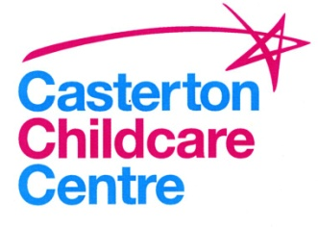

Exclusion procedure for illness/communicable Diseases

Disease/Illness Minimal exclusion period
Temperature Until temp is normal for 24 hours and/or until child is well within themselves.
Conjunctivitis Return to Nursery when eyes are no longer gluey.
Vomiting 48 hours after last episode and until child is well within themselves.
Diarrhoea 48 hours after last episode and until child is well within themselves.
Gastro-enteritis, food poisoning, Until authorised by GP.
salmonellosis and dysentery
Impetigo Until skin is healed, unless area can be covered or if taking antibiotics
Head Lice Until appropriate treatment is given and no live lice are apparent, whole family must be checked.
Ring worm of scalp or body Seldom necessary to exclude, providing treatment is given.
Thread worm Seldom necessary to exclude, providing treatment is given to child and family.
Scabies Need not exclude once appropriate treatment is given.
Slap Cheek Until the child appears well.
Chicken pox Spots must be dry and scabbed
Measles 4 days from appearance of rash.
Meningococcal infection Until recovered from the illness.
Mumps Until swelling has subsided and in no case less than 5 days from onset of illness.
Rubella (German Measles) 4 days from appearance of the rash.
Scarlet Fever 24 hours after antibiotic treatment is given.
Hand, Foot and Mouth 3-5 days or until the blisters have dried.
Whooping Cough 5 days after commencing anti-biotics.
Croup 3 days from diagnosis and until well.

