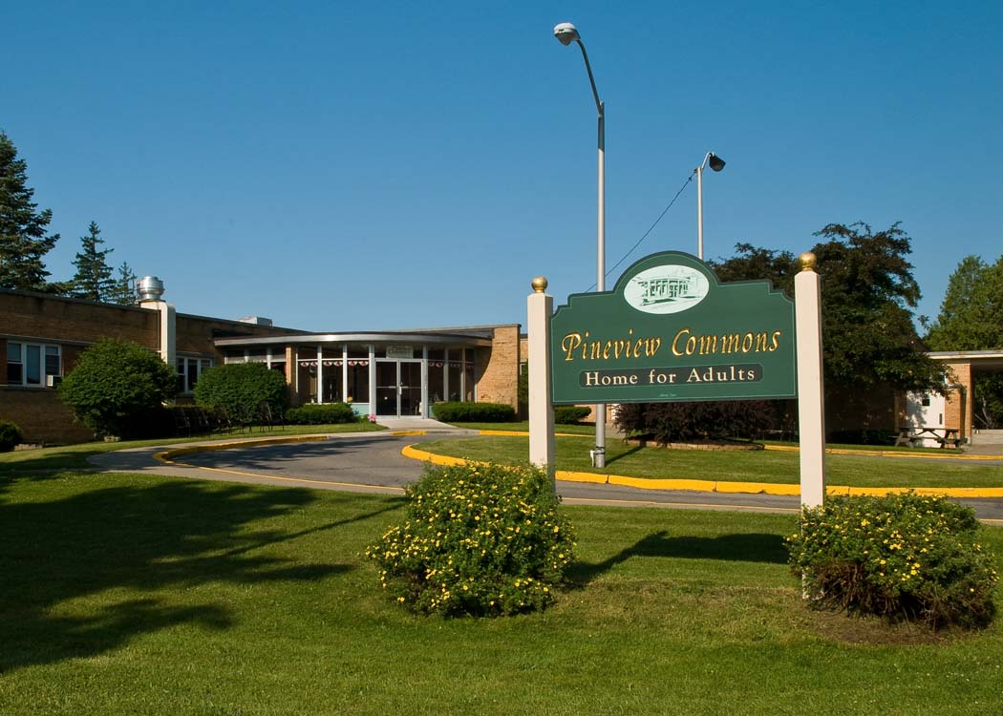

Dear Applicant;

Enclosed is the admission application that you requested for our facility. Please complete and return the first section of the application in order to be placed on our waiting list. Returning the application does not obligate the applicant in any way to become a resident of our facility. It will be kept on file and in the event that the type of room that you have requested becomes available a member of our administrative staff will contact you. Again, at this time you are not obligated to accept the room being offered. If you do not wish to proceed at that time and decline the bed offer but wish to remain on our waiting list for the future availability we will contact you the next time a similar room becomes available.

In order for the application to be reviewed and/or approved, it must be completed in its entirety. If something on the application does not apply to you, please write “N/A” in the space. Please do not leave any blank spaces. The application cannot be processed if any space is left blank.

The second section of the application must be filled out by the applicant’s primary care physician (or the attending MD if in a hospital or skilled nursing facility). Please do not complete any part of the medical section. Once a decision has been made to proceed with the admission process the primary MD or physician currently following the potential resident must complete all parts of this section after a full examination of the potential resident. The MD exam, completion of paperwork and admission to facility must all occur within 30 days of each other. If it is completed more than 30 days prior to admission, it will have to be completed again so appointments for completion of paperwork should be made in coordination with our facility. Our policy is that all residents are tested for Tuberculosis (PPD test) within 30 days prior to admission. Paperwork is included for primary MD use.

Please submit a copy of all insurance cards and advance directives with the application to the business office.

For questions or to schedule a tour of our home; please feel free to contact our facility at (518) 762-5488 Monday-Friday 9am-4pm. The following is a directory of our Administrative staff:

Kara Vollmer – RN, Administrator – Extension 101 or kvollmer1@hotmail.com
Amy Ouellette – Financial Manager – Extension 106 or pineviewcommonsalf@gmail.com
Bernadine Buseck- Administrative Assistant- Extension 110 or bernadinebuseck@yahoo.com

We look forward to meeting you.

Sincerely,

Kara Vollmer, RN
Administrator/Operator

PINEVIEW COMMONS HOME FOR ADULTS

PRE-ADMISSION QUESTIONNAIRE

Name: _________________________________________

Please complete

Do you wear glasses ? Yes ____ No ____ Only for Reading ____

Do you have dentures? Yes ____ No ____

Partials ____ Full ____ Upper Plate Only ____ Lower Plate Only ____

Do you wearing hearing aids? Yes____ No ____

Both Ears ____ Left Ear Only ____ Right Ear Only ____

Do you use a device to assist you with walking? Yes ____ No ____

Walker ____ Cane ____ A wheelchair for long distances? Yes ____ No ____

Comments: ____________________________________________________________

________________________________________________________________________

________________________________________________________________________

IMPORTANT

Please make sure all clothing is marked upon admission.

Please submit a copy of all insurance cards with this application.

Please submit a copy of all advance directives with this application.

APPLICATION FOR ADMISSION TO
PINEVIEW COMMONS ASSISTED LIVING

I, __________________________________, do hereby make application for admission to Pineview Commons LLC, located at 201 South Melcher Street, Johnstown, New York 12095.

PLEASE FILL IN ALL INFORMATION - (PLEASE PRINT)

PERSONAL INFORMATION

Home Address: _________________________________________________________

Present Address: __________________________________________________________

Social Security Number: ________________________ Phone Number: ______________

Place of Birth: ________________ _____________ ________________ _____________
City State Country County

Date of Birth: _________________________ Present Age: ________________________

My occupation has been: ___________________________________________________

I am a member of the ______________________________________________ church.

Religion: _____________________________ Pastor/Rabbi: _______________________

My Hobbies and Interests are: _______________________________________________

My Marital Status is: (PLEASE CIRCLE ONE) Single Married Widowed Divorced

FINANCIAL INFORMATION

I understand the basic private pay rates for all services offered in the admission agreement are: (ALL RATES BELOW ARE MONTHLY RATES)

$2,400.00 for a semi-private room.
$2,700.00 for a private room.
$3,100.00, $3,300.00, $3,500.00, $4,500.00 – large private/suite
$5,500.00, $6,000.00 for a suite (TWO PERSON OCCUPANCY).
$8,000.00 (DOUBLE ROOM SUITE - TWO PERSON OCCUPANCY).

I expect to be able to pay this private rate for ________ years. (Please Estimate).

I am the owner of the following property:

1. Real Estate: (Describe and List Value) ______________________________________

2. Car: (Describe and List Value) ____________________________________________

3. Stocks/Bonds: (Describe and List Value) ____________________________________

If I should exhaust my private funds and apply for assistance, (S.S.I.), I understand the S.S.I assistance rate paid to the Adult Home is a Room and Board rate and is below the Home’s private rate. I further understand the Home will not accept this S.S.I. rate without a third party contributor supplementing the Home up to the Home’s private rate.

THIRD PARTY CONTRIBUTOR’S INFORMATION

Name: _________________________________ Phone Number: ___________________

Address: ___________________________________ Relation to Applicant: __________

I will have my relative (s) or representative take care of my financial affairs while I am at Pineview Commons LLC.

REPRESENTATIVE’S/EMERGENCY CONTACT INFORMATION

Name: ____________________________________ Relation to Applicant: ___________

Address: ________________________________________________________________

Email Address: ___________________________ Cell Phone: __________________

Home Phone: ______________________________ Work Phone: __________________

***ADDITIONAL FAMILY CONTACTS - IF REPRESENTATIVE ABOVE CANNOT BE REACHED.

________________________________________________________________________
Name Address Phone Relation to Applicant

________________________________________________________________________
Name Address Phone Relation to Applicant

________________________________________________________________________
Name Address Phone Relation to Applicant

MEDICAL INFORMATION

Resident’s Primary Physician: _______________________________________________

Address: ________________________________________ Phone: _________________

Hospital of Choice: _______________________________________________________

Social Security #: ___________________________ Medicare #: ___________________

Medicaid #: __________________ County of Medicaid: _______________________

Other Health Insurance: ____________________________________________________

Policy #: __________________________________ Group #: ______________________

Other Physicians:

Physician: _______________________________ Type of Physician: ________________

Address: ____________________________________________ Phone: _____________

Physician: _______________________________ Type of Physician: ________________

Address: ____________________________________________ Phone: _____________

PERSONAL ASSISTANCE INFORMATION

I understand this is an ADULT CARE FACILITY providing room and board with laundry and housekeeping services. There will be adequate staff to assist me with personal care services such as: personal hygiene, medication management, and functions of daily living. A recreation and social program will be provided. There will be personal care staff available to me on a 24-hour basis.

Options for transportation to medical appointments
1. Family will take and/or make arrangements
2. Pineview Commons to arrange/provide transportation.

We need to know how you would like us to handle doctor appointment transportation. Pineview Commons can provide this transportation at an additional cost unless Medicaid is in effect.

___Pineview Commons ___Family Transportation

I will be needing assistance with personal care services as listed below:

1. ______________________________________________________________________

2. ______________________________________________________________________

3. ______________________________________________________________________

4. ______________________________________________________________________

If I am admitted to the Home, I request that my personal mail be given to me and that my business mail be handled by ___me, or ___my representative. (Please check one)

Date of Application: _______________________________________________________
Applicant’s Signature: _____________________________________________________

RESIDENT’S REPRESENTATIVE INFORMATION

I understand if the resident should require a higher level of care due to physical or mental impairment, it will be my responsibility to make arrangements for the proper placement and transfer.

This will be done by me, after proper evaluation, assistance, and notice by the Home.

Resident Representative Signature: ___________________________________________

Date: ___________________________________________________________________

HOW DID YOU HEAR ABOUT PINEVIEW COMMONS? _____________________________
__________________________________________________________________________________________________________________________________________________________________________________________________________________________________________

***AFTER COMPLETING PLEASE REVIEW ENTIRE APPLICATION TO BE SURE IT IS COMPLETED IN FULL***
RESOURCES - BANK ACCOUNTS, CD’S

Name of Bank and Address: ________________________________________________
________________________________________________________________________

Savings: $____________________________ Checking: $_______________________

Who has authority to deposit and withdraw from these accounts--:

Name: _________________________________________________________________

Relationship to Applicant: _________________________________________________

Address: _______________________________________________________________

Phone Number: __________________________________________________________

REAL ESTATE

Do you own any real estate: _____ If so, appraised value: ______________________

Do you have any assets held by other parties? _____ If so, please describe: __________

________________________________________________________________________

Power of Attorney: _______________________________________________________

Applicant Signature: __________________________________________________

Date: ____________________________________

PINEVIEW COMMONS HOME FOR ADULTS - ALP

ADVANCE DIRECTIVE INFORMATION

**This form to be completed with the Application for Admission.

Name:__________________________________________________________________

BURIAL ARRANGEMENTS

Funeral Home: __________________________________________________________

Address: _______________________________________________________________

Contact Person: ________________________________ Phone #: _______________

ADVANCE DIRECTIVES
(health care proxy, DNR, living will, etc.)

Please list what directives have been obtained.

1. ______________________________________________________________________

2. ______________________________________________________________________

3. ______________________________________________________________________

4. ______________________________________________________________________

POWER OF ATTORNEY

Name: ________________________________________ Phone #:________________

Address: _______________________________________________________________

**The facility must have copies of all documents listed above**

THE FOLLOWING IS THE MEDICAL PAPERWORK

This paperwork goes with the applicant to the doctor’s appointment. To be completed by physician and submitted to Pineview Commons for review before admission can proceed.
Do not use this document – form no longer in use
Check all that apply: _X_ AH __EHP __ALP __Initial __RUG Category Change __12 Month

DSS-4449-C1 (rev. 4/97)
 |  | Name:
This form may be used to verify that an individual's health/safety needs can appropriately be met in an adult home, enriched housing program or residence for adults. It may also be used to verify that an applicant/resident of an Assisted Living Program (ALP) is medically eligible to reside in a nursing facility but does not require continual nursing or skilled care and the individual's needs can be met in an ALP.

Facility Name:

Pineview Commons LLC
Address:
201 South Melcher Street
Johnstown, NY 12095
 |  | Sex Date of Birth  M( ) F( ) / / | Weight B/P

Primary Diagnosis:

Secondary Diagnosis:

Significant medical history and current conditions:  do not use this form – old document | Continence: Bladder: __Yes Bowel: __Yes | __No  __No
Diet:
Regular, CAT
NAS, CAT
Consistent Carbohydrate, CAT
Needs assistance with self-administration of meds? _X_Yes __ No | Allergies:
List ail current medications (prescription and OTC), including dosage, type, frequency, and method of administration, and note any special instructions:(attach additional sheet if necessary).
MEDICATION | DOSAGE | TYPE | FREQUENCY | METHOD
DO NOT USE THIS FORM – OLD DOCUMENT

Revised 3/99

DSS-4449-C2 (Rev. 4/97)
MEDICAL EVALUATION (page 2)
Name:__________________________________
Is the Individual:
Free of communicable disease? __Yes __ No If no describe: ______________________________________________________
_________________________________________________________________________________________________________________
Able to transfer without Assistance? __Yes __No If no, describe: _____________________________________________________
_________________________________________________________________________________________________________________
Ambulatory without assistance? __Yes __No If no, describe: ________________________________________________________
________________________________________________________________________________________________________________
Describe Activity Restrictions/Assistance Needed with ADLs (e.g., eating, transferring, toileting):
DO NOT USE THIS FORM – OLD DOCUMENT_______________
Does the individual have a history, current condition or recent or current hospitalization for mental disability?
__Yes __No If yes describe:________________________________________________________________________________
Is a Mental Health Evaluation recommended? __Yes __No
Date of Today's Examination: ________________Recommended Frequency of Medical Exams: As ordered by MD__________________
I certify that I have accurately described the individual's medical condition, needs, and regimens, including any medication regimens, and that the individual is medically appropriate to be cared in an Adult Home enriched housing program or an ALP

Signature: _________________________________________________ Date: _______________
Nurse Practitioner, Physician's or Specialist Assistant
Signature: _________________________________________________ Date: _______________
Physician (required)
Revised 3/99

ATTACHMENT TO MEDICAL EVALUATION

STANDING/PRN ORDERS - OVER THE COUNTER MEDICATIONS

Resident: __________________________________________

Acetaminophen 325 mg
- 2 tablets po every 4-6 hours as needed (not to exceed more than 12 tablets in 24 hours)
May be used for relief of Headache, Minor aches and pains, Minor Arthritis Pain,
For the reduction of Fever

Maalox (or generic equivalent)
- 10-20 ml po up to 4 times daily (not to exceed 80 ml in a 24 hour period)
May be used for the relief of: Upset Stomach/Indigestion

Milk of Magnesia (or generic equivalent)
- 5-15 ml po with water up to 4 times daily - Not to exceed more than 60 ml in 24 hours)
May be used as a Laxative to relieve constipation

Imodium AD tablets (or generic equivalent)
- 2 tablets po after the first loose stool; 1 caplet after each subsequent loose stool
- Not to exceed more than 4 tablets in 24 hours

Imodium AD Liquid (or generic equivalent)
- 20 ml po after the first loose stool; 10 ml after each subsequent loose stool
- Not to exceed 40 ml in 24 hours

Robitussin DM (or generic equivalent) Regular ______ Sugar Free_____ (check one)
- 10 ml po every four hours - Not to exceed 60 ml in 24 hours
To be used to relieve cough and to help loosen secretions

Cough Drops Regular ______ Sugar Free _____ (check one)
- 1 drop dissolved in mouth for minor cough - Repeat every 2 hours as needed

*Physician Signature verifies order and that resident is capable of requesting any of the above.

Physician’s Signature:__________________________________Date:_____________________

Pineview Commons Home for Adults

Record of TB Screening

***Must be completed in full***

Per New York State Department of Health Regulations, (NYS DOH), all residents must be screened for TB before being admitted into the Adult Home. One or Two Step Tuberculin Skin Tests, (TST) are acceptable to the NYS DOH. Please note that NYS DOH does prefer the Two Step TST. However: The decision to use the One or Two Step TST is up to each individual physician.

Resident: _______________________________ Physician: _________________________

Date PPD Given: _______ Manufacturer: _________________ Lot # ________ Site:_______

Given by: ____________________________________________________________________

Date Read: ______________ Read by: __________________________________________

Results of Test: Negative _____ Positive _____ Induration (mm): _____________________

IF POSITIVE: Date of CXR: ____________________________ Results: ______________

***If date of first TST is negative do you want a second TST? Yes _____ No _____

*****Physician Signature: __________________________________ Date: _____________

**** If applicable - Submit copy of written CXR report.
------------------------------------------------------------------------------------------------------------------
Date of 2nd TST – IF APPLICABLE

Given: ________ Manufacturer: ___________________ Lot # __________ Site: ________

Date Read: _______________ Read by: __________________________________________

Results of Test: Negative _____ Positive _____ Induration (mm): _______________________

Physician Signature: ____________________________________ Date: _____________

Pineview Commons Home for Adults

Record of Vaccinations/Influenza/Tetanus/Pneumonia

***Must be completed in full***

Resident: _______________________________________________________________

Physician (please print): ___________________________________________________

Has your patient received:

1. A tetanus shot - in the past five years? Yes____ No____

If yes: Date: ____________________________

2. Pneumonia Vaccination: Yes____ No____

If yes: Date: ____________________________

***If no, do you want facility to arrange for administration of vaccine Yes ____ No ____

3. Influenza Vaccination: Yes____ No____

If yes: Date: ____________________________

***If no, do you want facility to arrange for administration of vaccine Yes ____ No ____

MD Comments: ________________________________________________________________

______________________________________________________________________________

Physician’s Signature: _________________________________ Date: ____________
Pineview Commons Home for Adults
201 South Melcher Street
Johnstown, NY 12095
762-5488
Fax# 762-5583

PRIMARY MD AUTHORIZATION FOR PODIATRY CARE

Resident: _______________________________________

Primary Physician: ________________________________

Date: _______________

Dr. Lam, DPM comes to the facility on a scheduled basis to provide podiatry care for the residents.

Please verify below with signature that your patient may see Dr. Lam for an initial consult, every 2-3 months, and PRN for one of the reasons listed below.

PLEASE CHECK ONE OR MORE OF THESE

_______DIABETES MELLITIS
_______PVD
_______NEUROPATHY
_______FUNGAL NAILS
_______INGROWN NAILS
_______THICK MYCOTIC NAILS

Physician’s Signature: _________________________________ Date: ________________

PINEVIEW COMMONS HOME FOR ADULTS
201 SOUTH MELCHER STREET
JOHNSTOWN, NEW YORK 12095
518-762-5488
FAX 762-5583

Resident: ___________________________________

Physician: __________________________________

Date: ___________________

PLEASE CHECK ONE OF THE FOLLOWING AND VERIFY WITH YOUR SIGNATURE BELOW THAT YOU WISH TO BE NOTIFIED ON A

DAILY BASIS___________

WEEKLY BASIS___________

MONTHLY BASIS___________

NOT AT ALL___________

OF ANY MEDICATION REFUSALS BY THE ABOVE MENTIONED RESIDENT

WHO RESIDES AT PINEVIEW COMMONS.

MD COMMENTS: ______________________________________________________

________________________________________________________________________

________________________________________________________________________

***IF MONTHLY NOTIFICATION IS REQUESTED IT WILL BE SENT TO YOU AT THE BEGINNING OF THE FOLLOWING MONTH.

Physician's Signature: ________________________________ Date: ____________

MENTAL HEALTH EVALUATION

NAME: ___________________________________________________

FACILITY: PINEVIEW COMMONS HOME FOR ADULTS

SIGNIFICANT MENTAL HEALTH HISTORY AND CURRENT CONDITION:

____________________________________________________________________________________________________________________________________
____________________________________________________________________________________________________________________________________
______________________________________________________________________________________________________________________________________________________________________________________________________
____________________________________________________________________________________________________________________________________

Date discharged to: PINEVIEW COMMONS HOME FOR ADULTS from:

_____________________________________________________________________________________
(Name of Facility/Hospital)

I have completed this evaluation in the presence of the above named within the past thirty (30) days, and I find him/her mentally suited for the care provided at PINEVIEW COMMONS HOME FOR ADULTS. This person does not show evident need for placement in a residential treatment facility licensed or operated pursuant to article nineteen, twenty-three, twenty-nine, or thirty-one of the mental hygiene law.

MD SIGNATURE: _____________________________________________________

TITLE:_______________________________________________________________

DATE:____________________________________

CHECK ONE:
______PREADMISSION EVALUATION
______ANNUAL EVALUATION
______HOSPITAL DISCHARGE EVALUATION-(Mental Health Admit)
______ER EVALUATION

State of New York
Department of Health

Non hospital Order Not to Resuscitate
(DNR Order)

Person’s Name:_______________________________________________________________

Date of Birth:_____/_____/_____

Do not resuscitate the person named above.

Physician’s Signature:_________________________________

Print Physician’s Name:________________________________

License Number:______________________________________

Date:_____/_____/_____

It is the responsibility of the physician to determine, at least every 90 days, whether this order continues to be appropriate, and to indicate this by a note in the person’s medical chart. The issuance of a new form is NOT required, and under the law this order should be considered valid if it has not been reviewed within the 90 day period.

PCHFA

