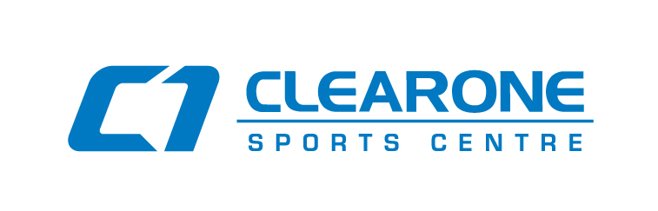

ORLANDO’S HOME FOR

Badminton, Pickleball & Ping Pong

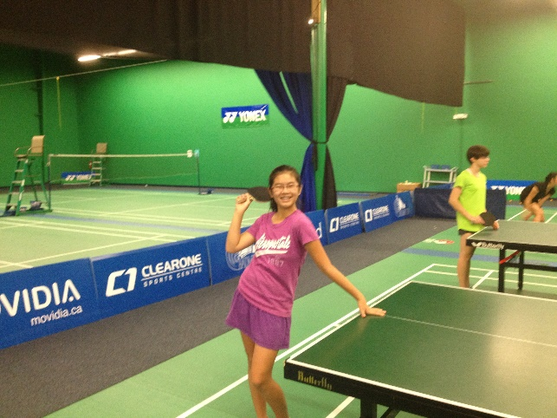

4141 N John Young Parkway, Orlando, Suite 3

Tel: 407-730-3596

Email: Orlando@ClearOneBadminton.com

www.ClearOneSports.com

CLEARONE

2018 SUMMER SPORTS CAMP

TRY SOMETHING NEW!!
WE OFFER

BADMINTON, PICKLEBALL & PING PONG

ClearOne Sports Centre is pleased to offer our Summer Camp Program.

Come and enjoy learning to play Badminton, Pickleball and Ping Pong. These sports are easy for beginners to learn and more experienced players will quickly see improvement in their game. And it’s all to have FUN!

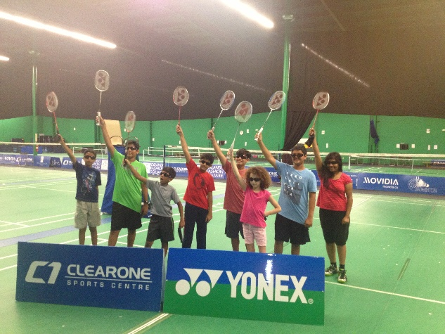

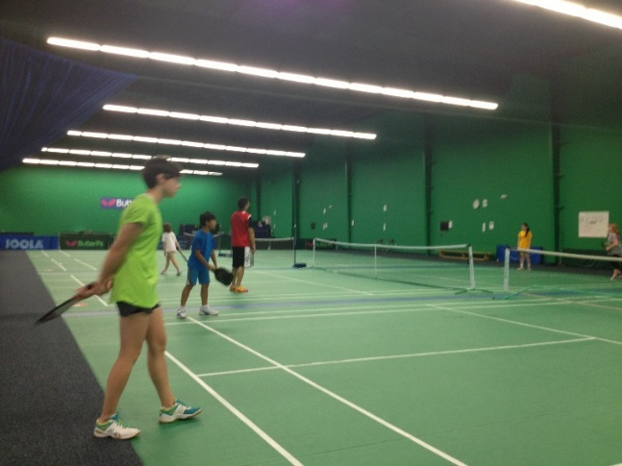

TOP COACHING

ClearOne has some of the most qualified and experienced coaches in the country. Our coaches are:

Badminton Head Coach - HENDRY WINARTO
- #1 Ranked Indonesian Junior
- Spanish National Team Coach
- International Competitor for over 8 years
- Spanish League Team Champion

Pickleball Head Coach – TODD HUTCHESON
- Native Floridian and Pickleball Coach at ClearOne for the last year
- Accomplished player having won numerous tournaments in Florida
- He loves teaching new players

Ping Pong Head Coach - HUNG TRAN
- Vietnam Women's National Coach
- World Class Coach – Olympic Committee Certification
- 30 years of experience
- President, Central Florida Table Tennis Club
TIMES

Camps run on the following dates. We have a limited number of slots available per camp. Place a check mark on your desired time(s) and which age group you fit in and if you want a focus on one sport.

- June 25th – 29th
- July 16th – 20th
- July 30th – Aug 3rd

AGE
- Kids (ages 6 – 12 years)
- Teens (ages 13 – 18 years)

FOCUS
All Sports
Or Pick One
Badminton
Pickleball
Ping Pong

DAY SCHEDULE

Start at 9:00 am DOORS OPEN at 8:45 am

9:00 am - 12:00 pm Coaching
12:00 pm - 1:00 pm (Lunch- Meals extra $6.00 Per Day)
1:00 pm - 2:30 pm Coaching
2:30 pm – 3:00 pm Open Play of Students Choice
3:00 pm - 3:30 pm Pickup

3:30 pm – 6:00 pm LATE PICKUP (Arrange in Advance)

PRICE

$250 per Week

Try it with a One Day Rate of $60

$10 per day early drop-off (Must Schedule in Advance)

$10 per day for Late Pickup (Must Schedule in Advance)

(Ask about Multi Camp and Family Member Discounts)

Camp lunches can be added for $6.00 per day or $30.00 per week. A selection sheet will be sent to each participant.

CAMP APPLICATION

(Please Print)
Full Name:__________________________

Phone:_____________________________

Email:______________________________

Age:_____ Gender:_____

Please indicate relevant medical or physical limitations including any allergies.
__________________________________________

Register NOW to secure your spot

Payment must be received IN FULL for all sessions by Cash, Check, Visa, Mastercard, Discover or American Express prior to participation.

Come in or Call..

407-730-3596 to make your payment.

WAIVER OF CONSENT:

I or the mother/father/guardian of _____________will not hold ClearOne Sports LLC., its directors, employees, staff or coaches liable or responsible for any injury or accident that might happen to my child while at the ClearOne Sports Centre.

Signature of parent or guardian:____________________________________

Emergency Contact:_____________________________________

Phone (day):__________________________________

