**"Worthy is the Lamb that was slain to receive power and riches, wisdom and strength, honor and glory and blessing."**

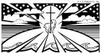

**-- Revelation 5:12**

PLEASE PRAY FOR:

***During November, we remember all family and friends who died. Place envelopes in the collection basket or on the altar.***

**OUR SICK & HOMEBOUND:** Don Dean (husband of Sandy Dean), Jean Latucci, Herbert Temple, Jerry Chambers, Frenda Tagliaferri, Jeremy Brown, Paul McLaughlin, Michael Walsh, Karen Chambers, Joanne Henry, Ellie Brown, John Armstrong, Ted Rampp, Arthur Reid, Pam Boyd, Gene Burcham, Peggy Burcham, Jimmy Longo, Clara Jensen, Frannie Whitaker, Gloria Juarez (daughter in-law of Delfina Paniagua), Wally Laskis, Frankie Wise, Jack Carrico, Richard Sturgis (family and friend of Jerry and Sally Sturgis), Sheila Polk (friend of John & Linda Dillon), Jean Williams, Sonia Bolz (sister and aunt of Ray Bolz), Paul Stewart, Patty Purcell, Rosmary Pratt, Harley Stumbaugh (grandson of Lupe Armstrong) Rita Schmeltzer (sister of Pat Snider), Darin Boyd, Alice Radewicz (grandson and friend of Jim & Pam Boyd), Jimmy Chambers (brother-in-law of Karen Chambers),Morris and Georgianna Lunt (parents of Darlene Brown), Miles McNutt, Nancy Reed, (family of Kathy Laskis), Amanda Williams (daughter-in-law of Gary Provost), Lloyd Stover Sr. (Smokey’s father), Leonel Hernandez (Delfina Paniagua), Gabriel Ward (requested by Linda Conley), Joel Schoeher (friends of MaryBeth Corron), Valentin Aguilar (nephew of Oswaldo & Maria Aguilar), Juan Carlos Castellanos, Emiliano Deras Flores (children with cancer) *To add or remove someone to our prayer lists, email* [*olhsecretary@gmail.com*](mailto:olhsecretary@gmail.com)*.*

**Contributions for weekend of**

**May 28 & 29,**  Offertory $ 2,214.00

**FAMILY & FRIENDS SERVING OUR COUNTRY:** Amanda Sturgis , David Reid, Sarah Smithling, Ryan Smithling, Angela Monserrath Solis, Michael Harris, Nathaniel Ramsay, Joshua Ramsay, Jason Boyd, Matt Gobble, Rebecca Schweigart, Raul Soto, Mac Figaro, Luigi Soto, Marc Green, Jasmine Leahy, Britt Baxley, Everett Henry, Nelson Ortiz, Felipe D. Rodriguez, Leslie Rodriguez, Alex Paniagua, Christopher Hackney , Josh Ducharme.

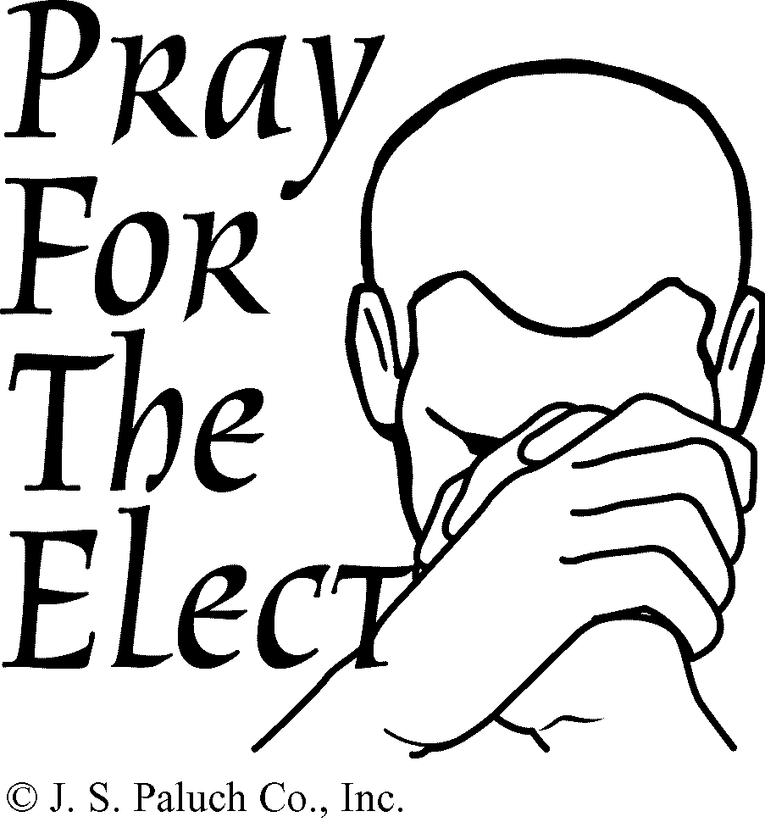

**THE SOULS OF THE FAITHFULLY DEPARTED**

**OUR NEOPHYTES:** Ricardo Argueta Soto, Jose Henriquez, Eder Ornales, Christopher Noyola Olmedo, Mara Camacho, Berenice Noyola Olmeldo, Yakari Rosales, Gabriel Cabrera Alvarez, Yesenia Flores, Isidro Teoba Lozano.

**Contributions Weekend of**

**March 26 & 27, 2016**

Offertory $ 3,078.00

**Thank you for the generous contributions to the offertory which makes it possible to cover the operating expenses of the parish.**

**STEWARDSHIP**

Stewardship opens an avenue of thought that allows us to give without always questioning what we will get in return.

**WEEKLY READINGS**

**Contributions for weekend of August 22 & 23,215**

Offertory $ 2,453.00

Thank you for the generous contributions which make it possible to cover the operating expenses of the parish.

Monday: Acts 6:8-15; Ps 119:23-24, 26-27, 29-30; Jn 6:22-29  
Tuesday: Acts 7:51 -- 8:1a; Ps 31:3cd-4, 6, 7b, 8a, 17, 21ab; Jn 6:30-35  
Wednesday: Acts 8:1b-8; Ps 66:1-3a, 4-7a; Jn 6:35-40  
Thursday: Acts 8:26-40; Ps 66:8-9, 16-17, 20; Jn 6:44-51  
Friday: Acts 9:1-20; Ps 117:1bc, 2; Jn 6:52-59  
Saturday: Acts 9:31-42; Ps 116:12-17; Jn 6:60-69  
Sunday: Acts 13:14, 43-52; Ps 100:1-3, 5; Rv 7:9, 14b-17; Jn 10:27-30 **ROSARIES:**

**First Saturday of the Month**



The Pro-Life Rosary is held outdoors, rain or shine, on the **first Saturday** of each month at 901 N. Main St. & Sunset Dr., High Point, at **9:00 AM** .

**Sunday Morning**



Sunday morning to pray the rosary before the 10:00am Mass, in the cryroom.

Also after the 10 am Mass.

**EXPOSITION OF THE HOLY SACRAMENT**

Exposition of the Holy Sacrament begins at 10:00 am each First Friday until 7pm followed by Mass for Devotion to the Sacred Heart of Jesus.

**MEET AND GREET**

Come join us for coffee, donuts, and milk after the 5:30pm mass each last Saturday of the month. See you there!

SECOND SUNDAY

FOOD COLLECTION

This month we donated 371 pounds of food and $235 in the name of our parish to the Cooperative Community Ministry. We also donated 37 pounds of rice to His Laboring Few.

We look forward to seeing all of you the weekend of 9-10 April when we will collect for the Fairgrove Family Resource Center.

 As always, God bless you and thank you for your support and generosity!

- Pat & Joan White

.

**Sunday , April 17th**

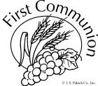

First Communion will be celebrated at all Sunday Masses. Please pray for all our First Communicants.



**Saturday, April 16**

Bishop Jugis will be here to celebrate Confirmation at the 5:30pm Mass. Please pray for our Confirmation students.

**SALESIAN**

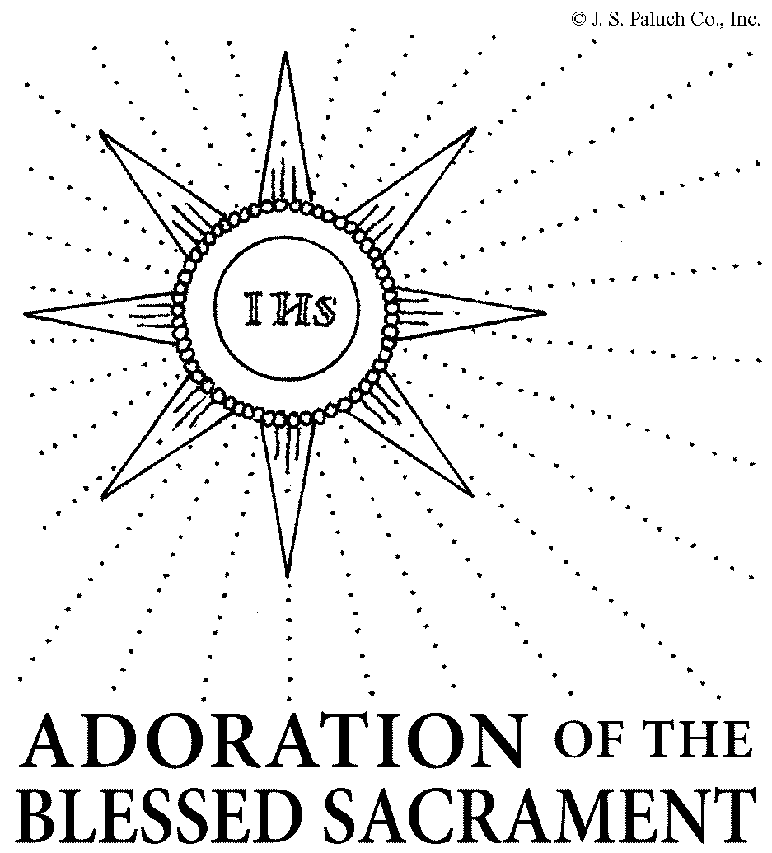

**PERSPECTIVE**

John’s recounting of the appearance of the risen Jesus to his As a first step in "going public" goes, this first demonstration of Jesus' divine power is, to say the least, an understatement. No miraculous healing. No exorcism of demons, no raising someone from the dead. Instead, he simply prevents the caterer from running out of wine at a wedding reception.   
  
Many might consider this a misuse - nay, even a waste - of Jesus' saving power. Initially, even Jesus himself seems to feel that his power could be used better - and later - elsewhere.   
  
Not Francis de Sales. He sees that there is more to this miracle than meets the eye. Here is an example of how God's power permeates all human experiences, even the most ordinary. We are speaking here of the practice of the "little virtues," a notion precious indeed to St. Francis de Sales and a hallmark of his understanding of Christ's saving power. In his Treatise on the Love of God, Francis de Sales wrote: "It may well be that a very small virtue has greater value in a soul in which sacred love reigns with fervor than martyrdom itself in a soul in which love is languid and feeble." (Book 11, Chapter 5) Put another way, the little virtues, the expression of care or concern in seemingly ordinary circumstances, may be "found more pleasing in God's sight than great and famous deeds performed with little charity or devotion."   
  
Still, there is a place for great displays of love: "I do not say that we may not aspire to outstanding virtues, but I say that we must train ourselves in the little ones without which the great ones may be false or deceptive." (Stopp, Selected Letters, p. 159)   
  
Jesus may have been tempted to believe that changing water into wine was beneath his divine - perhaps even his human - dignity. In the end, however, the needs of others were more persuasive than the desire to make a "big splash" in the eyes of others. Ironically, it may have been Jesus' willingness to employ his heavenly powers for such a down-to-earth request that enabled his disciples to "begin to believe in him."   
  
His greater, more famous and once-in-a-lifetime displays of power would, indeed, come later. But whether on the cross of Calvary, or at a simple wedding in Cana, the power, the promise and the person were one and the same.   
  
The moral of this miracle? *Nothing is too small for the Kingdom of God.*

Rev. Michael S. Murray, OSFS, is the Executive Director of the De Sales Spirituality Center.

**APRIL LECTOR &**

**EXTRAORDINARY MINISTER SCHEDULE**

**Saturday 5:30 Mass Sunday 10:00 Mass**

1st Lector...... Vanessa Osborne 1st Lector... .Sally Sturgis

2nd Lector…. Joanne Heilman 2nd Lector…..Robert Todd

EM…..Linda Dillon EM ….. Jim Boyd

Billie Porter Beth Ellis

**FAITHFUL SERVANT LEADERSHIP INSTITUTE**

June 19 – 25, 2016 – A Weeklong Catholic Leadership experience for mature high school students. Daily Mass along with sports options each day including horseback riding, swimming, rugby, and many more.

Practice the skills you need to succeed in life and grow in holiness. Register today while space is available! http://education.charlottediocese.

org/youth-ministry/youth-services/faithfulservant

**WORLDWIDE MARRIAGE**

**ENCOUNTER**

Let your marriage sacrament truly reflect God’s love and mercy. The next Worldwide Marriage Encounter weekend is April 29 – May 1 in Chapel Hill, NC. Early sign up is recommended. For more information contact us at applications@NCMarriageDiscovery.org or 704-315-2144 or our website at: http://NCMarriageDiscovery.org.

**EUCHARISTIC CONGRESS**

SAVE THE DATE! Our Charlotte Diocese Eucharist Congress will take place on Friday and Saturday, September 9 & 10. This spiritually unifying event brings together thousands of Catholics from across the diocese and southeast for spiritual talks, music, prayer, and fellowship – all centered around the Most Blessed Sacrament. All ages welcome!

**PRESCHOOLERS 2016-2017**

Are you interested in enrolling your child in free Pre-K? Preschool screening for children who are 4 or who will be 4 by August 31, 2016 will take place at Thomasville Primary School Auditorium at 915 East Sunrise Avenue on May 10 – 13 beginning at 8:30 a.m.

To schedule an appointment call 474-4160 from 8 a.m. – 3 p.m. You must bring: child’s birth certificate and income verification.

The screening is open to families who live in the Thomasville city district only.

**MASS FOR US MILITARY**

His Excellency, Bishop Peter J. Jugis, will celebrate a Mass for U. S. military personnel on Monday, May 30, 2016 at 11:00am at the Cathedral of St. Patrick in Charlotte. The mass and rosary (to be recited at 10:30 am) will be offered for all military personnel who have died and for those who are now serving. All personnel are invited and encouraged to come in uniform.

Photos of those who have died or who are now serving will be displayed in the Cathedral. To include your service member, preferably in uniform, please mail a photocopy of them with their name and military rank on the back to: Nancy Weber, Office of the Bishop, 1123 South Church Street, Charlotte, NC 28203 no later than May 23, 2016. (Please do not send original photographs as they will not be returned)