Offertory September 9 & 10, 2017
Offertory $ 2,738.25 Spanish Breakfast $ 190.75
Thank you for all your donations which help to pay the church expenses.

Gracias por todas sus generosas donaciones que ayudan a pagar para los gastos de funcionamiento de la iglesia.

Forgive from your heart.

SAINTS AND SPECIAL OBSERVANCES
LOS SANTOS Y OTRAS CELEBRACIONES
Sunday: Twenty-fourth Sunday in Ordinary Time; Catechetical Sunday
Tuesday: St. Januarius
Wednesday: Ss. Andrew Kim Tae-gon, Paul Chong Ha-sang, and Companions
Thursday: St. Matthew
Friday: Autumn begins
Saturday: St. Pius of Pietrelcina (Padre Pio)

Domingo: Vigésimo Cuarto Domingo del Tiempo
Ordinario; Domingo Catequético
Martes: San Jenaro
Miércoles: Santos Andrés Kim Taegon, Paul Chong Hasang y compañeros;
Jueves: San Mateo
Viernes: Inicio del Otoño
Sábado: San Pío de Pietralcina (Padre Pío)
PLEASE PRAY FOR/PETICIONES:
REPOSE OF THE SOUL: Jimmy Longo
OUR SICK & HOMEBOUND: Manola Chan, Pam Boyd, Peggy Cecil, Peggy Burcham , Janet Clodfelterr, Kelsey Berger, Patrick Walsh, Pat Rogaski, Joanne Henry, Mimi Young, Herbert Temple, Jerry Chambers, Frenda Tagliaferri, Paul McLaughlin, Michael Walsh, Karen Chambers, Joanne Henry, Ellie Brown, Ted Rampp, Barbara Reid, Jimmy Longo, Clara Jensen, Frannie Whitaker, Charles Holdaway, John Shuping (son of Mark and Nancy Shuping), Tom Zoellner, Joel, Holly and Theo Schroher, (MaryBeth Corron), Gloria Juarez (Delfina Paniagua), Jean Williams, Alice Radewicz (Jim & Pam Boyd), Georgianna Lunt (Darlene Brown), Dan & Kittie Newsom (Kathy Laskis), Valentin Aguilar (Oswaldo & Maria Aguilar), Juan Carlos Castellanos, Emiliano Deras Flores, Carmen Evans, Virginia Dackus (Peggy Cecil), Deacon Ron Steinkamp, Matthew Feliciano (Joseph’s son), and John Jones. To update, call 336-475-2667 or email olhsecretary@gmail.com
Contributions for weekend of
May 28 & 29, Offertory $ 2,214.00

FAMILY & FRIENDS SERVING OUR COUNTRY:
John Wagner, David Reid, Ryan Smithling, Angela Monserrath Solis, Michael Harris, Nathaniel Ramsay, Joshua Ramsay, Jason Boyd, Matt Gobble, Rebecca Schweigart, Raul Soto, Mac Figaro, Luigi Soto, Marc Green, Jasmine Leahy, Britt Baxley, Everett Henry, Nelson Ortiz, Felipe D. Rodriguez, Leslie Rodriguez, Alex Paniagua, Christopher Hackney , Josh Ducharme , Richard Archer, Tiffany Jaramillo.

THE SOULS OF THE FAITHFULLY DEPARTED
STEWARDSHIP
Stewardship is not job-oriented or projectminded.
It is a way of life for a lifetime.

La Administración de los bienes de Dios no es opcional. “Ninguno de nosotros vive como se fuera su propio dueño, y ninguno de nosotros muere como sífuera su proio dueño,” dice San Pablo. “Mientras vivamos, somos respnsables ante el Señor; y cuando morimos, morimos como Sus siervos.”

SEPTEMBER READER/EM SCHEDULE

Saturday 5:30pm: Sunday 10am:
1st Reader- Jim Hoyng Smokey Stover
2nd Reader- Susan Thornton Rose Moore
EM- Linda Dillon Jim Boyd
Billie Porter David Safewright

WEEKLY READINGS
LECTURAS DE LA SEMANA

Monday: 1 Tm 2:1-8; Ps 28:2, 7-9; Lk 7:1-10
Tuesday: 1 Tm 3:1-13; Ps 101:1b-3ab, 5-6; Lk 7:11-17
Wednesday: 1 Tm 3:14-16; Ps 111:1-6; Lk 7:31-35
Thursday: Eph 4:1-7, 11-13; Ps 19:2-5; Mt 9:9-13
Friday: 1 Tm 6:2c-12; Ps 49:6-10, 17-20; Lk 8:1-3
Saturday: 1 Tm 6:13-16; Ps 100:1b-5; Lk 8:4-15
Sunday: Is 55:6-9; Ps 145:2-3, 8-9, 17-18; Phil 1:20c-24, 27a; Mt 20:1-16a

ROSARIES/ROSARIOS:
Sunday Morning
Join us each Sunday morning at 9:30am in the cryroom to pray the rosary and also after the 10 am Mass for Vocation.
First Friday Adoration
Primera Adoración del Viernes
Adoration begins at 10am and ends with mass at 7pm.

La adoración comienza a las 10am y termina con la misa a las 7pm.
First Saturday Pro-Life Rosary
Each First Saturday, a Pro-Life Rosary will be held to pray for the end of abortion at 901 North Main St and Sunset Dr. at 9:00 am,, High Point.
Fifth Saturday Rosary
Join us at 5 – 5:30 pm on each 5th Saturday of the month to Pray the Rosary.

GRUPO CARISMĂTICO ESPAÑOL

El Grupo Carismático Español se reúne en la Iglesia cada jueves por la noche de 6:30 pm a 9:00 pm. Todos están invitados..

2nd SUNDAY COLLECTION
COLECTA DE COMIDA 2o DOMINGO

This month we donated 263 lbs of food and $337 to Cooperative Community Ministries. Our next collection will be the weekend of October 7 & 8 for the Fairgrove Resource Center. Thank you for your donations!

Este mes donamos 263 libras de comida y $ 337 a Cooperative Community Ministries. Nuestra próxima colección será el fin de semana del 7 y 8 de Octubre para Fairgrove Resource Center. ¡Gracias por sus donaciones!

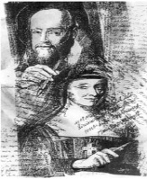
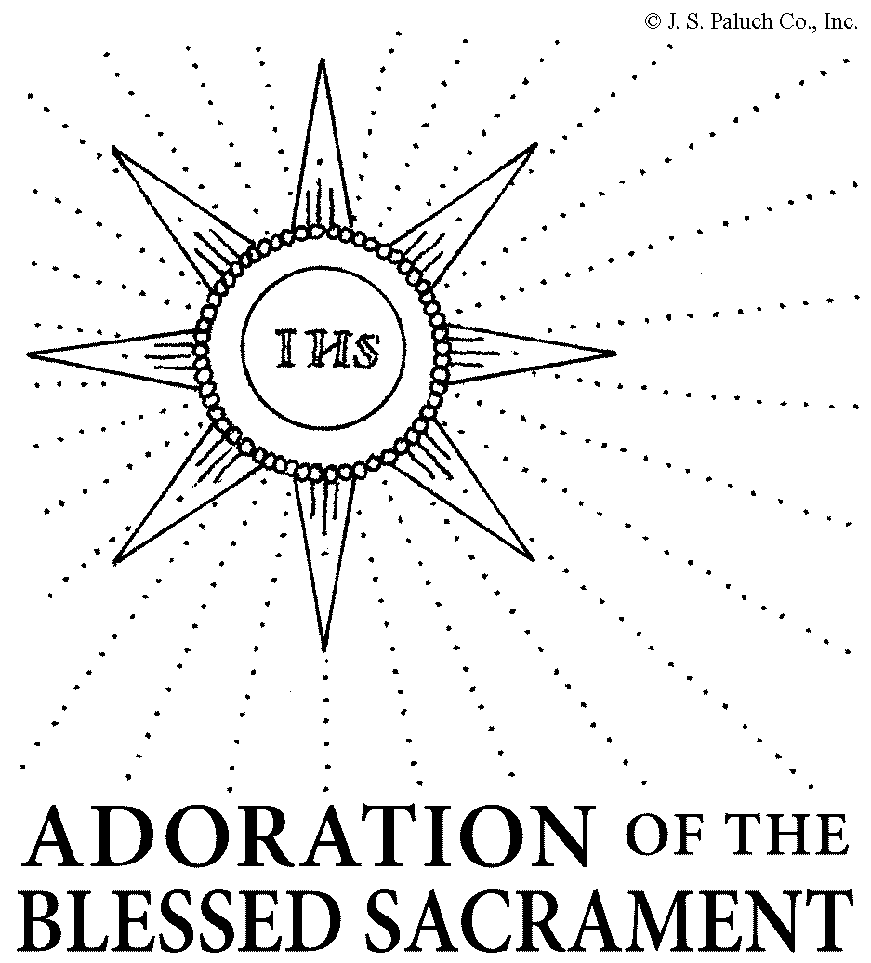
SALESIAN PERSPECTIVE
PERSPECTIVA SALESIANA

The old law required that a person forgive three wrongdoings. When Peter asks Jesus about forgiving the wrongs done to us, he suggests forgiving seven times -twice the required number plus one for good measure - a very generous measure he must have thought. Jesus’ response must have surprised him - “Seventy times seven times.”
Jesus was telling him that there is to be no limit to a disciple’s forgiveness.
Jesus goes on to explain “why” in a parable about God’s reign. The king generously writes off the debt of the official who owed the king so much that he could never pay it all back. When the official leaves the king’s presence he immediately begins to throttle a fellow servant who owes him a small debt. He doesn’t even listen when the slave pleads with him for patience.
The obvious question arises: has this man forgotten so soon how forgiving his master had been? The anger he shows doesn’t seem like the appropriate response to the forgiveness he has received. Where is his anger coming from?
One possibility is that the man doesn’t know how to receive forgiveness. He may feel that the master now has a hold on him and he has no way to get out of that hold. Perhaps if he repaid some of his debt, his master would have less of a hold. The one hundred denarii of his fellow slave would be a start.
For this man, forgiveness has not been a freeing experience; rather it has bound him even tighter to his master in his thinking. He has misunderstood his master’s act of forgiveness.
Jesus immediately applies the parable to his disciples, to us. His Father has forgiven us any debt we have incurred with Him by our wrongdoing, even the most evil of our sins.
The Father’s forgiveness sets us free; and we don’t owe the Father anything. But His Father hopes that this freedom will give us the example we need in forgiving one another. God holds nothing over us, so we are not to hold anything over each other. This is to be true not only in giving forgiveness, but in receiving it as well. True forgiveness means that no payback is ever necessary. The result of forgiveness is a newfound freedom to choose to love again.
Isn’t that good news? And we are to share that good news with each other every day - by forgiving freely.
Para el español, vaya a: http://www.oblates.org/sundays-salesian-feed-spanish/domingo-20-en-tiempo-ordinario-agosto-20-2017
PROTECTING GOD’S CHILDREN
PROTEGIENDO A LOS NIÑOS DE DIOS
Protecting God’s Children Workshop will be held on Saturday, October 7th from 1 – 4pm in English and Spanish at Our Lady of the Highways.

“Protecting God’s Children” is a three-hour mandatory training workshop for diocesan employees and volunteers designed to help recognize and prevent the sexual abuse of children. Employees and volunteers must attend one of the sessions that are held at various locations throughout the diocese. Pre-registration is required. To register, go to www.virtusonline.org and click on “First-time Registrant”.
El taller de Protección a los Hijos de Dios se llevará a cabo el Sábado 7 de Octubre de 1 a 4 pm en inglés y español en la parroquia Nuestra Señora de los Caminos.
"Proteger a los hijos de Dios" es un taller de capacitación obligatoria de tres horas para los empleados y voluntarios diocesanos, diseñado para ayudar a reconocer y prevenir el abuso sexual de los niños. Los empleados y voluntarios deben asistir a una de las sesiones que se llevan a cabo en varios lugares de la diócesis. Se requiere un pre-registro. Para registrarse, visite www.virtusonline.org y haga clic en "Registrar por primera vez".

2017 PRIESTS’ RETIREMENT COLLECTION
COLECTA PARA LA JUBILACIÓN DE LOS SACERDOTES 2017
The annual collection for Priests’ Retirement and Benefits is scheduled for the weekend of September 30 and October 1 in our parish. Our parish has been assessed $5,030.00 for this collection. Please be as generous as you can in this second collection.
La colecta anual para la Jubilación y Beneficios de los Sacerdotes está programada para el 30 de Septiembre y el 1 de Octubre en nuestra parroquia. Nuestra parroquia ha sido desiganada para colectar $ 5,030.00 para este servicio. Por favor, sea tan generosos como podamos en esta segunda colecta.
OUR LADY OF THE HIGHWAYS DAY
NUESTRA SEÑORA DEL DÍA DE LAS CAMINOS
Our parish feast day will be celebrated on Sunday, September 24. We will begin with a bilingual mass at 11AM followed by a covered dish picnic. (This will be the only mass for Sunday, Saturday mass will be at the normal time.
After mass, we will have a parish picnic. Hamburgers and hotdogs will be provided by the Knights of Columbus. Those whose last names begin with the letters A-M are asked to bring 1 or 2 side items (chips, salads, chili, pickles, etc.). Everyone whose last name begin with N-Z are asked to bring a dessert item and/or drinks. Food will be served in the social hall, then taken outside to eat at picnic tables, other tables or your own picnic blanket.
Overflow parking will be available at the bus lot by Food Lion with a shuttle vehicle to bring you to church and take you back to your car. (Handicap and seniors will park at the church) Bring your family and friends!!!
BIBLE STUDY
We will have a Bible Study on the Movie “Do You Believe” for confirmed teens and adults. Each Saturday evening after the 5:30pm Mass about 6:45pm beginning October 7 through November 18th. The cost is $7 for the workbook; please see Kathy to sign up.
LIFE CHAIN - THOMASVILLE
Cadena de Vida 2017
On Sunday, October 1, 2:30-3:30 p.m. the 2017 Life Chain will form along Highway 109 in front of the Southgate Shopping Center between I-85 and Julian Avenue. The National Life Chain is the largest peaceful, prayerful, pro-life, public witness in the world. More than 1,500 cities across the U.S. and Canada are expected to participate this year.

El domingo, 1o de Octubre, 2:30-3: 30 p.m. La Cadena de Vida 2017 se formará a lo largo de Battleground Ave en Greensboro, NC. La Cadena Nacional de Vida es el testimonio público, pacífico, devoto, pro-vida más grande en el mundo. Se espera que más de 1,500 ciudades de Estados Unidos y Canadá participen este año.

ROOM AT THE INN 18TH ANNUAL BENEFIT BANQUET
The Room at the Inn will have its’ 18th Annual Benefit Banquet on Thursday, October 5, 2017 at the Sheraton Greensboro at the Four Seasons Mall from 6:15 – 8:30 pm. Registration and Cocktails start at 5:30 pm. This year’s theme is “Building a Culture of Life with Love”.

Reservations are required. Dinner is complimentary but a donation will be requested. Register online at www.Roominn.org or contact Marianne Donalio at 336-391-6299 or MDonadio@Roominn.org.

