Digby Eye Associates

What Do I Do Before My Surgery?

You need to get all of your prescriptions filled. There are three medications you will need total. You need to refer to your attached Eye Drop Schedule to know when to begin these drops.

You cannot have anything to eat or drink after midnight the night before your surgery unless otherwise directed.

If you are currently on medication to treat glaucoma or Dry Eye continue to use these drops as directed.

IF YOU ARE A DIABETIC: Do not take your usual insulin dosage or diabetic pill the morning of your surgery.

IF YOUR ARE ON A FLUID PILL: Do not take this the morning of your surgery.

You should not wear any make-up.

Someone must come with you the day of surgery. You will not be allowed to drive yourself home after surgery.

Remember to take your insurance cards, medication list, and ID to the Surgery Center the morning of surgery.

Caring for Your Eye After Surgery

Continue to follow your Eye Drop Schedule.

Securely tape the eye shield found in your kit over your surgical eye when you are resting for 1 week after surgery.

Take the sunglasses with you to surgery. They are there for comfort. You will experience some glare and light sensitivity immediately after surgery and the sunglasses will help.

YOU SHOULD NOT rub your eye.

YOU SHOULD NOT do anything that requires heavy lifting that causes strain for 1 week after surgery.

YOU SHOULD NOT go underwater swimming for 2 weeks after surgery. This puts you at risk of infection. You may take a shower or bath. You cannot wear eye make-up for 1 week after surgery.

PLEASE CALL US IF you notice a sudden decrease in vision, have any pain that is not relieved by Tylenol or Ibuprofen, or if you notice any increased redness or swelling.

Your eye should heal over a period of 4-6 weeks. Once it is completely healed we will update your glasses prescription.

Digby Eye Associates

Eye-Drop Schedule for Surgery

RIGHT EYE LEFT EYE

Medications | Breakfast | Lunch | Dinner | Bedtime | Duration
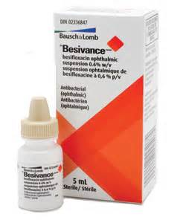  Besivance  (Tan Top-Antibiotic)  Start_______________ | √ | √ | √ | √ | Use every day, including surgery day until Gone  (This will last 5-7 days)
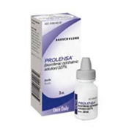  Prolensa  (Grey Top Anti-Inflammatory)  Start_______________ | √ |  |  |  | Use every day, including surgery day until gone.  (This will last for 2-3 weeks)
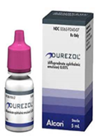  Durezol  (Pink Top Steroid)  START THIS WHEN YOU GET HOME FROM SURGERY | √ |  |  | √ | Use until gone or until the doctor instructs you differently
Other______________

Start:__________

BE SURE TO WAIT 5 MINUTES IN BETWEEN EACH DROP

REMEMBER TO SHAKE THE BOTTLE BEFORE EACH USE

Feel Free To Contact Us With Any Questions.
Greensboro Office High Point Office
Phone: 336-230-1010 Phone: 336-454-2020

