1/17/14 When fate takes a hand

When fate takes a hand by Lisa Head | Jan 14, 2014
Every moving company has had to work out how to survive the recent bad times and manage the recovery. But for family firm Pete Holbrook
Removals on the Isle of Wight, it wasn’t just the economy that struck a blow – fate dealt a hand too. By Steve Jordan
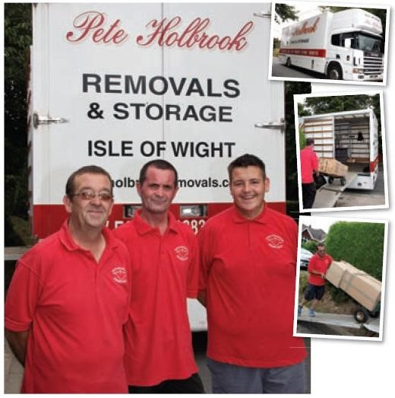
Harold Dibbens, first started his moving company in Ryde on the Isle of Wight’s sheltered east coast in 1920s. After a devastating fire that destroyed the company it fell to his son-in-law Pete Holbrook, a fisherman, and his son Mark to maintain the family’s connection with the industry. The business today has six vehicles, including two 18-tonners, and has a great reputation on the Island for domestic and commercial moving.
For most in the moving industry, 2007 was a great year with plenty of work at sensible prices. For Holbrooks too, business was good until illness, possibly caused by the stress of the additional work (who knows), took its toll. It was in that year that Fay Sayce, Pete’s middle child and only daughter joined the company in what was to prove to be a fortunate appointment in view of what was to come.
Later in 2007, Pete’s wife, Grace had a heart attack. She survived, but the experience had a profound effect on both her and Peter. Pete found it necessary to take a step back from the business leaving Mark, his eldest son to take the reins. Later that year, Mark suffered a severe heart attack and died – on his Mum’s birthday. “It was a very bad year,” said Fay. “Mark was the ideas man. We were left floundering.”
So with the business’s driving force lost, Pete and his wife both suffering from ill health, and the business being managed by
Fay and her younger brother Glenn (nicknamed Olly for reasons only the family know) – the 2008 financial crash hit! “In 2009 Dad started acting strangely,” said Fay. “We took him to A&E but he was suffering from a brain tumour, he died in July that same year. Dad loved to drive. If he couldn’t drive, life wouldn’t have been worth living for him.”
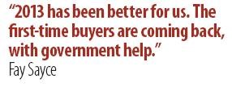
Even then, the troubles were not over; mum was diagnosed with cancer in 2010 and Fay herself suffered a heart attack herself the following year. Thankfully both survived. Then came 2012 with its extra bank holidays and the Olympics that devastated the moving industry for most of the summer.

I went to the Island to visit Holbrooks this summer and, having already heard some of the story, I was both shocked and delighted to find a company that was apparently thriving and had lost none of its spirit or family feel. “2013 has been better for us,” said Fay. “The first-time buyers are coming back, with government help.” And while I was there Fay was working out how she could fit in yet another booking. “It’s a storage job,” she said, “so I don’t want to let it go, but we are very busy.”

Going out on a job that morning with the crew it was easy to see why they were busy. Glenn(Olly) and the boys were uniformed, smiling, busily running a clearly delighted customer’s goods into a sparkling Holbrooks 18-tonner. It could be that they were just putting on the style for the camera but I’ve spent enough time around removal men to know the difference. This was a happy crew.
Although Holbrooks generates most of its own work on the Island it is keen to aid its recovery through offering trade services, whether they be portering with other crews from the mainland, handling whole moves to and from the Island as a trade agent, or simply picking up back loads from the mainland, Fay and the boys are happy to help. “People from the mainland often don’t appreciate the cost of the ferries,” she said. “We get concessionary rates so it can often be cheaper for us to handle a job than for a mainland company to do it themselves.”
And, of course, as with many family businesses, there’s another generation on its way. Simon (Fay’s son) and Harry (Glenn’s son) work on the vans and Ross (Mark’s son) has also worked with the company. Glenn’s daughter, Amber, works in the office.
Holbrooks is a company that has had its share of troubles in the last few years. Perhaps now there can be a new dawn and happier times ahead.
To contact Holbrooks and enquire about trade services, go to www .holbrookremovals.co.uk or email Fay at: peteholbrook_removals@yahoo.co.uk
Photo: Holbrooks - Uniformed, smiling and busy; left to right - Glenn (Olly) Holbrook, Michael Canning, Harry Holbrook.
Photos: Picture left to right -Glenn (Olly) Holbrook, Michael Canning, Harry Holbrook.

All material © 2011 The Words Workshop Ltd

