Submission Guidance:
Defective Representation
This paper is intended to provide guidance for those thinking of applying to the Commission on the basis of alleged misrepresentation by trial lawyers. It sets out, in brief outline, the Commission’s understanding of the key principles of law. It then explains the information that the Commission is likely to require in different categories of case. For a fuller explanation of the Commission’s understanding of this area of law, see the Commission’s more detailed position paper.
Defective Representation – in Brief
- A lawyer’s conduct of the defence may give rise to a miscarriage of justice if it makes the trial unfair. This is described as “defective representation”.
  - The test for defective representation is very high. The plea rarely succeeds.
- Defective representation is either:
  - A failure to present the instructed defence; or
  - Conducting the defence in a way that no competent lawyer could.
- Defective representation can be established only in relation to events that take place before the conviction.
- The accused is entitled to “instruct” his lawyer on the line of defence to be pursued. But they do not have the right to issue directions on the way in which the defence is to be presented (eg which witnesses to call.)
- A defective representation appeal is not a “performance appraisal”. It is not enough to show that the overall standard of the representation was poor.
  - Complaints about lawyers’ service standards and conduct should be directed to the Scottish Legal Complaints Commission
- A failure to prepare the defence properly may amount to defective representation, but it is necessary to show in that case what proper preparation would have uncovered.

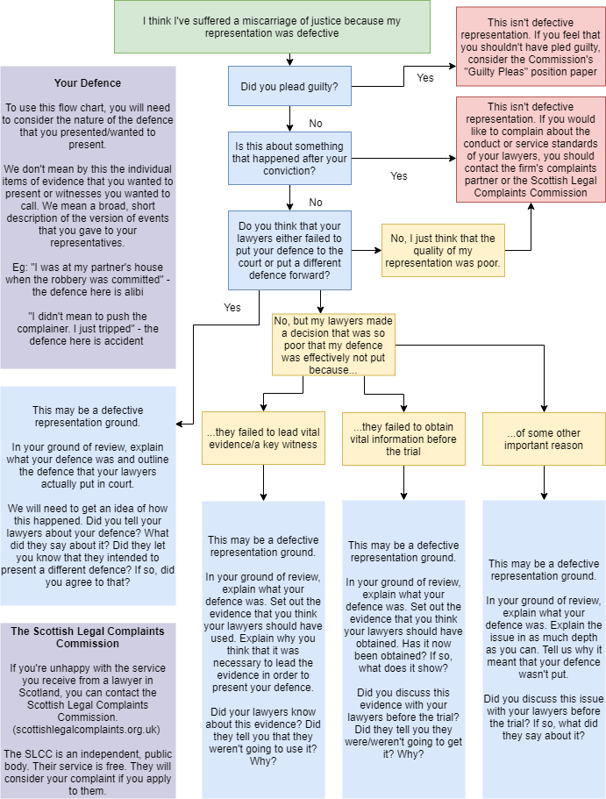

Position Paper:
Defective Representation
This paper sets out, in broad terms, the Commission’s approach when dealing with this area of law.
Introduction
- It is a fundamental principle, recognised in both domestic and international human rights law that everyone accused of a criminal offence has the right to a fair trial. The question as to whether or not a trial was fair is complicated somewhat when the source of the unfairness is said to be the conduct of the accused’s own legal representatives. In almost all cases, the accused is responsible for the selection of legal representatives. It is open to the accused to dismiss them at any point. Scots law, in common with other related jurisdictions, traditionally refused to accept that the conduct of a legal representative could, through its inadequacy, give rise to a miscarriage of justice. This situation persisted until the case of Anderson v HMA in 1996, in which the court held for the first time that where the inadequacy of the accused’s representation is such as to deprive them of the right to a fair trial this may amount to a miscarriage of justice.
- Whilst the circumstances outlined in Anderson under which the ground could be established were very narrow, the introduction of the ground resulted in a significant new volume of criminal appeals. Defective representation is by some way the most common ground for review in applications to the Commission. It is also one of the most frequent grounds for referral. To date, only one referral has been successful on this ground, the case of Joseph Wallace, which did not produce a written decision.

The Commission’s Position
The Basic Principle
- Anderson and subsequent case law establishes that the conduct of an accused’s defence can be said to amount to a miscarriage of justice only where it has deprived them of a fair trial. A fair trial is denied to an accused where the defence was not presented to the court because counsel “either disregarded his instructions or conducted the defence in a way in which no competent counsel could reasonably have conducted it”. Alternative formulations for the latter part of this test employed by the High Court, which the Commission considers are all equivalent, include counsel having made a decision that: was “so absurd as to fly in the face of reason”; was “contrary to the promptings of reason and good sense”; and, one “which no reasonable counsel could have taken”.
The Applicability of Anderson
- As the Commission understands it, the decision in Anderson applies only (indeed can only apply) to trials in which the accused has presented a defence. It is not possible to apply the test of failure to present a defence in a situation in which the accused has chosen not to present one. It is for this reason that the court in Pickett v HMA held that the principles could not apply to cases resolved by way of a guilty plea. That is not to say that the quality of an accused person’s representation may never be of relevance to such a case. On the contrary, in one of the more significant cases on the withdrawal of guilty pleas, the court held a miscarriage of justice established as a result of the conduct of the instructed solicitor. But that case was not “defective representation” within the restrictive meaning that the court in Anderson attached to the term.
- Similarly, it is not possible, in the Commission’s view, to advance the submission that the accused’s representation has been defective as a result of events that took place after the verdict has been recorded. The principles in Anderson are not applicable to matters relating to sentence, although, once more, there are limited situations in which the actions of legal representatives may be relevant to the resolution of a sentence ground. The conduct of a legal representative at an appeal may found a claim of inadequate professional services or misconduct, but cannot support a plea of defective representation. By the stage at which the appeal takes place, the defence has already been presented (or, indeed, not presented). There is nothing that a representative can do at that later stage to alter that fact.
- On the other hand, it does appear as if the principles in Anderson may be applied to a failure to present a plea in bar of trial. As the court in Murphy v HMA noted, a plea in bar is not a defence and does not result in an acquittal. The court allowed that appeal on other grounds, but indicated that it would otherwise have been willing to consider an Anderson ground.

Instructions
- The first basis upon which the court may hold that there has been a failure to present the defence is in situations in which counsel has disregarded his client’s instructions. It is important not to construe this too widely. Within certain boundaries prescribed by legal professional ethics, the accused is entitled to have presented on his behalf their own position with regard to the subject matter of the charges. However, as the court made clear in Hughes v Thomson, the accused is not entitled to direct counsel with regard to the manner in which the defence is presented. That, generally speaking, is a matter for the professional discretion of counsel. In the Hughes case, the court on this basis rejected a submission that a failure to lead a witness whom the accused wished to be called to give evidence amounted to defective representation.
- Counsel is also not bound to present a line of defence that he considers untenable in law. If he advises his client in these terms, it is a matter for the client whether to accept this advice or seek alternative representation.
- As one would expect from this narrow conception of the “instructions” that counsel is bound to follow, successful appeals on the basis of a failure to do so are scarce. The court in Winter v HMA held defective representation established where counsel had failed to lead an instructed alibi. In E v HMA, the court considered the representation defective in a situation in which counsel had failed to pursue a defence that child witnesses were being manipulated by the accused’s estranged wife. Both of these cases were decided relatively soon after Anderson. Perhaps the starkest example of a miscarriage of justice of this type may be found in the slightly later JB v HMA. In that case, the accused had instructed his legal representatives to advance the position that the complainers were lying. Their cross-examination had proceeded upon this basis. Nonetheless, in his closing speech, and without the authority of the accused, counsel suggested to the jury that the complainers had convinced themselves of the truth of their allegations, effectively arguing, without any evidential basis, that they were suffering from some form of false memory syndrome. In these very unusual circumstances, the court found itself “driven to conclude that the taking of that course represented a material departure from the appellant's instructions as to the basic nature of his defence and deprived him of his fundamental right to a fair trial.”
“Performance Appraisals”
- An important consideration to bear in mind when attempting to determine whether or not an accused person’s representation is, within the terms set out in Anderson, defective is the extent to which that case and those following it focus upon the effect of any failure on the presentation of the defence. The key question is always whether or not the trial was unfair because the defence was not presented. It is thus crucial that a defective representation ground sets out not only some failure on the part of counsel but also a concomitant effect on the presentation of the defence. To reiterate, it does not matter how egregious any failure on the part of counsel may have been if it may be said nonetheless that the accused’s defence was presented to the court. This is what led the court in Woodside v HMA to the observation that a defective representation appeal “is not a performance appraisal in which the court decides whether this question or that should or should not have been put; or whether this line of evidence or that should or should not have been pursued.” The court in that appeal conceded that the advocacy on behalf of the accused “lacked a certain finesse”. It described the speech to the jury as “unstructured and ill focused”. In light of its view that the defence was, nevertheless, placed before the jury “in all its essentials”, the court concluded that the representation was not defective.
- Nothing in the foregoing paragraph should be taken to suggest that there is no recourse against legal representatives whose service is inadequate but not, in terms of Anderson, “defective”. Such recourse may indeed exist, but it is not part of the Commission’s function to provide it. Complaints about the service or conduct of a lawyer in Scotland should be directed in the first instance to the advocate him- or herself (or the complaints partner in respect of a firm of solicitors) and subsequently to the Scottish Legal Complaints Commission.
Putting the Defence “Properly”
- The High Court has, from time to time, upheld appeals where the defence did not seek expert medical evidence which might have supported the accused’s account of events, even though the accused’s account was nevertheless put before the court. In Garrow v HMA and Hemphill v HMA, the court applied the formulation that the defence was “not properly presented”. In DS v HMA, the Commission had referred a case to the court on the basis of a failure to obtain medical evidence, expressing the view that this meant that the applicant’s defence had not been “fully” presented. Refusing the appeal, the court criticised the Commission’s form of words and cast doubt on the earlier Hemphill line of authority. Renton & Brown’s Criminal Procedure, on the other hand, argues that that particular phrase “encompasses both cases where the defence is simply not put and also those where it is put in a way which no competent counsel could have done.” The Lord Justice Clerk (Gill) in McBrearty observed that it may be difficult to draw a dividing line “between a judgment made by counsel in the presentation of the defence and a failure properly to present it at all.” He went on to state that if the judgment flies in the face of reason, the court is entitled to hold that the defence was not properly conducted, adding that to hold otherwise “in pursuit of a rigid legalistic distinction, would be to lose sight of the underlying question in every Anderson appeal, namely whether the accused was given a fair trial.”
- The formulation that the Commission prefers to use in modern practice is that found in Anderson v HMA, which is to say that the defence was “not presented”. The Commission accepts, nonetheless, that there are rare cases in which a decision of counsel’s may be so absurd as to render the presentation of the defence ineffectual and thus, constructively at least, “not presented”. These cases (by way of comparison with those discussed at paragraph 8) are the second form of defective representation ground. It should be noted in this regard that what is key to the ground is the effect of the “absurd” decision on the conduct of the defence. No matter how open a decision may be to criticism, it cannot found an appeal unless it has a significant structural impact upon the defence.
Strategy and Tactics
- Criticism of “strategic or tactical decisions” as to how the defence should be presented will not be sufficient to support an appeal on the ground of defective representation if those decisions were reasonably and responsibly made by counsel in accordance with their professional judgement. Accordingly, a failure to present a particular line will not found an appeal if the decision not to do so is within the scope of the reasonable judgement of counsel involved.
Inadequate Preparation
- An accused’s right to adequate presentation of his case extends to the manner in which the case is developed and prepared pre-trial. Failure to properly investigate a case, to precognose witnesses or to pursue particular lines of defence may result in the accused being denied a fair trial. For an appeal to succeed on this basis, it will be necessary to set out the specific information that proper investigation would have uncovered. Lawyers preparing for trial have to bring a “professional and practical judgement” to the extent to which matters require investigation. A “counsel of perfection” is not the relevant test even where it can be demonstrated that a defence enquiry could have revealed an answer favourable to the defence. It is “not every single, conceivable or remote stone which must be turned in preparation for trial”; regard must be had to what is reasonable and practical.
- In this latter regard, a comparison between the decisions of the court in Yazdanparast v HMA and Murphy v HMA is instructive. In the former case, the court considered that the representatives were entitled to rely upon the findings of a Crown-instructed report to the effect that the accused was not suffering from a mental disorder at the time of his offence. In Murphy, on the other hand, the court suggested, without deciding the point that the defence team may not have been entitled to rely upon their own assessment of their client’s capabilities in circumstances in which they knew that he had been diagnosed with Alzheimer’s disease and dementia. It had been subsequently established that the accused was most likely incapable at the time of the trial. It was at least arguable in that case that the representatives were obliged, in light of the diagnosis, to make fuller enquiries. The court noted that it was difficult to characterise as “strategic” or “tactical” a decision not to obtain information that had stemmed, perhaps, from overconfidence on the part of the legal representatives about their own assessment of the client’s capacity.
Specific Considerations
- In considering a claim of defective representation at stage 2 the Commission will, in the ordinary course of events, begin the stage 2 review by requesting the defence papers. There are often delays or difficulties in obtaining these papers. The legal officer should make clear from the outset that the request includes all correspondence files. The correspondence files frequently contain valuable information on the approach of the defence to the preparation and presentation of their case.
- Thereafter, the Commission may undertake the following steps:
- correspondence/ interviews with solicitors and counsel – this will involve varying degrees of formality from a short telephone call or letter to a tape recorded interview. In some cases it will be necessary to seek support for the representative’s position;
- investigations to identify information which more detailed preparation of the defence would have uncovered – e.g interviewing witnesses not called, instructing expert reports etc
- It will be necessary in any referral to (i) set out a prima facie case that on the information available to trial counsel the defence was not put before the court, and that in consequence there was a miscarriage; (ii) specify the allegation on all material points and (iii) provide objective support for it.
Date of Approval: December 2020
Date of Review: December 2021

See, for example, Article 6 of the European Convention on Human Rights and Fundamental Freedoms and Article 14 of the International Covenant on Civil and Political Rights
McCarroll v HMA 1949 JC 10. In this case, the accused had had a solicitor assigned to him as a “poor person”, the lack of selection forming the basis for the submission that there had been a miscarriage of justice. The court held that it could not make a distinction between selected and assigned legal representatives. The Lord Justice Clerk (Thomson) was of the view that the ground would have been wholly unarguable if the appellant had instructed his own solicitor.
1996 JC 29
The Commission’s 2018-19 Annual Report records that in the Commission’s first 20 years of operation defective representation was the main ground of review in 19.5% of applications, which is almost 6% higher than the next most frequent ground.
15% of the Commission’s referrals from 1999-2019 (e.g. Mark Paterson, unreported (allowed on other grounds – defective representation not considered); Gary Polland 2010 SCL 854 (refused); James Kinsella 2011 SCCR 442 (refused); DS 2008 SCCR 929 (refused); Joseph Wallace, unreported (allowed – narrow ground that solicitor did not challenge the failure to serve a statutory notice upon the applicant/ registered keeper of the vehicle) and, most recently, Stephen Rodger 2017 SCL 971 (refused)).
Anderson v HMA; E v HMA 2002 SCCR 34; Jeffrey v HMA 2002 SCCR 822
The majority of the case law relating to defective representation arises from prosecutions at solemn level, and thus generally concerns itself with the conduct of counsel. The principles are equally applicable to cases in which a solicitor has conducted the defence. For the sake of brevity, the Commission has used the word “counsel” in this paper.
SD v HMA [2014] HCJAC 17 ; Grant v HMA 2006 SCCR 365
McBrearty v HMA 2004 JC 122 at paragraph 36
McIntyre v HMA 1998 SCCR 379
McEwan v HMA 2010 SCL 557
That is not to say that the accused must have led a positive defence in the sense of leading evidence. It is enough that there has been a contested trial.
2007 SCCR 389
Gallagher v HMA 2010 SCCR 636
The Commission deals with withdrawal of guilty pleas in its position paper “Guilty Pleas”.
On sentence grounds generally, see the Commission’s position paper “Sentencing”.
It is less clear whether or not the Anderson principles may be adapted to other procedural errors on the part of representatives. This strikes the Commission as a possible argument in a situation where, for example, counsel has failed to request necessary special measures. In Griffith v HMA 2013 SCCR 448, the court considered a situation in which counsel had failed to advise the appellant that his own criminal record could be put in issue if he gave evidence against his co-accused. Counsel for the appellant conceded that she could not make the submission that the defence had not been presented. Indeed, the defence relied upon the appellant’s evidence. Without deciding whether or not such circumstances could in principle give rise to a miscarriage of justice, the court dismissed the ground on the basis that there was no submission to the effect that the appellant’s decision to give evidence had cost him a chance of acquittal.
2017 SCL 176
2010 SCCR 492
The exception being the situation in which the decision making is so unreasonable as to move the case into the second category of “defective representation” grounds.
Although there is, in the Commission’s understanding, a universally applied convention that the accused is permitted to decide whether or not to give evidence him or herself.
SB v HMA [2015] HCJAC 56
2002 SCCR 720
2002 SCCR 34
2009 SCCR 301
2009 SCCR 350. The court in Woodside drew upon earlier observations in McBrearty v HMA; Grant v HMA 2006 SCCR 365 and DS v HMA 2008 SCCR 929.
For further information, see https://www.scottishlegalcomplaints.org.uk/
2002 SCCR 772
2001 SCCR 361
6th Ed paragraph 29-22
In K(B) v HMA 2017 SCL 990, for example, the court held that to be defective representation a situation in which the instructed solicitor advocate had failed to lead evidence of a rigid system of conduct which, if followed, rendered the allegations against a foster carer impossible. The court commented that this “was not simply a judgement by [the solicitor advocate] as to the manner in which that defence was presented, but a failure to present it at all”.
Grant v HMA
Garrow v HMA 2000 SCCR 771; Hemphill v HMA 2001 SCCR 361 and E v HMA
McIntosh v HMA (No 2) 1997 SCCR 389
Lindsay v HMA 2008 SCCR 391; Boath v HMA 2016 SCL 857 at paragraphs 23-24
Urquhart v HMA 2009 SCCR 339
2016 JC 12
At paragraph 54 et seq
Grant v HMA, DS v HMA 2008 SCCR 929; Addison v HMA and Boath v HMA

