Sinclair Tour and Travel 5494 5083
A Country Easter. St George, Lightning Ridge, Roma.
Departs Wednesday 28th March – 6 days
$1,750 per person twin share. Single $350

Day One. Wednesday 28th March.
After pick up from your door as usual, your Country Easter Tour gets under way. Our morning tea stop will be Kilcoy and we’ll travel through towns like Yarraman before our lunch stop (own expense) in Dalby. Dinner in our Hotel tonight. St George is on the banks of the mighty Balonne River – our overnight destination. St George has a district population of 3,800 people. Beautiful country gardens, streetscapes and a river walkway are features of the town. The riverside walk can be entered from The Terrace (St Georges Terrace) via cement footpaths. The times of sunrise and sunset are particularly nice to enjoy the atmosphere of the river gums, landscaping and birdlife. (D)
Riverlands Motel – St George. (07) 4625 1229
Day Two. Thursday 29th March.
After a delicious breakfast at our Hotel, we’ll visit a truly unique attraction – the murals on the silos at Thallon. The people of Thallon hope that the huge colourful artwork will do more than add a splash of colour to the town. They hope it will boost local morale and bring more tourists and therefore save their town
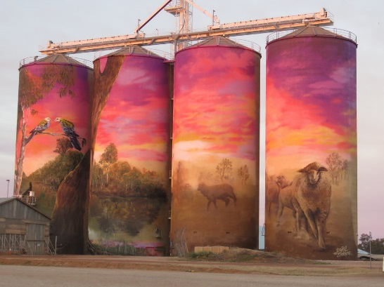
Then we’re off to Lightning Ridge. Such is the allure of the Ridge, that many who initially planned to stay a day or so as part of a larger travel experience, end up staying a lifetime without being able to pinpoint the exact reason. At the Ridge, one can experience underground sculptures, bottle-houses, antique lamps, castles, astronomy monuments, unique gardens, hills named 'Lunatic', 'Pig' and Bald', a pub crawl to 'The Pub in the Scrub', 'The Glengarry Hilton' and 'Sheepyard Flat', and even tour underground mines. And how do you find all these things? Look out for a coloured car door! Make sense? ...probably not, but it will when you visit the Ridge! They are a unique bunch of characters out there that prides themselves on a wonderful and heartfelt eccentricity; it is something about the pioneering spirit.
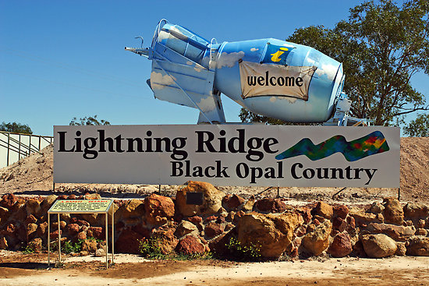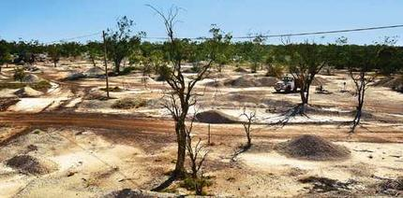
We’ll discover Lightning Ridge with Black Opal Tours and go on a journey through the opal fields of Lightning Ridge and through time as your local guide introduces you to a unique place and way of life. For more than a century and right up until the present, a community of persistent and determined opal miners women and men alike have faced hardship and danger in their search for the most mesmerising of gemstones, the elusive Black Opal. We’ll visit the Opal Mines with experienced guides who are opal miners, visit a treasured old miner’s camp, see the famous Lunatic Hill open cut mine, learn all about Lightning Ridge’s history and culture, learn about the Artesian Bore Baths and even fossick for an opal!
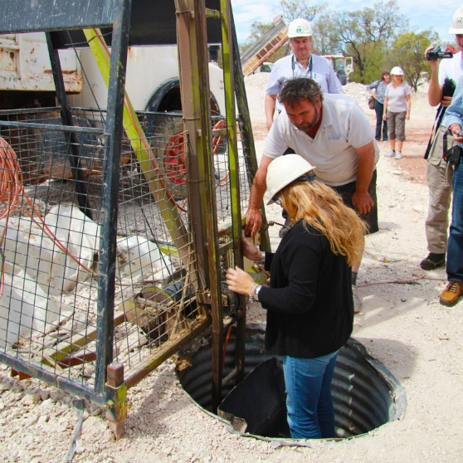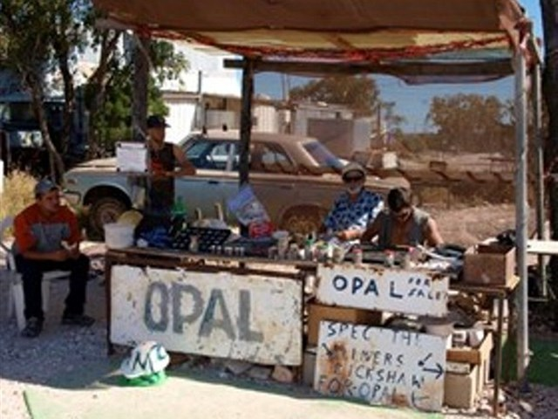
Then you’re in for another treat as we visit The Chambers of the Black Hand - both a collection of sculptures, hand carvings, paintings and an informative and entertaining tour of an opal mine that has been worked for over100 years, learn how hard it was for the old timers that dug by hand. Here you will get to see tunnels and shaft hand dug it is a very informative part of the tour.
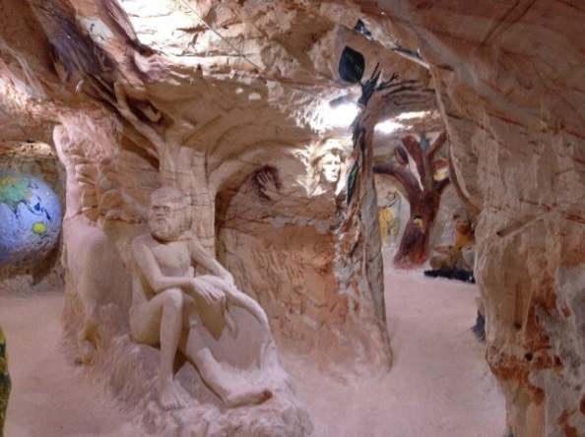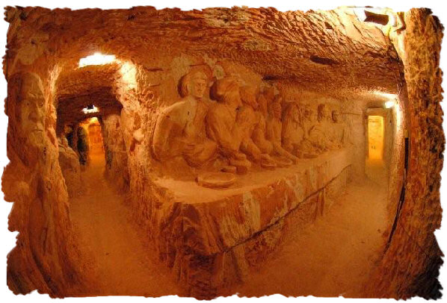
The carving level is 11.2 metres underground. The 100-year-old mine is 19.6 metres underground. Subterranean tunnels open into vast chambers. The walls have over 700 eclectic carvings and paintings created by our artist Ron Canlin, the owner of this uniquely Australian attraction and his talent is never ending. All of the guides are very passionate about the opal and mining and love to share tales of the olden days. Between the 6 guides they have 180 years mining history behind them. Trevor is very passionate and can tell you all about the opal. Combine his enthusiasm for opal mining and prospecting along with Ron’s passion for carving and art and you can see they are on a winner. Complete your visit by calling in on Black Opal Jewellery Shop – also uniquely located 11.2 metres underground. It is the only underground shop in The Ridge. Dinner at our Motel again tonight. (B) (D)
Riverlands Motel – St George. (07) 4625 1229
Day Three. Friday 30th March.
After another delicious brekky, we’ll pack up and leave St George and head to Roma where the Easter in the Country Festival is being held. Lunch in Roma today (own expense).
Roma's Easter in the Country festival is a five-day celebration of all things country. Now entering its 41st year, it is widely recognized as one of South West Queensland's premier Easter events, and brilliantly showcases the country lifestyle. The festival offers a range of activities for the thrill-seeker, the cultural buff, and for those that like to take things a little more leisurely. The event gives an opportunity for the residents of Roma to invite their relatives and friends to spend a long weekend in the country to enjoy the atmosphere and friendliness that Roma and the Maranoa has to offer. Today there are two art exhibitions to visit and the “Maranoa Performance – Poetry and Song” you may wish to enjoy. There are many activities open to you. Dinner at our Hotel tonight. (B) (D)
Explorer’s Inn Roma (07) 4620 1400
Day Four. Saturday 31st March.
After brekky at our Hotel, it’s time for all the fun of the fair! You’ll love the street parade, with market stalls – great shopping I’m sure ladies. For a change of pace, we’ll visit an open garden of a friendly local and visit the outdoor country music festival. Or there’s loads of good fun as you get down and dirty watching high powered vehicles take to the mud pits. Something for everyone at this fair. (B) (D)
Explorer’s Inn Roma (07 4620 1400
Day Five. Sunday 1st April.
Brekky again before we go back to the fair. There are more markets, Billy cart races, goat races (cheer on your favourite goat!) and much much more. At 1pm we’re in for a real treat as we witness top quality rodeo action at the Professional Rodeo. Come and see some of the best cowboys in the business show you what they can do.
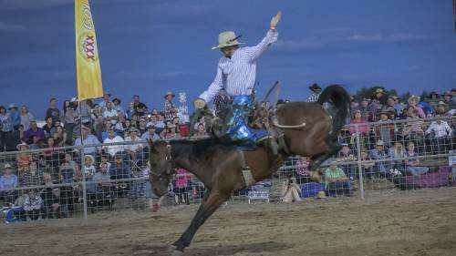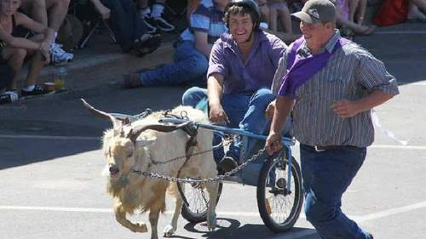
Dinner at our hotel again tonight. (B)(D)
Explorer’s Inn Roma (07 4620 1400

Day Six. Monday 2nd April.
Sadly, this is our last breakfast together. Back to tea and toast tomorrow! We’ll travel home through towns like Miles, Chinchilla and Dalby. We do hope you enjoyed your Easter in the Country with Sinclair Tour and Travel. Please tell your friends. That’s how our business grows. We look forward to travelling with you again really soon. (B)
INCLUDED IN TOUR

- Air conditioned bus fitted with coach seats for your comfort.
- Door to door airport transfers.
- Motel accommodation on a twin share basis.
- Breakfast (B), Lunch (L) and Dinner (D) as indicated.
- All entries as listed.
- Morning Teas.
- Name badge, luggage labels & water bottle.

GENERAL INFORMATION

BOOKINGS
Please phone 5494 5083 for bookings. A Tour Booking Form will be sent to you for completion and return with a deposit of $100.00 per person within 7 days to secure your booking.

BALANCE PAYMENT
Balance of payment is to be received at least 60 days prior to Tour Departure Date. For Tour Bookings made within 60 days of Tour Departure Date, full payment is required on booking.

CHANGES TO ITINERARY
Sinclair Tour and Travel reserves the right to alter any itinerary due to unforeseen circumstances beyond its control and to cancel any tour due to insufficient bookings. A full refund of fare will be made if tour is cancelled by Sinclair Tour and Travel

CANCELLATION FEES

Number of day’s notice given | Fee payable
More than 60 days | Nil
30 – 59 days | 50% of tour Price.
15 – 30 days | 75% of Tour Price
8 - 14 days | 100% of Tour Price
Less than 8 days | 100% of Tour Price
Day of Departure or during tour | 100% of Tour Price

In addition to the above fee any moneys paid in respect of bookings with other tour operators, airfares, attractions, etc. on your behalf and which cannot be recouped will also be payable. A $50 administration fee (per person) will be charged on ALL cancellations regardless of the number of days’ notice given.

To cover cancellations due to illness or for loss of baggage we strongly encourage passengers to have travel insurance. We can arrange Travel insurance for you as we now sell Cover-More Travel Insurance. Phone us today 5494 5083 for a quote. We just need your date of birth.

