Astra Business Corporation Seller Profile_____
CONFIDENTIAL M&A Consultants
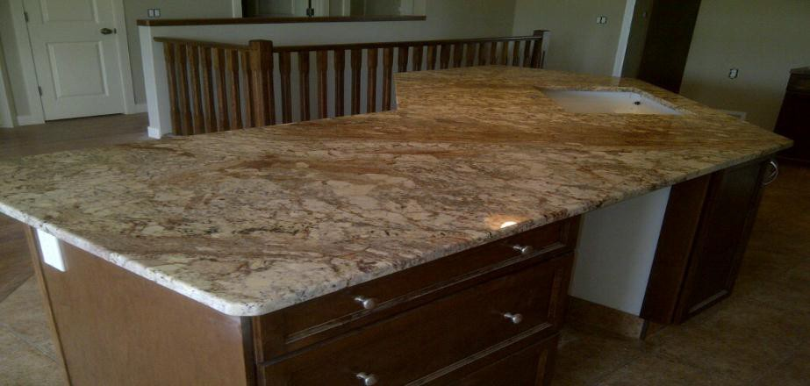
CONFIDENTIAL ACQUISITION OPPORTUNITY
Sales and Installation of Granite & Tile
Business Description
This fine granite retail and installation company has a 50% repeat client base from builders. The business offers a wide selection of products to choose from including granite, tile, quartz, slate and marble. This authorized Schluter Dealer also offers grout and accessories to complete the project. They offer high end granite in both exotic and neutral colours. For clients with a smaller pocketbook, they offer ceramic, glass and porcelain tiles, a great wall or floor accents for any room. This facility has it all, and on site fabrication. The company had seen quick growth since their inception in 1998 and they have had a substantial amount of referrals to the business as well. Due to the economic conditions of the last couple years revenue have dipped. However, revenue has remained steady and outlook looks favourable.
Business Details
With highly experienced granite specialists offering exceptional customer service, this company has established a superb reputation. Whether clients are trying to upgrade their countertops, add outdoor granite finishings, this business has a new CNC router with staff to get the job finished right and efficiently. They also offer ceramic wall and floor tiles as well as all of the supplies for those “do it yourselfers”. One of the owners will retire while the other will remain under an employment agreement with the new owners. Contact us today on more information on this profitable company.
Products and Services Offered
According to management, the Company attributes 95% of sales and installation to countertops, 4% to sales of support and miscellaneous items and one percent to sink sales.

Financial Information: Financial Summary

January 31 | 2013. | 2014 | 2015 | 2016 | 2017
Revenue | $ 1,360,016 | $ 1,283,068 | $ 1,250,879 | $ 1,047,378 | $ 770,699
Adjusted EBITDA | $ 160,169 | $ 249,854 | $ 142,089 | $ 169,975 | $ 103,338

For further detailed information please contact:
File 736
Bob Hughes
Astra Business Corporation
T- 604-240-6164 E - bhughes@abc-astra.com

