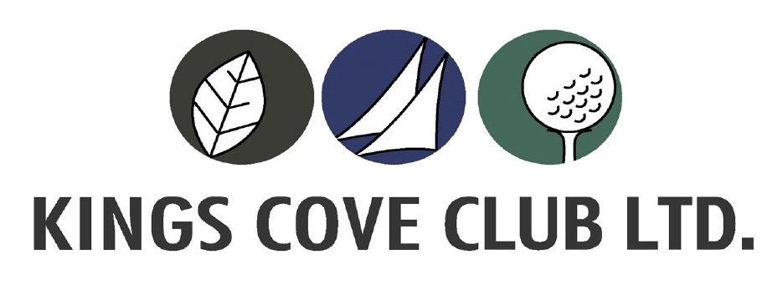

94 Kings Cove Blvd, Metung Vic 3904 Ph: 03 5156 2927 W: www.kingscoveclub.com.au
E: manager@kingscoveclub.com.au

Sponsorship Opportunities

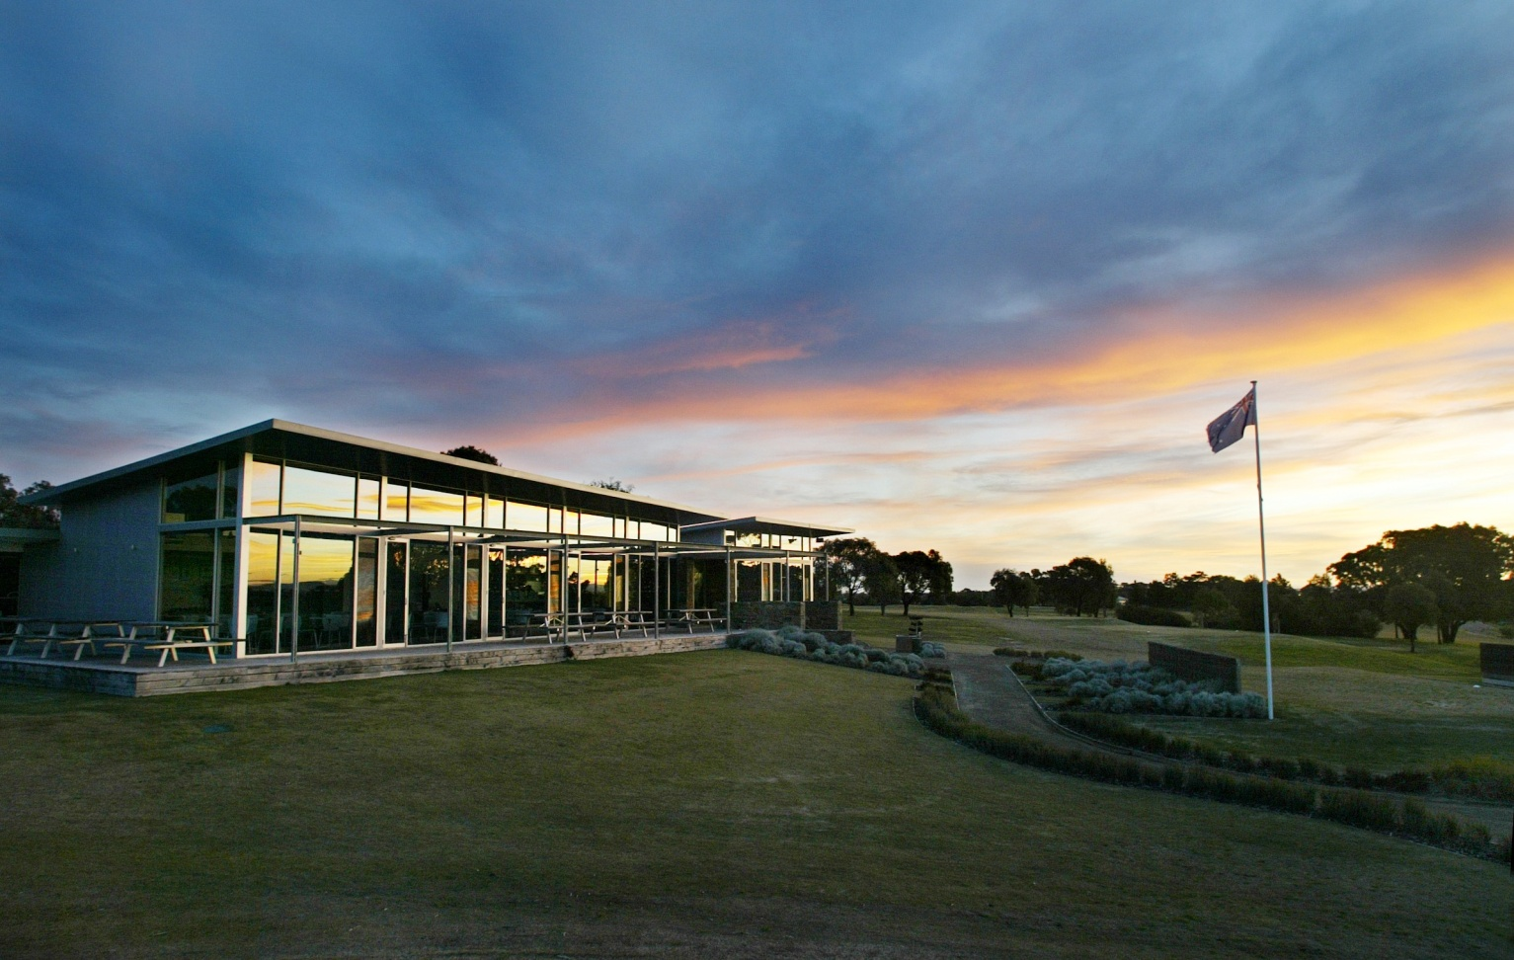

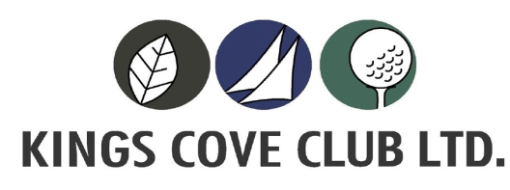

SPONSORSHIP & ADVERTISING OPPORTUNITIES

Looking for an opportunity to increase your business and get involved in your community?

During the last 12 months, over 3,000 people played golf at Kings Cove Metung Golf Club. For a very affordable and reasonable price, we are offering you the chance to advertise and promote your business where a significant number of people will see your advertisement.

Take advantage of targeted business exposure at Kings Cove Golf Course by becoming a sponsor today.

The Golf Course

Kings Cove Metung Golf Club is nestled in Gippsland’s premiere lifestyle, golf and marina development, Kings Cove Metung. With views from the course extending from the lakes and Bass Strait to the mountainous high country, playing at Kings Cove Golf Course is a real treat for all golfers.

With undulating parkland and spectacular views of the Gippsland Lakes, internationally renowned golf course designer Ted Parslow has architecturally designed the resort-style course. The course layout challenges golfers of all levels, with nine greens and two sets of tees on each hole, which significantly alters the length and play the second time around.

The course is around 6,100 metres in length, par 72 with an Australian Course Rating of 72, with a V.G.A affiliation. The ladies distance is 5,200 metres also with a par of 72.

The Kings Cove Golf Course opened in early February 2006, along with the new Club House and is well established with all facilities for an enjoyable game of golf – practice putting green, driving range, a very well equipped Golf Shop with some great clothing, motorized golf carts and buggies for hire with a licensed club house with Restaurant & Bar. After golf, members and visitors can relax in our clubhouse that overlooks the lush landscape of the golf course and enjoy a quiet drink or lunch with friends or book our restaurant for a wedding, party or celebratory event.

Sponsorship Benefits

Kings Cove Metung Golf Club is offering local businesses the opportunity to advertise their products and services on our Golf Course. There are many sponsorship and advertising opportunities within the Club. This is a great way to support your local community as well as reach your target market and creates brand awareness. Sponsorship ranges from Tee Box and Golf cart signage to Competitions and major events.

Please read over our brochure for detailed information on all the fantastic Sponsorship opportunities

If you do not wish to use the packages in the brochure, we have individual Tee Box Signage and Golf Cart Signage available on a 2 year term.

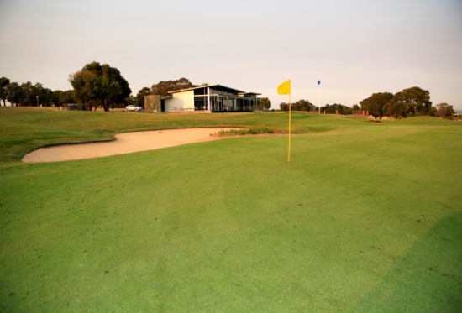
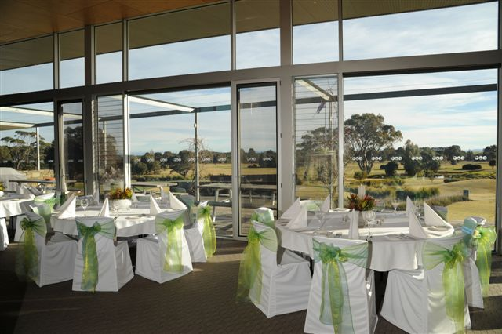
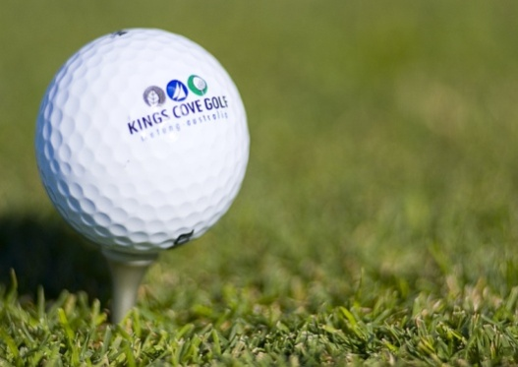

Sponsorship Agreement Form

Company Name: ______________________________Contact Name: ___________________
Address: ____________________________________Suburb: ________________P/Code____
Phone No: ____________________________ Alt Phone No: ___________________________
Email: __________________________________Website: _____________________________

Sponsorship Selection:
- Platinum $4000.00 – 1 Year
- Gold $3000.00 – 1 Year
- Silver $2000.00 – 1 Year
- Bronze $1500.00 – 1 Year
- Tee Box Signage $750.00 – For 2 Years of Signage
- Electric Cart Signage $750.00 – For 2 Years of Signage
Payment Details:
Total $___________________ (All prices are Inc of GST)
Signed___________________ Date____________________
Thank you for your sponsorship and support to Kings Cove Golf Club. In order to guarantee your sponsorship, please return this commitment form promptly and submit payment in full to Kings Cove Club, PO Box 299, Metung 3904 or email: manager@kingscoveclub.com.au

If you would prefer to receive a tax invoice, simply complete Sponsor Commitment Form and a tax invoice will be forwarded to the above address.

Payment Options: Cheque (made payable to Kings Cove Club Ltd), Visa/MasterCard or Direct Deposit – ANZ BSB: 013 510 Account: 4957 88644

Card Number Exp

CSV Name & Signature on Card________________________________

