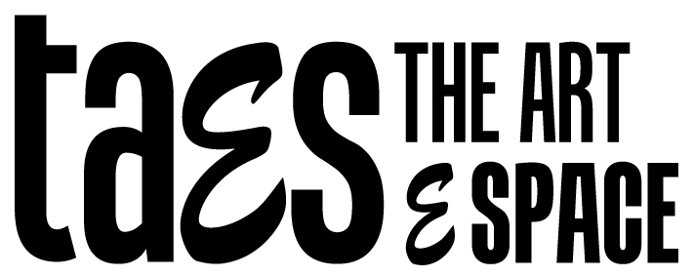

www.theartespace.com
3C-1-3, Straits Quay
0124019636
enquiries@theartespace.com

MEMBERSHIP APPLICATION FORM
NAME:
TELEPHONE:
EMAIL:
TYPE OF MEMBERSHIP | FEE (RM) | RENEWAL DUE DATE | PAYMENT  RECEIVED
FULL STUDIO | 600
PART-TIME STUDIO | 380
MONTHLY STUDIO | 100
FULL CAC | 240/ 180
PART-TIME CAC | 150/ 112
VISITOR/ GUEST | 20

KEY TYPE | DEPOSIT PAID | DEPOSIT RETURNED
LOCKER
ACCESS

I do not wish to be included in your email newsletter.

Signature: Date:

Please provide 1 photocopy of your IC or Passport.

TERMS OF USE
Submission of this application signifies that the applicant agrees to the terms & conditions of use of the facilities at The ArtESpace:
- Access and use of the facilities is to be only within the opening hours of Straits Quay.
- Members and Visitors are to be responsible for cleaning up and returning the studio to its original condition after each visit.
- Membership privileges apply only to the successful applicant. [The ArEtSpace reserves the right to determine the conditions of application. All decisions are final and may not be appealed.] On no account shall any member abuse these privileges by allowing non members of The ArtESPace, to use the facilities provided, either in their company or in their absence. [One membership allows ONE entry only.]
- Members who would like to bring a guest(s) to use the facilities, will have to sign the guest(s) in as a Visitor/ Guest for the fee of RM20 each.
- Full Studio Members are solely responsible for their access and locker keys. Loss of either of these keys will result in retention of their deposit by The ArtESpace, and full payment for any replacement keys thereafter.
- Members found to have abused their membership privileges, caused damage to the facilities provided at The ArtESpace, or the property belonging to the ArtESpace or any of its other members, will have their membership immediately cancelled, and will be required to return all access and locker keys immediately.

DISCLAIMER

1. The ArtESPace will not be responsible for any loss or damage of property, or any injuries sustained by persons using the facilities provided on the premises.
The ArtESpace does provide a security access system and cameras, to minimize the risks of theft etc, but in no way can this guarantee against such occurrences.

2. Any persons using The ArtESpace is [are] solely responsible for their property and children. There will be no babysitting facilities provided by The ArEtSpace. [All children below the age of 12, should be supervised by their parents or guardians at all times.]

