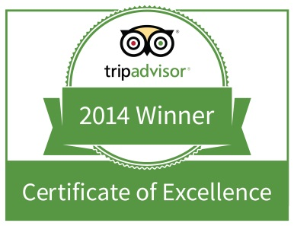

TWEED’S RESTAURANT & BUFFALO BAR
AWARDED 2015 TRIPADVISOR CERTIFICATE OF EXCELLENCE

Recognized as a Top Performing Restaurant as Reviewed by Travelers on the
World’s Largest Travel Site

Riverhead, New York, USA – May 21,2015 – TWEED’S RESTAURANT & BUFFALO BAR today announced that it has received a TripAdvisor® Certificate of Excellence award. The accolade, which honors hospitality excellence, is given only to establishments that consistently achieve outstanding traveller reviews on TripAdvisor, and is extended to qualifying businesses worldwide. Establishments awarded the Certificate of Excellence are located all over the world and represent the upper echelon of businesses listed on the website.

When selecting Certificate of Excellence winners, TripAdvisor uses a proprietary algorithm to determine the honorees that takes into account reviews ratings. Businesses must maintain an overall TripAdvisor bubble rating of at least four out of five, volume and recency of reviews. Additional criteria include a business’ tenure and popularity ranking on the site.

“Winning the TripAdvisor Certificate of Excellence is a true source of pride for the entire team at TWEED’S and we’d like to thank all of our past guests who took the time to complete a review on TripAdvisor,” said Ed Tuccio, owner at TWEED’S. “There is no greater seal of approval than being recognized by one’s customers. With the TripAdvisor Certificate of Excellence based on customer reviews, the accolade is a remarkable vote of confidence to our business and our continued commitment to excellence.”

“TripAdvisor is pleased to honor exceptional hospitality businesses for consistent excellence,” said Marc Charron, President of TripAdvisor for Business. “The Certificate of Excellence award gives top performing establishments around the world the recognition they deserve, based on feedback from those who matter most – their customers. From Australia to Zimbabwe, we want to applaud exceptional hospitality businesses for offering TripAdvisor travellers a great customer experience.”

